Advertising

The advertising mainly consists of website, google ads, social media, and attending trade shows or other events.
Website: meditativegroomer.com
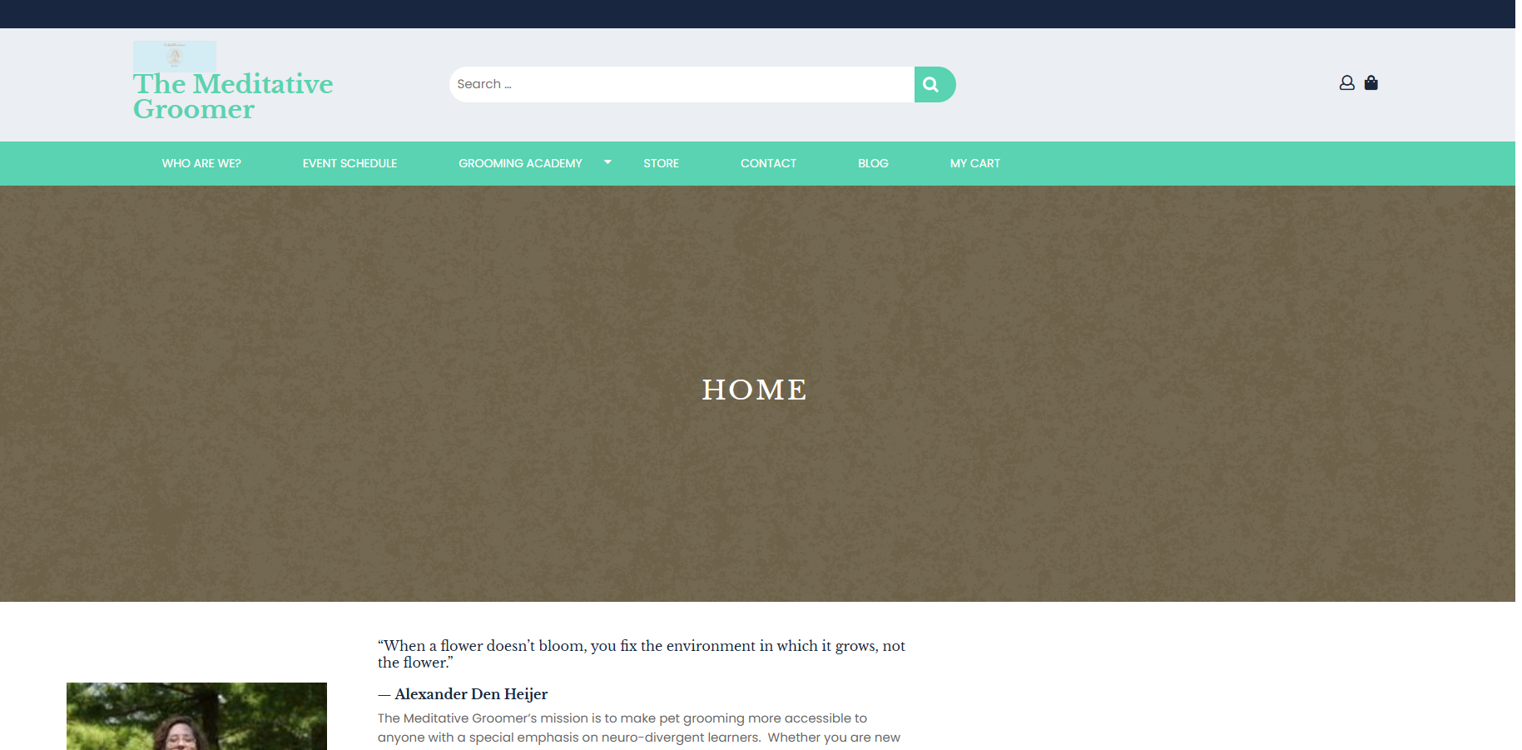

Google Ads
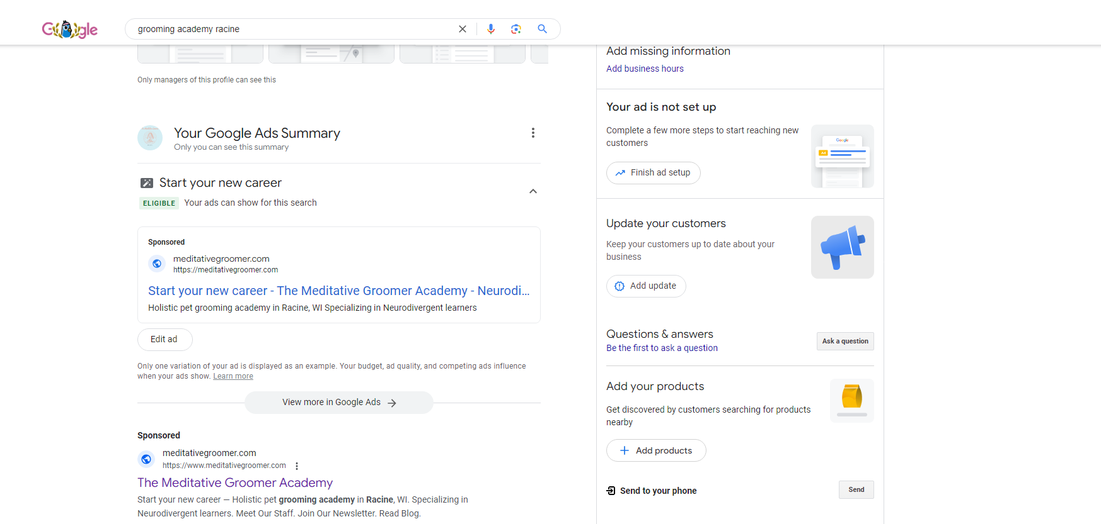
Social Media:
Instagram
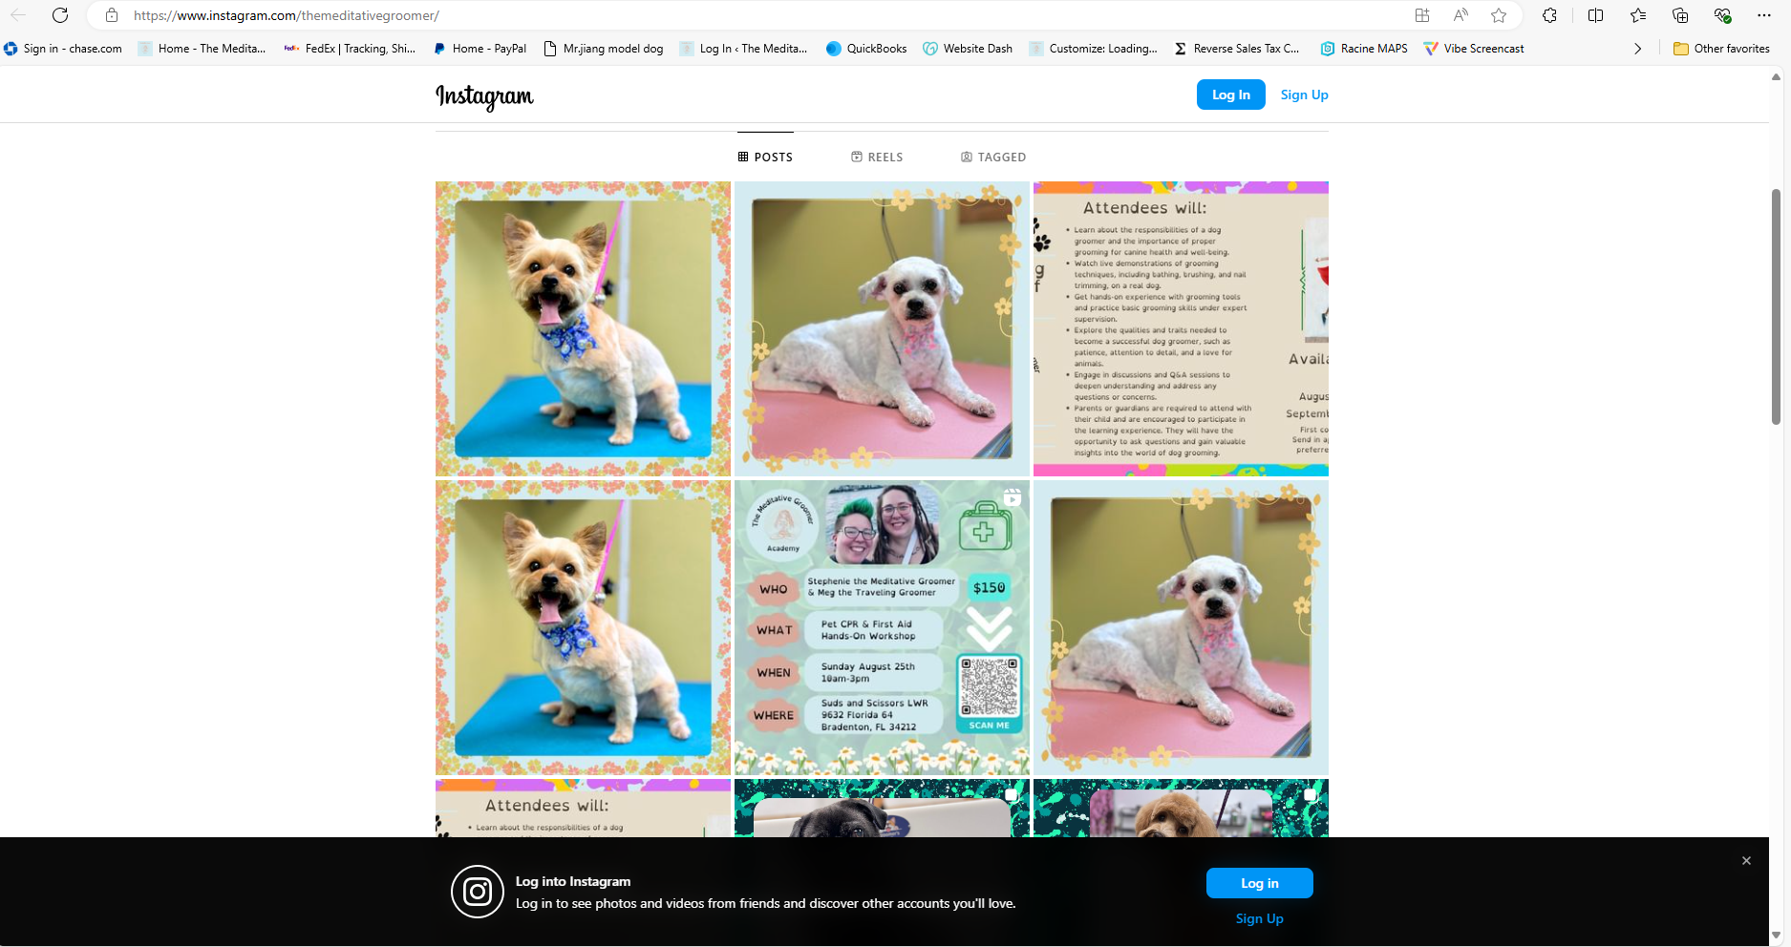
Facebook
