Managed Grazing Innovation Center Advertisement

**LinkedIn**

<https://www.linkedin.com/company/dairy-grazing-apprenticeship/posts/?feedView=all>

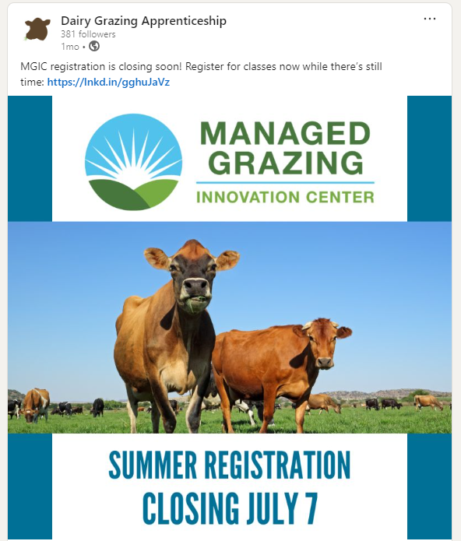

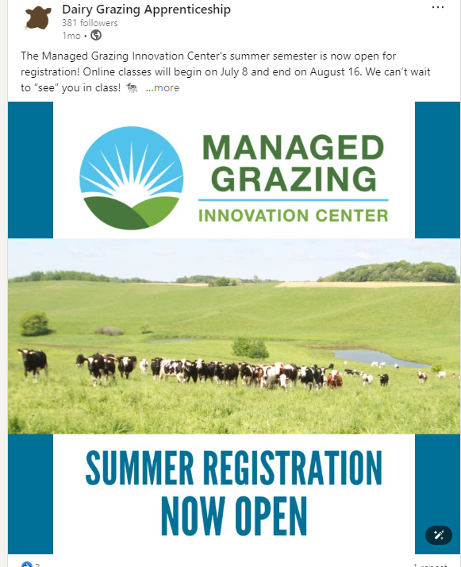

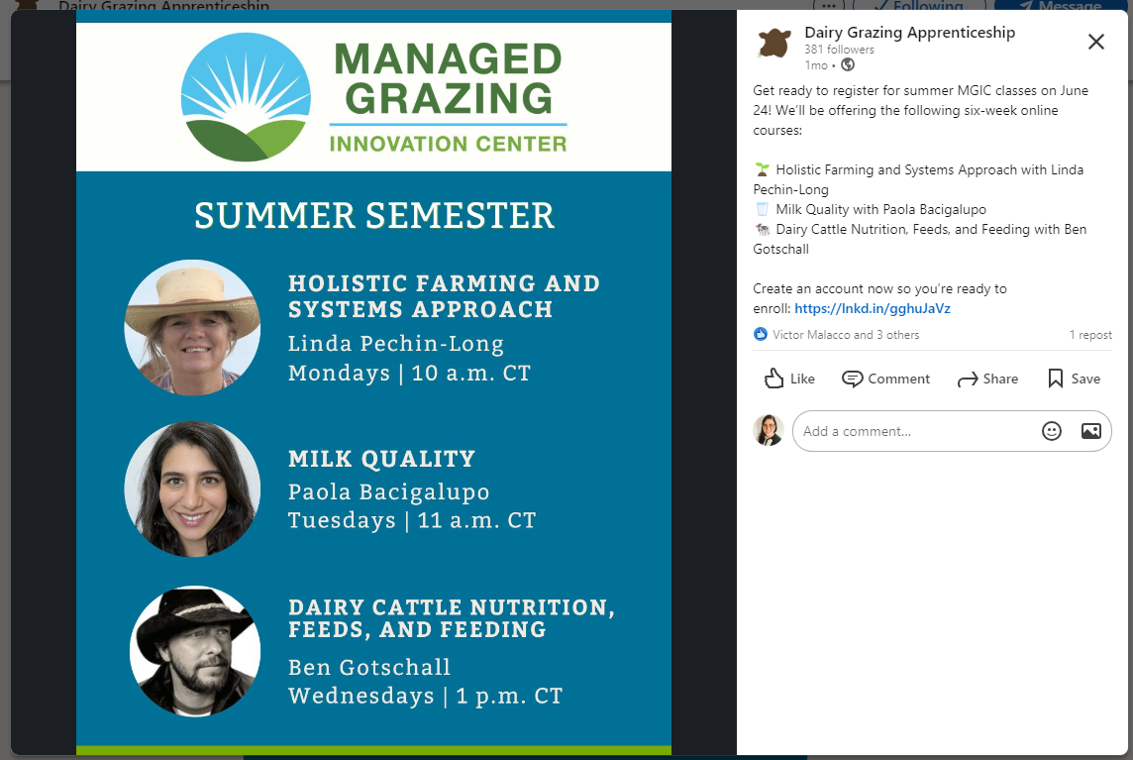

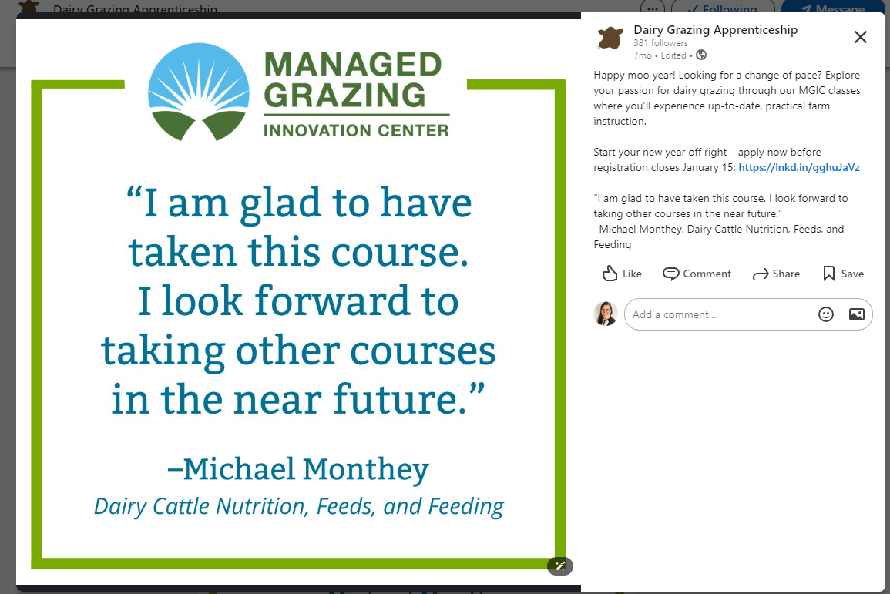

**Facebook**

**https://www.facebook.com/dairygrazingapprenticeship**

