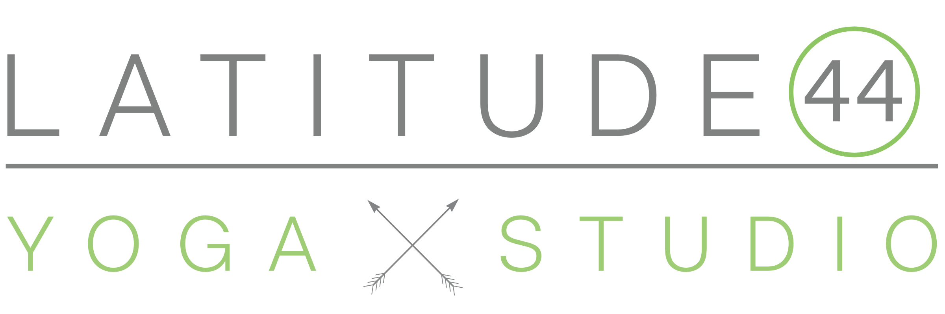

200 Hour Yoga Teacher Training

# Mission Statement

Latitude 44 Yoga Studio offers well-rounded teacher training programs designed to have you ready to teach upon completion.  Our trainings dig deeper, peel away the layers, and empower you to feel confident on your teaching journey.

# About the Training

This is a vinyasa based teacher training that empowers trainees to find their own voice while upholding respected yogic traditions. We dive into yoga philosophy, teaching methodology, anatomy & physiology, practice teaching, effective hands-on assists, cueing to the physical and spiritual level to deepen the students' experience, and ethics surrounding yoga and truthfulness. Upon completion of this training, students will be competent teachers and will have the tools to lead an effective Vinyasa class.

# Training Dates

* 12 Month Program: Thursday nights 5:00-9:00p
* Flexible learning per new Yoga Alliance guidelines in correlation to COVID-19

# General Schedule

5:00p | Meditation, Asana & Class Breakdown  
6:00p | Yoga Philosophy, Ethics & Lifestyle  
7:00p | Asana Workshop

9:00p | Depart

# About Latitude 44 Yoga Studio, Our Facility, & Location

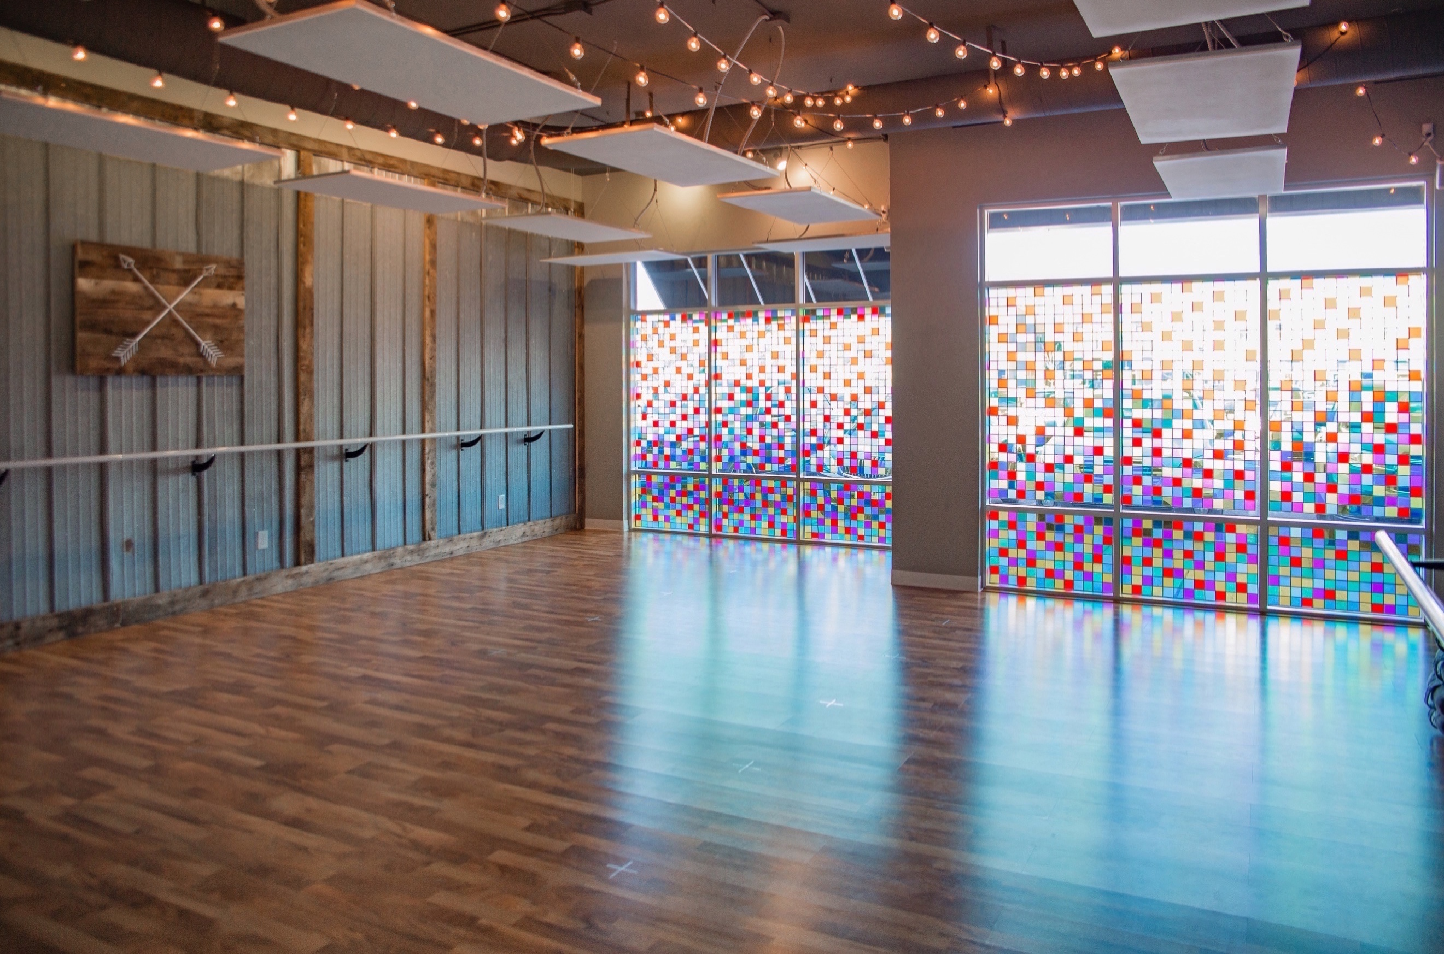Established in 2015, Latitude 44 Yoga Studio is the Chippewa Valley's favorite yoga studio! Focused on the holistic approach to overall well-being, Latitude 44 Yoga Studio provides comprehensive options to assist in living your best life. From hot yoga to yin yoga, barre, beginner yoga workshops to advanced inversion workshops, Latitude 44 makes wellness a journey instead of a destination.

We were proudly voted Best Yoga Studio in the Chippewa Valley (2020, 2019, 2018, Volume One reader poll), Best New Business (2016, 2nd place, Volume One), named one of the 10 best yoga studios in Wisconsin in 2017 & 2018 (Best of Wisconsin), and voted the Best Yoga Studio for Kids in 2017 (Chippewa Valley Family)!

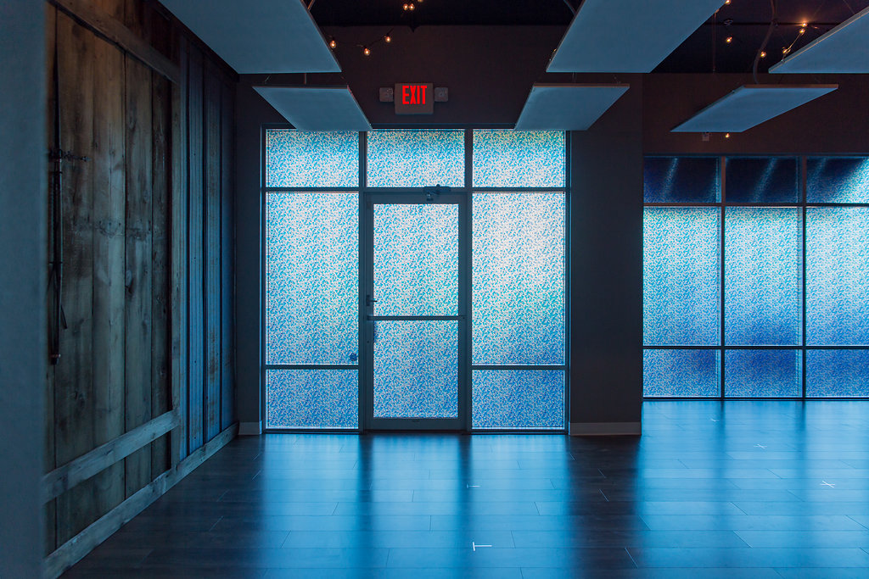We are located at 313 E. Madison Street in the Phoenix Park neighborhood of downtown Eau Claire. Our facility is handicap accessible.

Yoga blocks, bolsters, mats, and blankets are provided. You are welcome to bring any of your own items instead of using the studio supplied materials. Chairs are available for lectures and practice. Tea and water will be provided and there will be access to a microwave.

There are a variety of restaurants and coffee shops within walking distance of the studio as well as lodging options.

# About the Trainer + Owner of Latitude 44

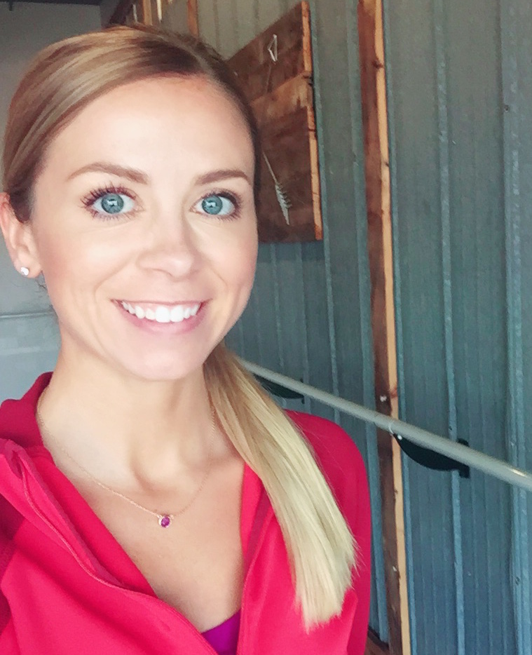Amy Erickson is certified through the Yandara Yoga Institute in Baja California Sur, Mexico at the 500 hour level. With over 1,500 teaching hours, Amy is designated as an E-RYT500. Her training has been Vinyasa based with emphasis in Kundalini, Ayurveda, Meditation, and Yin. Amy has also trained at 8 Limbs Yoga Centers in Seattle, Washington for Prenatal & Postnatal Yoga (RPYT) which is an additional 90 hour training. She has her Reiki II certification from Devanadi School of Yoga and Wellness in Minneapolis, Minnesota as well as her Barre Training from Barre Bliss in Minneapolis, Minnesota. Amy also holds a Bachelors in Business Management and a Masters Degree in Business Administration, both from the University of Wisconsin - Eau Claire.

After tragedy struck in April of 2014, Amy was drawn closer to her yoga practice. With the desire (and newly acquired need) to practice daily, Amy realized we had an opportunity in the community as we did not have any full-time yoga studios. Hopping from gym to cross-fit studio back to the gym to fulfill her needs just wasn't going to cut it. The vision of Latitude 44 Yoga Studio is to offer a full class schedule, an array of class options, and a supporting yoga community regardless of your background or the reasons you're joining us for class.

# Overview of the Training + How we will Assess your Progress

Full participation is required and is a pre-requisite for the next section. Any missed hours are required to be made up. Make-up hours must be scheduled with the lead trainer at the rate of $55/hour in advance of the next scheduled training section. Scheduled make-up hours are subject to lead teacher availability.

If you miss a weekend and do not make up the hours, you will be dismissed from the program. Unused tuition will be refunded per the refund policy.

## Required Readings

There are five required books for this course. These five required books are expected to be read during the student’s allotted non-contact hours. Though you will not be graded on the readings, the books will be used as resources throughout the training and should be read before the training begins.

* The Yamas & Niyamas by Deborah Adele (read before October 17)
* The Untethered Soul by Michael A. Singer (read before November 14)
* How Yoga Works by G.M. Roach & C. McNally (read before October 17)
* The Four Agreements by Don Miguel Ruiz (read before November 14)
* Yoga Anatomy 2nd Edition by Leslie Kaminoff & Amy Matthews (review before Nov 1)
* Asana Manual (provided)
* Philosophy Manual (provided)

## Grading and Pass/Fail System

Students will be assessed on a pass/fail basis. Feedback/grades will be provided most days within the training, and will be inclusive of all training days in which the student-teachers teach. Grades will be provided before departure each day. Grades will be gathered as the course progresses to create the total pass/fail decision upon completion with the grades being more heavily weighted as the course progresses. Criteria included in the grading assessment is as follows:

### Teaching

* Effectiveness of the class. Is the class well-rounded and offering the student/s with a quality experience?
* Clarity of cues. Are the cues provided clear enough without demonstration being needed?
* Atmosphere. Is the teacher easily heard, does the class environment feel professional and inviting, if music is used how is volume/choice/mood, etc.?

### Homework, Reading Assignments, Final Project

* Has the assignment/homework/project been completed?
* Is the student able to reflect on the assignment/homework/project with insight and understanding?

## Personal Practice

Student’s are expected to maintain their personal practice during the course of the training. Daily practice is preferred. Your personal practice can include classes in-studio or time spent in meditation or practicing asana at-home. The deeper you dive into your personal practice and exploration, the more you will connect with the training.

## Presentations

Throughout the course of the training, you will be teaching in front of the other student-teachers and the trainer. Presentation skills will be groomed throughout the training. Student teaching begins on the first day of the training and continues through the duration of the training. Skills associated with guiding asana and conducting class will be assessed throughout the course based on a pass vs. needs refinement system and provided same day.

## Final Project

The final training segment will include student led asana and guided meditation. Students will facilitate their final projects in small groups. Class theme, sequence, and structure will be determined within each small group. Student teachers will be assessed individually based on their teaching skill, clarity, effectiveness, and overall presence. This will be graded based on a pass vs. needs refinement system.

# Program Curriculum

## Techniques, Training, and Practice: 80 hours

Topics in this category could include, but are not limited to: asanas, pranayamas, kriyas, chanting, mantra, meditation and other traditional yoga techniques. These hours must be a mix between: 1) analytical training in how to teach and practice the techniques, and 2) guided practice of the techniques themselves. Both areas must receive substantial emphasis.

## Teaching Methodology: 50 hours

Topics in this category could include, but are not limited to:

* Communication skills such as group dynamics, time management, and the establishment of priorities and boundaries.
* How to address the specific needs of individuals and special populations, to the degree possible in a group setting.
* Principles of demonstration, observation, assisting and correcting.
* Teaching styles.
* Qualities of a teacher.
* The student learning process.
* Business aspects of teaching yoga* (including marketing and legal).

## Anatomy & Physiology 20 hours

Topics in this category could include, but are not limited to: human physical anatomy and physiology (bodily systems, organs, etc.) and may also include energy anatomy and physiology (chakras, nadis, etc.). Includes both the study of anatomy and physiology along with its application to yoga practice (benefits, contraindications, healthy movement patterns, etc.).

## Yoga Philosophy, Lifestyle, and Ethics 35 hours

Topics in this category could include, but are not limited to:

* The study of yoga philosophies and traditional texts (such as the Yoga Sutras, Hatha Yoga Pradipika or Bhagavad Gita)
* Yoga lifestyle, such as the precept of non-violence (ahimsa), and the concepts of dharma and karma
* Ethics for yoga teachers, such as those involving teacher – student relationships and community
* Understanding the value of teaching yoga as a service and being of service to others (seva)

## Practicum 15 hours

Topics in this category include:

* Practice teaching as the lead instructor (does not include assisting, observing or giving feedback).*
* Receiving and giving feedback.
* Observing others teaching.**
* Assisting students while someone else is teaching.

# Tuition and Fees

Tuition: $1,875

Your asana manual and your philosophy manual are included in the tuition rate. The purchase of the five required books are not included in the stated amount. These additional required books can be purchased from Amazon or any other preferred retailer.

## Cancellation & Refunds

The student will receive a full refund of all money paid if the student:

1. Cancels within the three-business-day cancellation period under SPS 406.03;
2. Accepted was unqualified and the school did not secure a disclaimer under SPS 409.04;
3. Enrollment was procured as the result of any misrepresentation in the written materials used by the school or in oral representations made by or on behalf of the school.

Refunds will be made within 10 business days of cancellation.

## Missed Sessions

Any missed hours must be made up by scheduling time with the trainer (subject to availability) at the rate of $65/hour. Missed hours must be made up prior to the start of the next training segment.

## Additional Mentoring Required

If additional mentoring is required, these hours can be acquired at the rate of $65/hour with the lead trainer. This would be supplemental hours if needed in case of a topic not being understood or demonstrated as part of home-study or previous contact hours as part of the general training time.

# How to Apply

1. Contact Amy Erickson at Amy@Latitude44Yoga.com or (715) 450-1062 for the application form.
2. Complete the form and email to Amy@Latitude44Yoga.com.

Early application is encouraged as spaces will fill. No more than 10 students will be accepted into the program. You will be contacted within five business days upon receipt of your application informing you of your acceptance or denial.

## Admission Requirements

* Applicants must be 18 years of age or older, unless written consent of a parent or legal guardian is provided. Acceptance of any minor children is subject to teacher approval on a case by case basis.
* Complete and submit an application form as provided upon inquiry.
* Applicants must adhere to the guidelines set out in this document including: attendance to scheduled sessions, inclusion of personal practice, and reading of required materials.
* Payment of tuition is required.

# School Policies

## Employment Services

Latitude 44 Yoga Studio does not guarantee employment nor provide employment services. Student referrals to prospective employers are not based on direct contact with the employer regarding current job openings.

## Student Records

An electronic summary of the students’ progress and completion will be kept on file with Latitude 44 Yoga Studio, LLC for a period of six years. The student is responsible to maintain a copy of any applicable completion certifications, however an electronic copy will also be kept on file with Latitude 44 Yoga Studio, LLC indefinitely. A duplicate certificate fee of $30 will be charged if a duplicate certificate is requested. Records are private and can only be accessed by Latitude 44 Yoga Studio, LLC owner, Amy Erickson.

## Advanced Standing

No prior education or training is admitted for advanced standing.

## Probation, Dismissal, & Re-Admittance

Any criminal activity during the course of the training is not permitted. This includes theft and possession of illegal substances. Criminal activity will result in immediate dismissal from the program without an option to return.

Students who do not adhere to the code of ethics will receive one warning with accompanied action plan. Upon a second infringement, the student will be dismissed from the program. The student may apply for future trainings but will not be guaranteed admittance. Tuition will be refunded based on the provided policy.

A student will be considered to be on probation if home-study or in-studio study is below standard. This would include if a student is not completing the home-study readings, participating in in-studio assignments, or grasping the content. A written warning with an action plan will be provided. Students are given until the next training segment (approximately four weeks) as probationary period to improve their performance to a ‘pass’ or seek additional mentoring. If performance does not improve, the student will be subject to dismissal with the option to apply for future trainings. Admittance to future sessions is not guaranteed. Tuition will be refunded based on the provided policy.

## Leaves of Absence

Leaves of absence are not permitted for Latitude 44 Yoga Studio teacher training programs. If a student must miss class, the student will be required to make up all necessary hours at the rate of $55/hour (that of our one on one sessions) before the next class. If all hours are not acquired, the student will not obtain their certification marking the successful completion of the program. Attendance will be maintained during all sections of the training. A student will be dismissed from the training after missing two consecutive sessions and refunded per the refund policy.

## Tardiness

Tardiness is defined as 10 minutes late for any section of the day. For each of 6 tardies are acquired, the student will have one hour (60) minutes to make up outside of regular classroom time to account for the required training time.

## Housing

Latitude 44 Yoga Studio, LLC does not provide any housing. Recommendations can be made upon request.

## Student Complaints

Student complaints can be submitted to Amy Erickson, Studio Owner & Lead Trainer, at Amy@Latitude44Yoga.com or in person. If student complaints are not satisfactorily resolved, you can contact the Educational Approval Program at 1(608)266-1996, DSPSEAP@wi.gov, 4822 Madison Yards Way Madison, WI 53705 or dsps.wi.gov.

## Student Conduct, Rules & Agreements

* Students will be on time for all scheduled sessions.
* Students will be courteous of other students and the staff.
* Students will conduct themselves in a professional and respectful manner at all times.
* Students will come prepared for each class session with all required material.
* Students will come well-rested, well-hydrated, and ready to learn.
* Students will respect all studio property and property of fellow students.
* Students will abide by the class schedule and expectations.
* Students will inform the teacher if they feel the need for additional mentoring.
* Students will complete their home-study as assigned.
* Students will stay committed to their personal practice.
* Video and/or voice recordings of sessions are not permitted without the teacher’s permission.
* Students are in agreement with being photographed with their inclusion of the program. Photos can and will be used by Latitude 44 Yoga Studio, LLC. The student teachers agree to full photo release as part of this program.
* Students will not partake in gossip or harmful language or actions.
* Students will exercise the yamas and niyamas and live their yoga, leading by example as they embark on their teaching journey.
* Students will follow all rules as set out by Latitude 44 Yoga Studio and all laws as set out by the State of Wisconsin.

## Liability Waiver (to be returned on first day of class)

I recognize that there are certain inherent risks associated with the activity and I assume full responsibility for personal injury to myself, and further release and discharge Latitude 44 Yoga Studio for injury or damage arising from the activity.

I agree to indemnify and defend Latitude 44 Yoga Studio against all claims, causes of action, damages, judgments, costs or expenses, including attorney fees and other litigation costs.

I agree to pay for all damages to the facilities caused by my negligent, reckless, or willful actions.

I agree and acknowledge that I am under no pressure or duress to sign this Agreement and that I have been given reasonable opportunity to review it before signing. I further agree and acknowledge that Latitude 44 Yoga Studio has offered to refund any fees I have paid to use its facilities if I choose not to sign this Agreement.

I agree to a photography release wherein Latitude 44 Yoga Studio can capture images and share them by means of social media and marketing.

I understand if the class is booked at capacity, pre-registered spaces we will be given away 5 minutes prior to class.  I should arrive to class 15 minutes early to reserve my space.

I understand that class, punch cards, and membership purchases are non-refundable and non-transferrable.

I understand that the cancellation policy is 2 hours for scheduled classes and 24 hours for private sessions. Cancellations are not refunded or transferred for workshops and events.

I have read this document and understand it. I further understand that by signing this release, I voluntarily surrender certain legal rights.

I agree to the following:

* Copyright Acknowledgement
* Photo-Video Release and Acknowledgement
* Student Conduct and School Policies
* Catalog Release
* Liability Waiver

Print Name: ____________________________Signature:­__________________________

Phone: ________________ Email: ___________________________ Date: ­­­­­­­­­­­­­­­­­_______________