Advertising for Weekend Dental Assistant School
We continue to market our school to all generations. We are active on our Facebook page itself but now have been advertising on Facebook as a platform. It seems to have brought up our traffic and applications. We have linked both Facebook and Instagram together so when our social media director makes a post it goes over both platforms. Last year we hired a media company to help with the website and make social media content for our staff to share. This year we have hired a media director to help with social media. Having a media director be a has helped bring new ideas, new content to younger adults. She has done an amazing job helping advertise from a different point of view. The media company and our media director have helped launch our platforms to reach everyone! No matter the generation. Between the two, they not only help put together posts with things such as 100% satisfaction rate, testimonials from past students, fall semester starting soon, etc., they help us by creating a schedule to create posts and stay active on social media.
We are in the process of looking at Tik Tok platform for more exposure. We are spending time to see if adding this to our platforms would benefit the program. The goal is to not only cater to all generations but to continue to expand our presence to where the market is going. We realize we must constantly change the way we advertise with how people use their devices. People stream, podcast, watch movies/TV and upload content in a blink of an eye. We not only will advertise by using radio and billboards but by implementing all social media platforms.
Website: www.weekenddentalassistant.com
Facebook: Weekend Dental Assistant School
Instagram: weekenddentalassistantschool
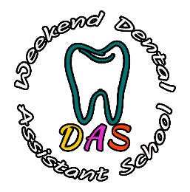
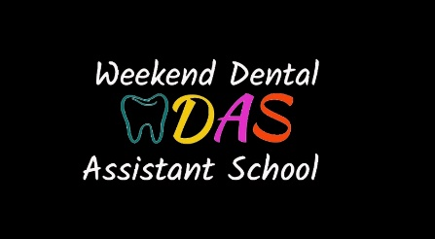
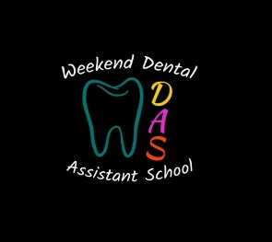
Logos:

