These Hands School of Massage, LLC

These Hands School of can be found at the following locations:

Listed on the American Massage Therapist Association website
https://www.amtamassage.org/fams/1997433/these-hands-school-of-massage

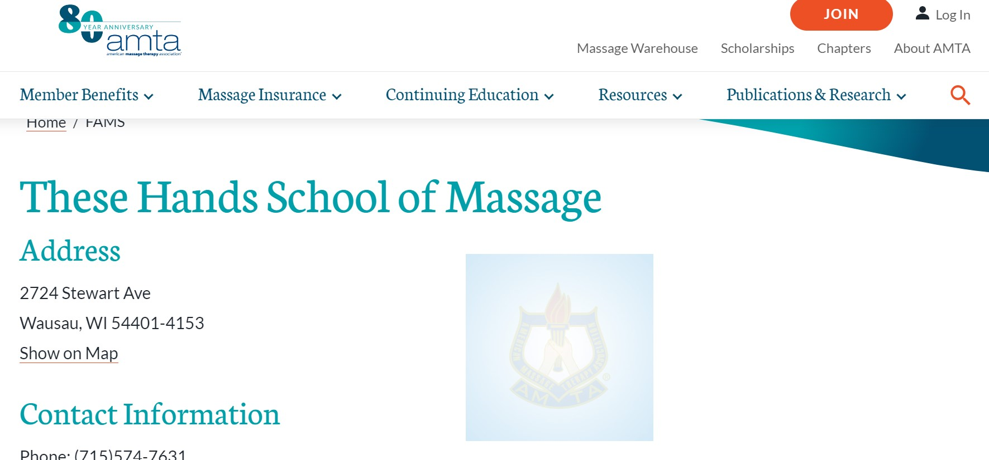

Listed on the Wisconsin Educational Approval Programs (EAP) website:
https://dspseap.wi.gov/search/viewschool.asp?schoolid=210&display=description

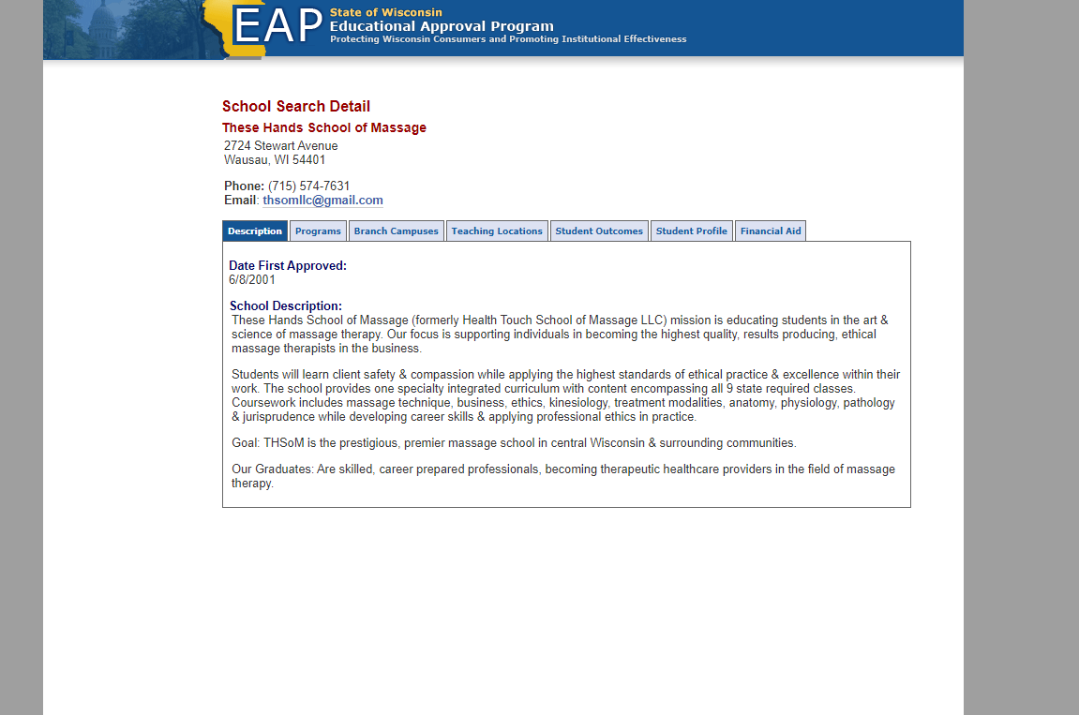

Wisconsin Eligible Training List Program website:
https://dwd.wisconsin.gov/ETPL/Home/Results?Keyword=These%20Hands%20School%20of%20Massage%20Therapy%2C%20LLC&raProgram=False

