Recording Radio Film Connection & CASA Schools (RRFC)

National Advertising Campaign Website and Social Media

Recording Connection 2

Website - Published - Programs 2

Audio Engineering & Music Production 2

Advanced Audio Engineering & Music Production 3

Ableton Electronic Music Production 3

Hip Hop & Beat Making 4

these are not included in the pics and program titles that follow 5

Logic Pro Electronic Music Production 5

Music Business 6

Music Producing 6

Creator Pro 7

Artist & Producer in Ableton Live 7

Social Media - Published Program Posts 8

Instagram 8

Facebook 9

Film Connection 11

Website - Published Programs Program 11

Film Production & Editing 11

Cinematography 11

Social Media - Published Program Posts 12

Instagram 12

Facebook 13

Chef Apprentice School of the Arts (CASA Schools) 14

Website - Published Program Program 14

Gourmet Chef 14

Social Media - Published Program Posts 14

Instagram 14

Facebook 15

Radio Connection 17

Website – Published ProgramProgram 17

Radio Broadcasting 17

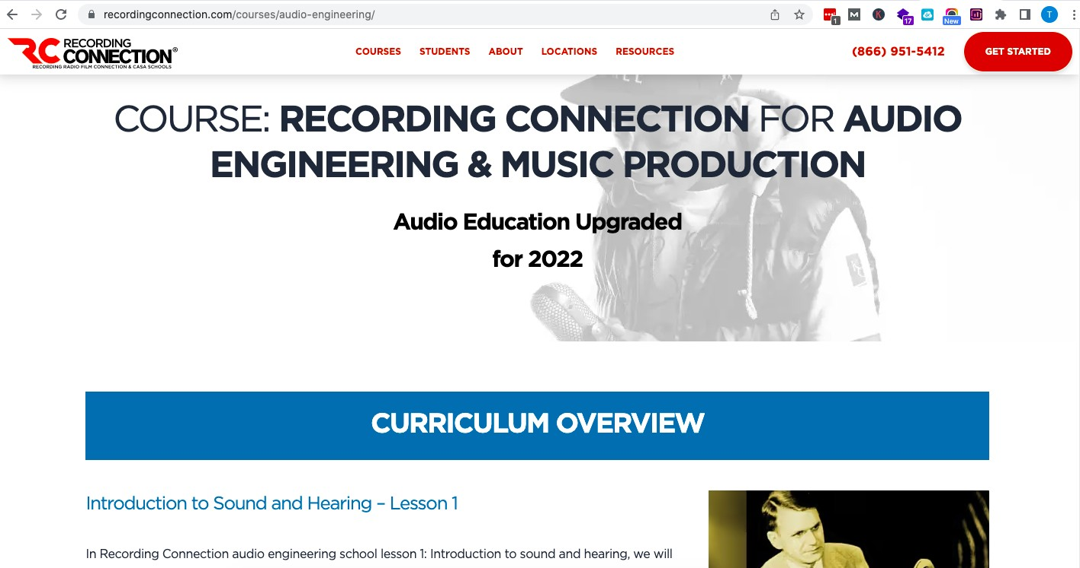Recording Connection Website - Published Programs

Audio Engineering & Music Production

Advanced Audio Engineering & Music Production

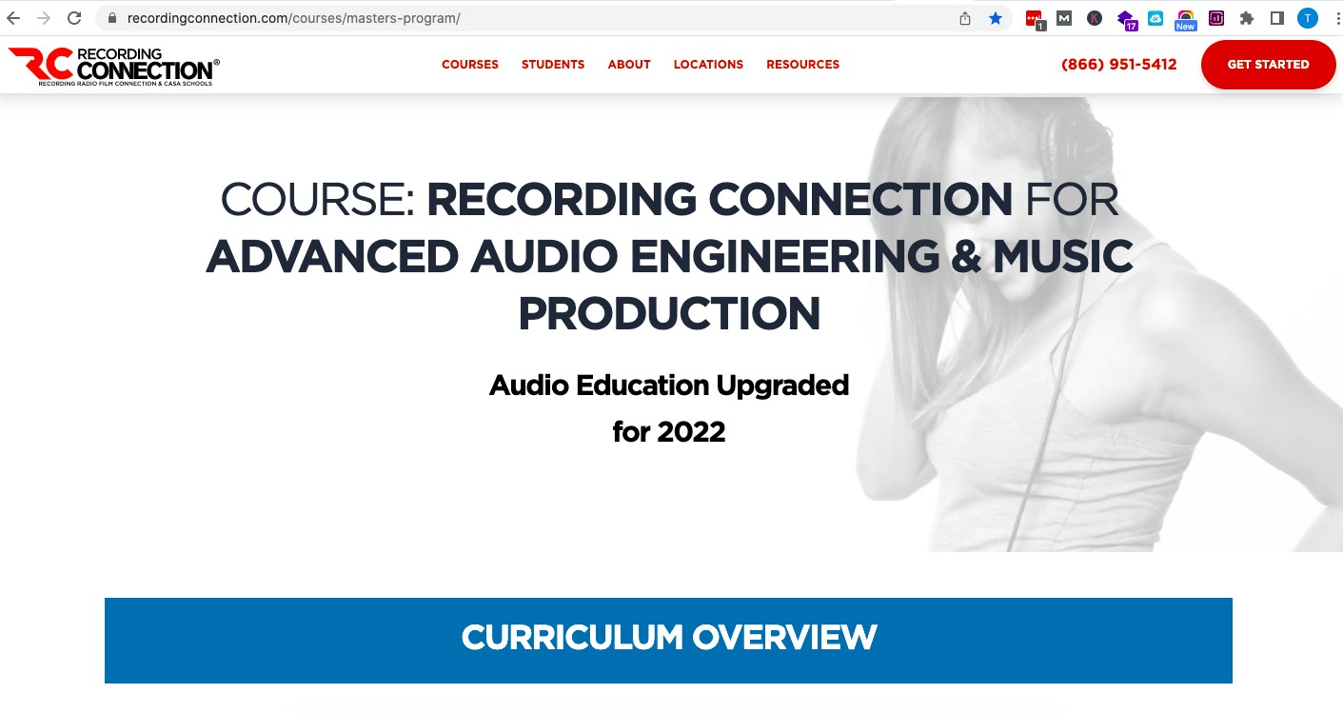

Ableton Electronic Music Production

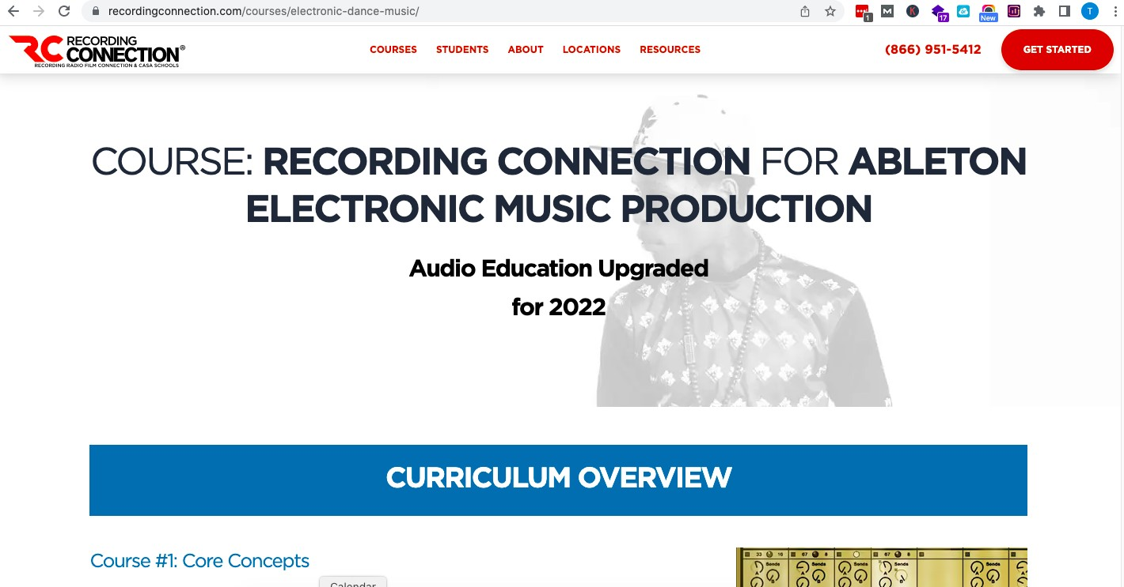

Hip Hop & Beat Making

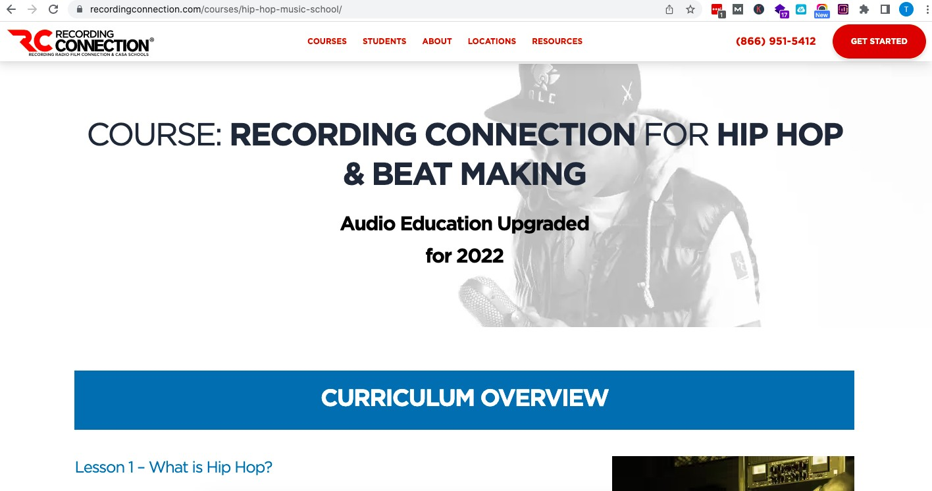

Logic Pro Electronic Music Production

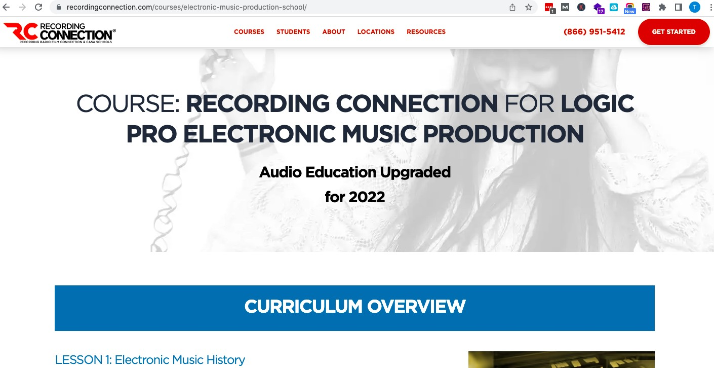

Music Business

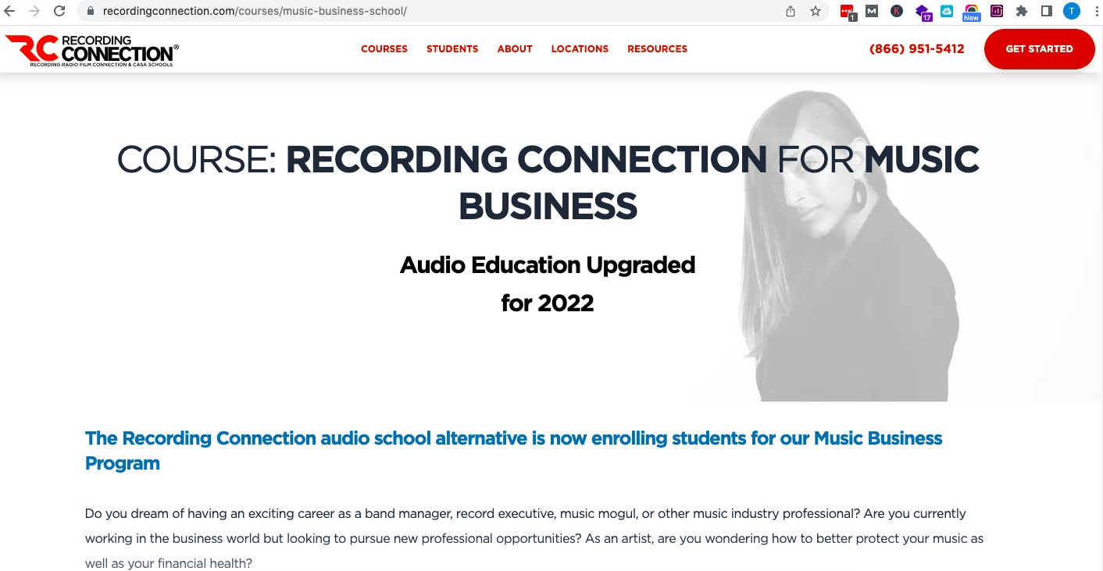

Music Producing

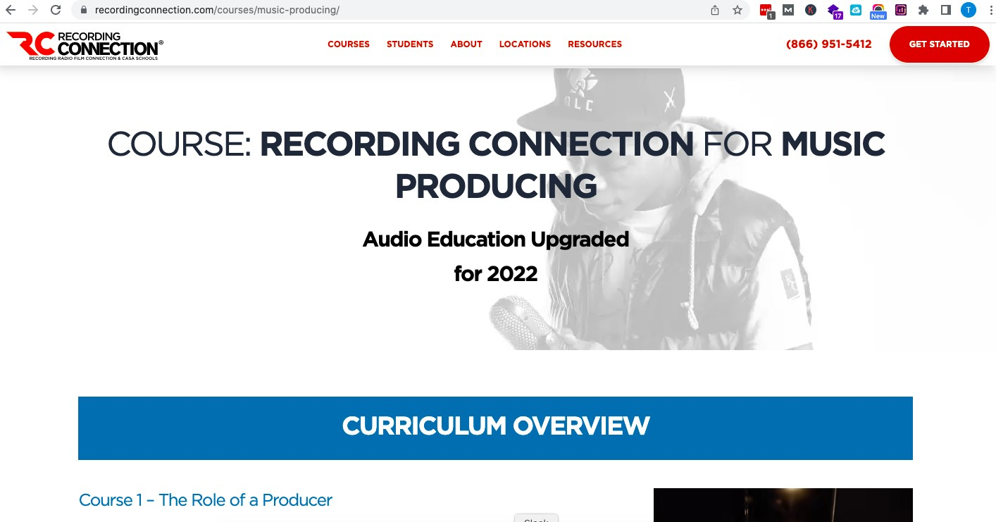

The Creator Pro

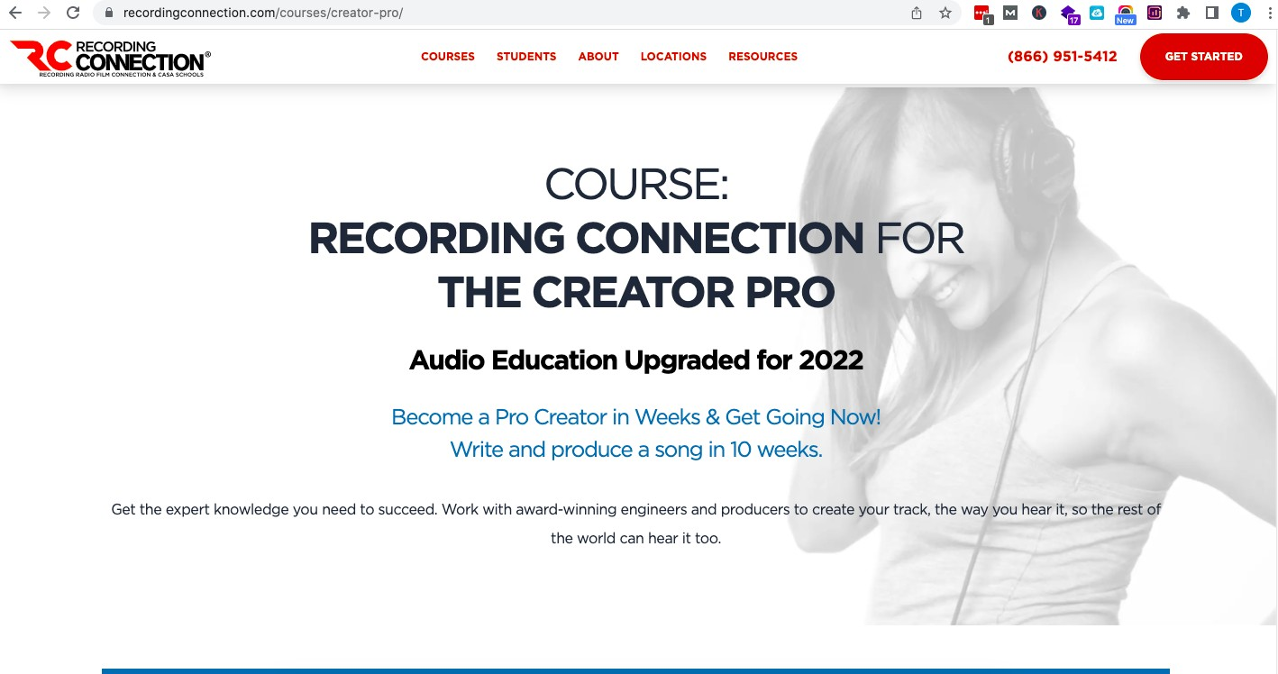

Artist & Producer in Ableton Live

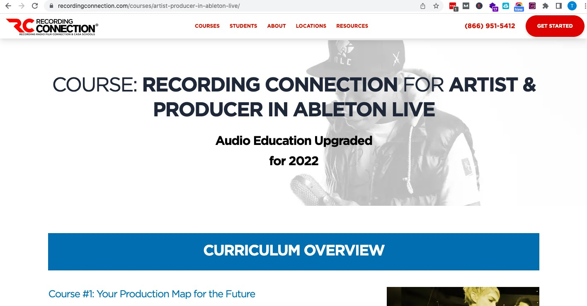

## Social Media - Published ProgramPosts

Instagram delete this reference unless you make the program name changes

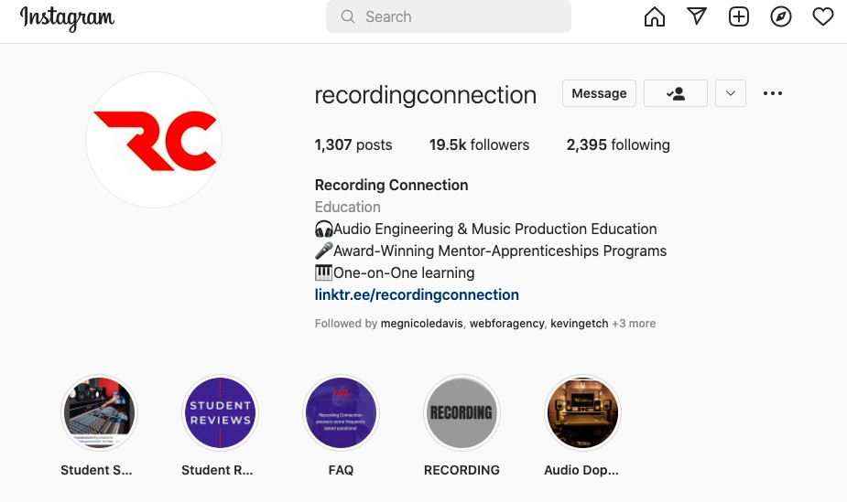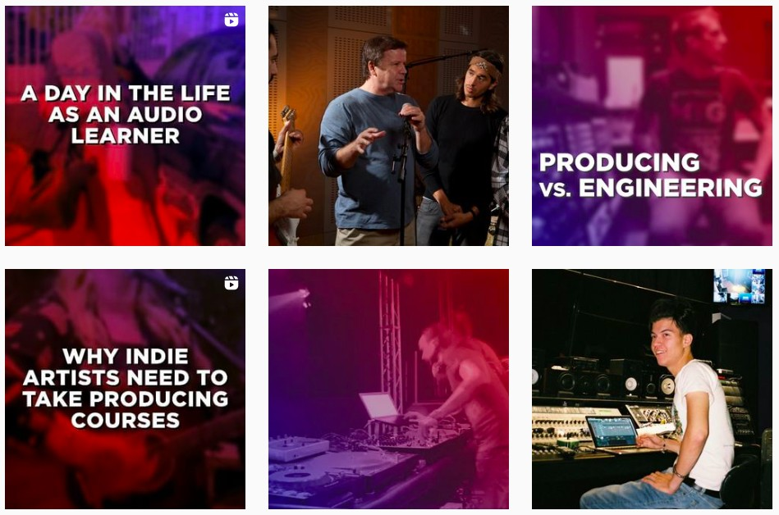

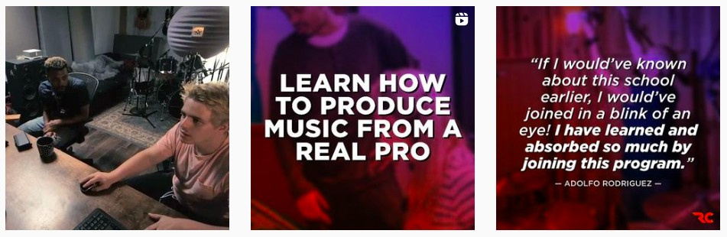

Facebook

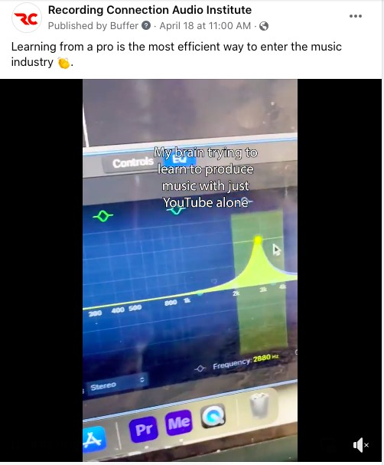

# Film Connection

## Website - Published ProgramPrograms

Film Directing (Film Production & Editing)

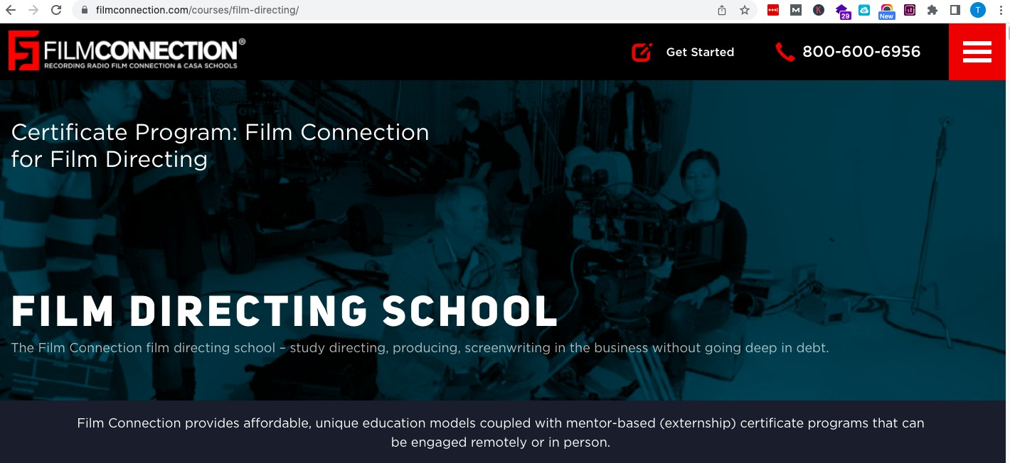

Cinematography

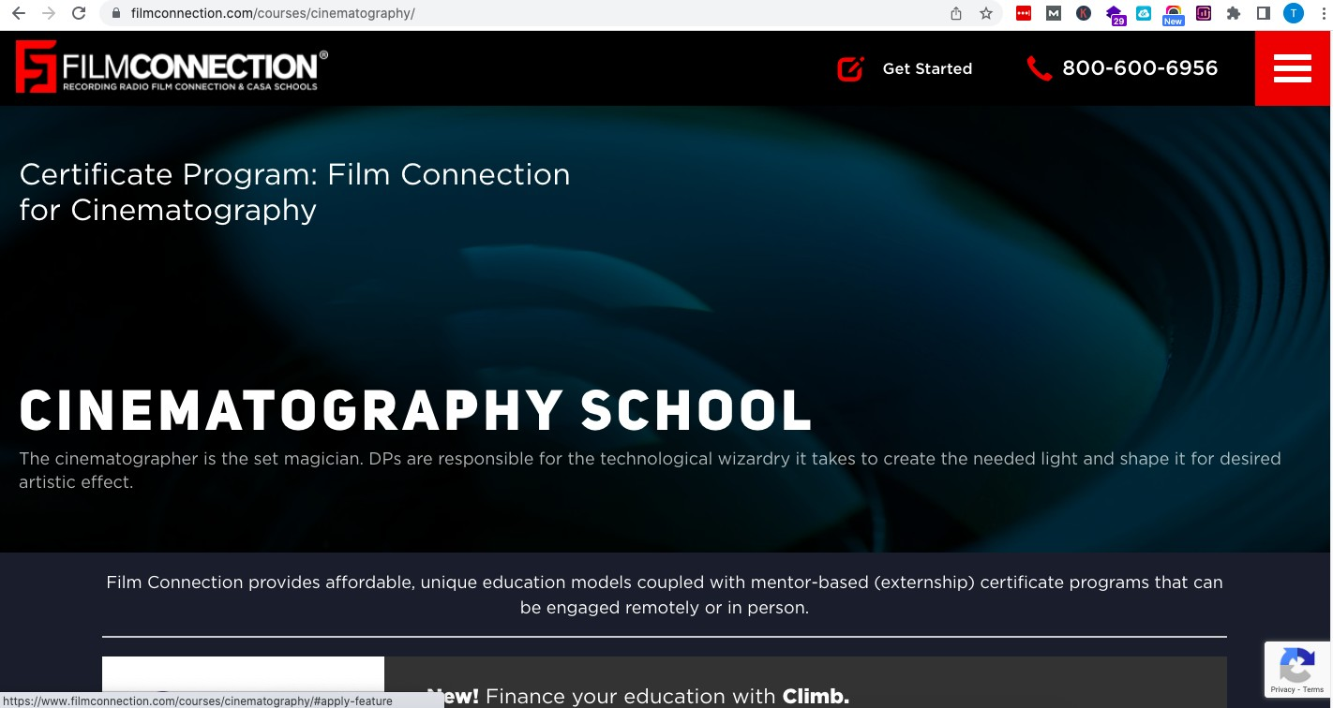

## Social Media - Published ProgramProgram Posts

### Instagram

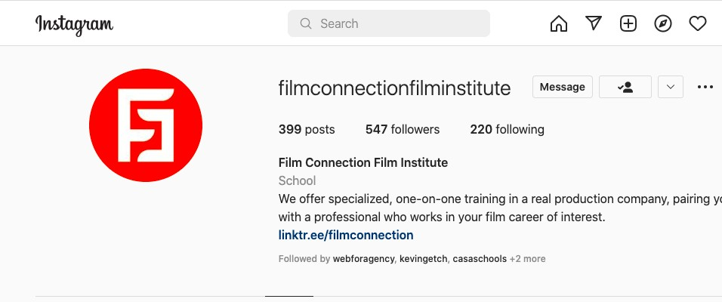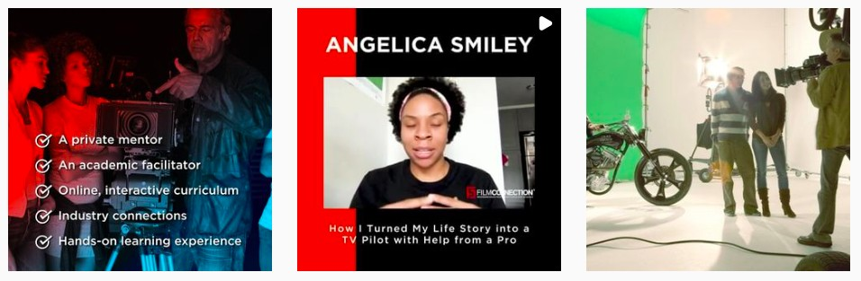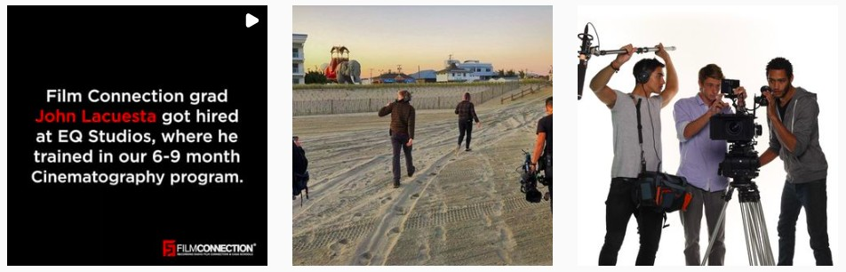

### Facebook

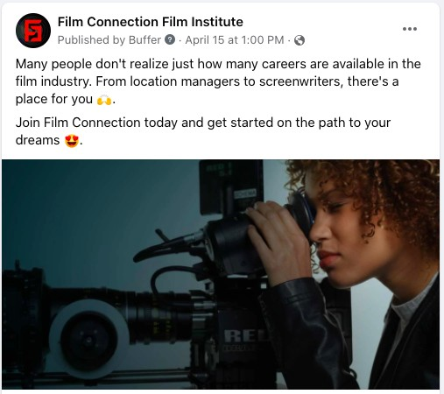

# Chef Apprentice School of the Arts (CASA Schools)

## Website - Published Program

Gourmet Chef

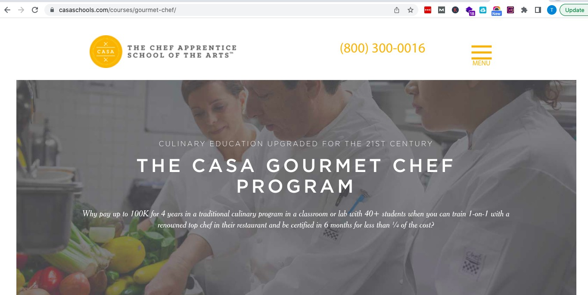

## Social Media - Published Program Posts

### Instagram

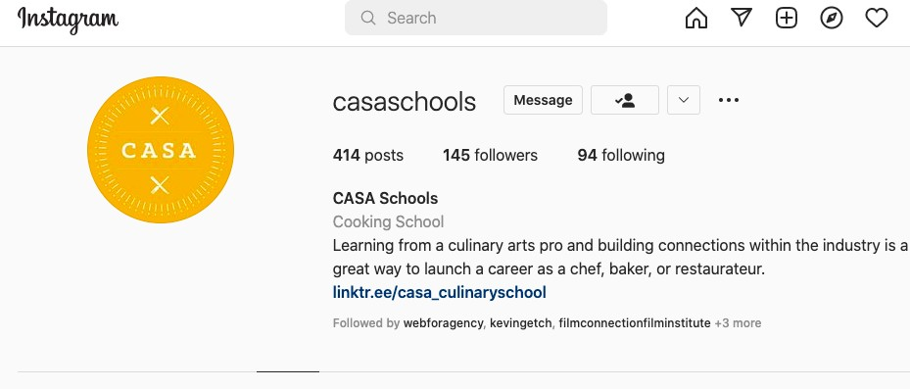

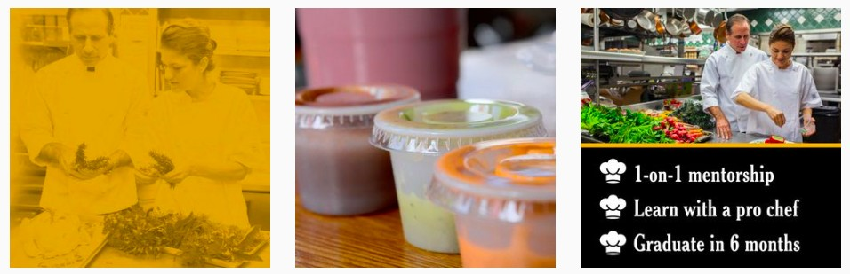

### Facebook

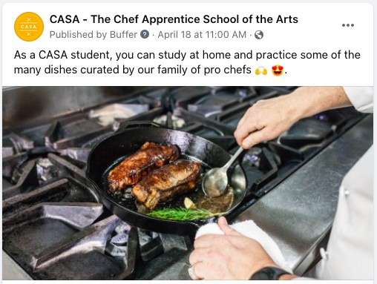

**CAS.A** - Time Chef **Apprentice** Schooll **o•f the Arts** ...

* Published by Buffer**8** - April 5 at 3:30 **PM** -**0**

CASA is more than just your average culinary school :.. ,

Our extemship-based education model gives you 26 hours of private instruction from a pro chef . Pllus we don't drag out the curriculum w11th unnecessary information to get more money from you.. You can even graduate in as Httlle as 6 months . That means you can get started on your dream career even sooner

This is your sign to applly today!

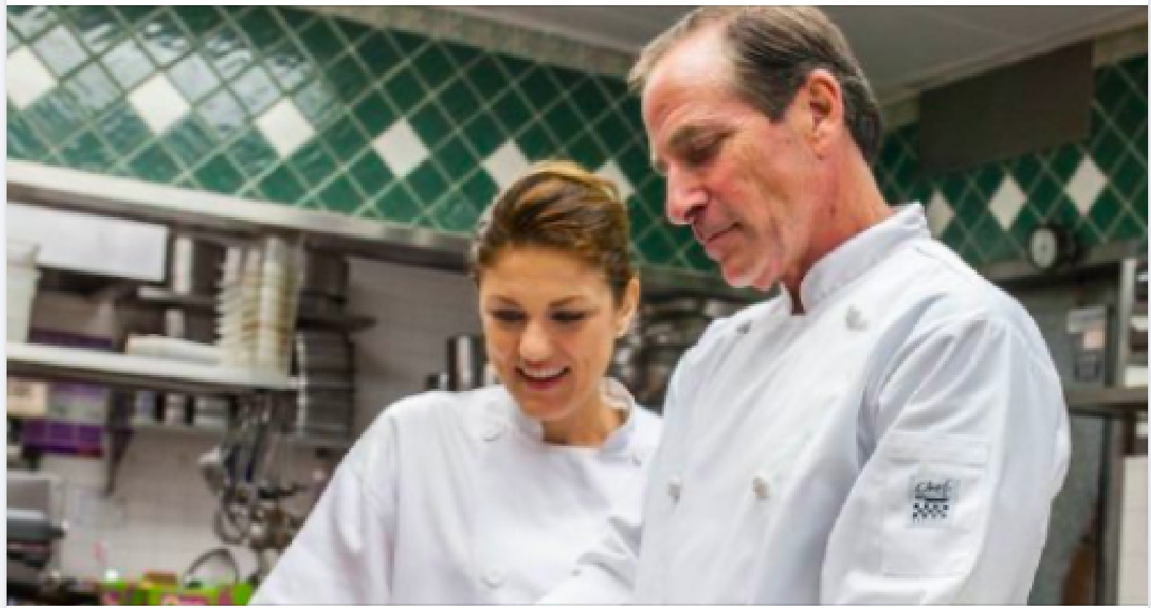

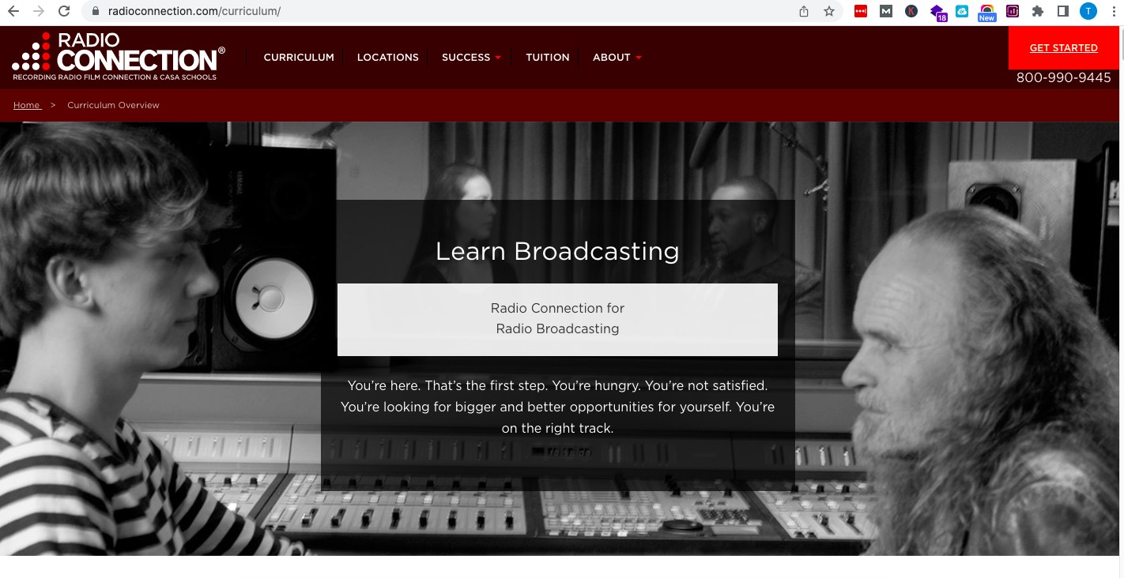Radio Connection Website - Published ProgramPrograms Radio Broadcasting