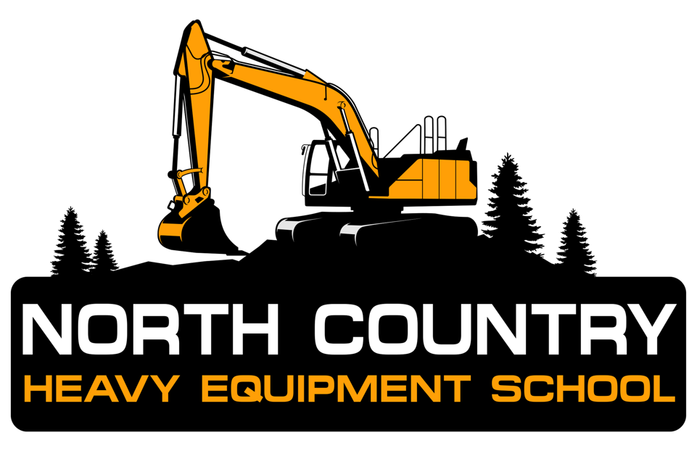
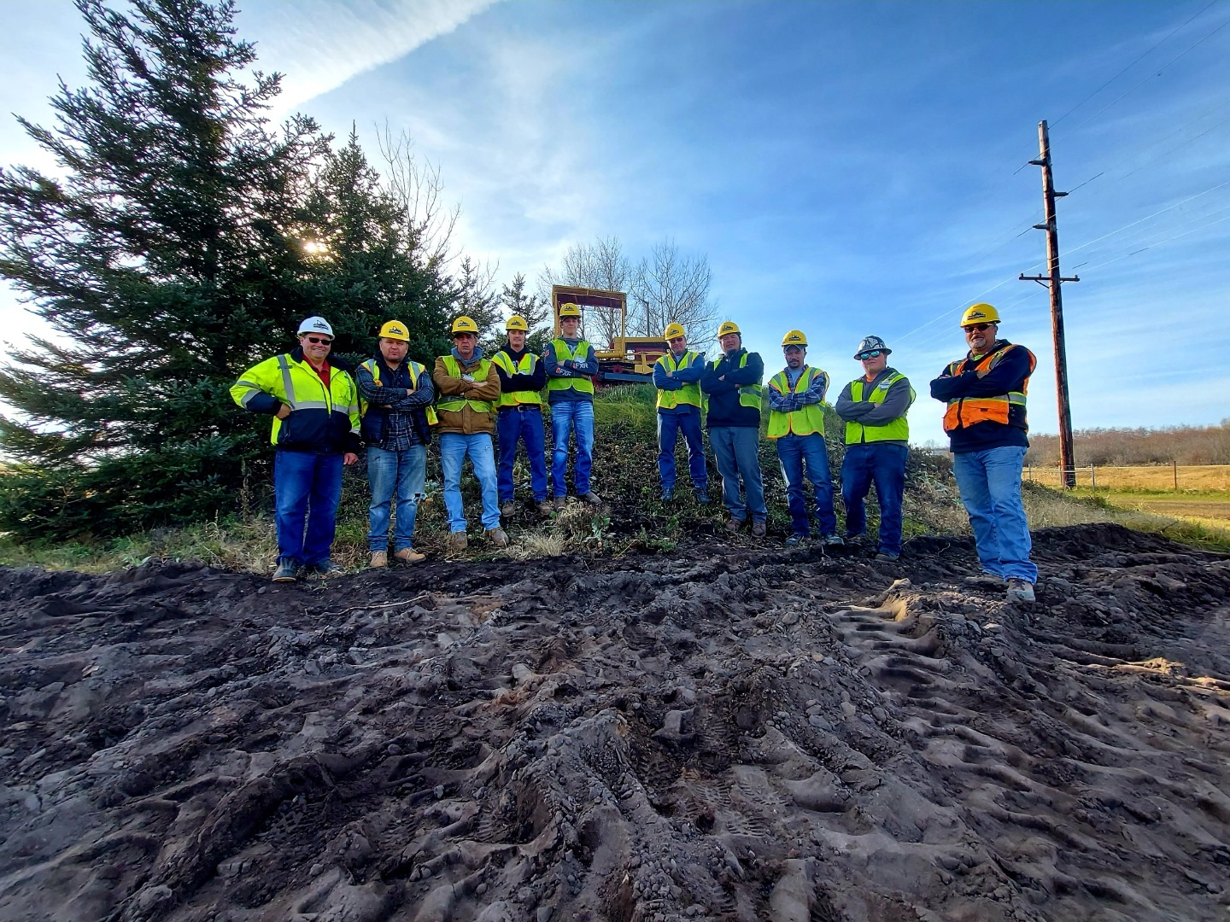

North Country Heavy Equipment School, LLC

School Catalog – April 1st, 2023

North Country Heavy Equipment School, LLC
2929 16th Avenue North
Escanaba, Michigan 49829
Postsecondary School Number 8604000471
Phone: (906) 789-3123 or (800) 682-9222
Fax: (906) 789-3124
E-mail: admissions@NCHESchool.com
Website: www.NCHESchool.com

This catalog is updated from the previous catalog. School is licensed by the State of Michigan; the Wisconsin Educational Approval Board; and the Michigan State Approving Agency for Veteran Training. This catalog replaces all others.

I hereby certify that the contents found herein are
true and correct in content and policy.

Kyle Barron 4/1/2023
_________________________________ ___________________________________
Kyle Barron - Director of Admissions Date
Table of Contents

Content Area Page
School Mission 4
Name and Location 4
Governing Body 4
State Licensure 4
Schedule 4
Class Size 5
Advisory Group 5
Instructors and Staff 5
Admission Requirements, Deadlines, and Notifications 5
Prerequisites for Enrollment 5
Overnight Accommodations 6
Tuition Charges 6
Equipment Needed by Students 6
Student Enrollment Agreement 6
Program Goal 6
Description of Training 6,7
Description of Heavy Equipment 7
Description of Facilities 7
Instructor’s Expectations of Student Conduct 8
Instructional Methods 8
Student Evaluation, Grading System, Criteria
and Student Records 8
Student Progress 9
Requirements for Graduation 9
Credit for Previously Learned Skills 10
Rules of Student Conduct and Conditions for Probation 10
Student Policies 10
Absences 10
Leaves 11
Tardiness 11
Make-up Work 11
Suspension and Dismissal 11
Withdrawal and Cancellation 11
Refund Policy 12
Student Complaints 12,13
Instructor and Course Evaluation 13
Course Schedule 14
Annual Holidays 14
Employment Assistance Services 14
Job Placement Assistance 14
Job Placement Survey 14
Content Area Page
Daily Schedule for the Four Week Course 15
Student Learning Objectives and Performance
Tasks for Tests 17,18
Veteran Student Addendum 19,20

Appendices may Include:
Application for Admission
Map to the School
List of Area Hotels
Course Brochure
Confirmation Letter
Student Enrollment Agreement
Daily Sign-In Form
Student Transcript
Test 3: Bulldozer Excavation
Test 4: Transit Operator for Bulldozer Excavation
Student Evaluation Survey
Job Placement Survey

North Country Heavy Equipment School Catalog

School Mission

The mission of North Country Heavy Equipment School is to give students the knowledge, skills, and abilities to succeed in the Heavy Equipment Operator Industry. This is achieved by delivering a safe and effective instructional program based on the highest degree of instructional and professional standards. After successful completion of the course students can enter the industry as an entry level professional operator.

Name and Location

North Country Heavy Equipment School, LLC
2929 16th Avenue North Escanaba, MI 49829
Postsecondary School Number: 8604000471
Phone: (906) 789-3123 or (800) 682-9222 Fax: (906) 789-3124
E-mail: admissions@NCHESchool.com
Website: www.NCHESchool.com

Governing Body

North Country Heavy Equipment School, LLC is a Limited Liability Company whose members include Director of Admissions and School Certifying Official (SCO) Kyle Barron, and School Director Josh Barron. At this time, they are the only members. Full time faculty includes the Director of Admissions and School Certifying Official (SCO) Kyle Barron, Head Instructor Emil LaFave, Instructor Roger Betzinger, and Instructor Donald Cugini.

State Licensure

North Country Heavy Equipment School has been licensed by the State of Michigan as a Postsecondary School License number 8604000471 since 1999, and by the State of Wisconsin since 2002. The School is also an approved training facility by the GI Bill® and Veterans Affairs and Army National Guard Tuition Assistance Programs.

Course Schedule

The four-week level 1 and level 2 heavy equipment operator course is scheduled as follows:
Four weeks, five days per week, 160 hours of total instruction
Day 1 – 8:00am to 4:30pm EST (Excavation Competent Person Training Certification, ECPT)
Days 2 through Day 20 – 8:00am to 4:30pm EST (Hands on training operating heavy equipment)
Graduation Ceremony on the last day of class is 3:00pm eastern time

GI Bill® is a registered trademark of the U.S. Department of Veterans Affairs (VA). More information about education benefits offered by VA is available at the official U.S. government Web site at https://www.benefits.va.gov/gibill.
Class Size

To provide students with quality instruction and sufficient hands-on time operating heavy equipment the class size is limited to twelve students for each four-week long program. There are at least two instructors offering a 1:6 instructor to student ratio.

Advisory Group

The Advisory Group meets with the Director and the instructional staff once each year. At this annual meeting the curriculum is reviewed, enrollment and job placement discussed, and the evaluation report presented. The Advisory Group also reviews the Student Catalog, and offers suggestions aimed at continual improvement. Advisory Group members are Carol Bergquist Ph.D., Robert Larson (Larson Land Services, LLC), Ed Burnette (Burnette and Sons Excavating), Kyle Barron, Jacob King (North Country Trucking, LLC), and Josh Barron.

Instructors and Staff

Emil LaFave, Licensed Excavator Operator (H306378-State of Michigan) Emil LaFave has over 40 years of experience operating heavy equipment and owning a successful excavating business. He has taught Heavy Equipment Operation to over 500 students in the past fifteen years and is the School’s Head Instructor. There are two additional Instructors for fieldwork exercises with one being Roger Betzinger, who has years of experience in heavy equipment operation and is an instructor at the School. The other is Donald Cugini, a former Navy Operator and NCCER Certified Instructors. They all have many years of experience associated with heavy equipment operation. Carol Bergquist, Ph.D. assists with the School, and also provides programmatic consultant services. Kyle Barron is the Director of Admissions and School Certifying Official at the School and is the contact for veteran students.

Admission Requirements, Deadlines, and Notifications

To apply, a student may call the School for an application, stop into the School and fill one out, or a form may be faxed to them. Information can also be taken over the phone or submitted electronically via e-mail or through our website. Since there are no prerequisites, enrollment is complete when the application is received by the School and the method of payment is confirmed. Admissions for each four-week class are on a first come first serve basis. A copy of the application and accompanying materials (flyer, brochure, off-site lodging, list of hotels, etc.) are in the Appendices.

Upon receiving the application, a letter is mailed to the student, and to the funding agency if applicable, confirming the student’s enrollment and the dates of the class. A copy of this letter is in the appendices. Depending upon availability, the deadline for admission may be up to the first day of class, if there are openings.

Prerequisites for Enrollment – None
Overnight Accommodations

Several hotels and restaurants are available in the Escanaba area. Many hotels offer discounts for North Country students. The student pays all hotel and food costs. A list of nearby hotels and their rates is mailed with each application package or electronic submission. The School also has an off-site lodging available to the students with many accommodations including washer and dryer, stove, sink, microwave, garage, grill, common area and much more. There is an additional charge to stay in the off-site lodging and that brochure is in the appendices.

Tuition Charges

Tuition for the four-week Heavy Equipment Operator Course effective 4/1/2023 is $9,990.00. A fuel surcharge has been added as of 5/31/2022 in the amount of $500.00 per student. Books and materials have been added in the amount of $289.00 per student. These above fees are inclusive of the: 160-hour Heavy Equipment Operator Course, Excavation Competent Person Training (ECPT), OSHA-10 Construction Certification, informational handouts, operator’s manuals, and use of mandatory personal safety equipment provided for use during the course consisting of safety vests, ear protection, safety glasses, and hard hats. There are no other fees, charges, or supplies required. Tuition payment arrangements are made with each student prior to their first day of class, as specified in their Student Enrollment Agreement. If installment payments are approved, then one-fourth is due the first day of each week of the class.

Dress Requirements

Students do not need to furnish any equipment outside required apparel for the class. All safety equipment and PPE is furnished, as well as all other supplies including paper, writing utensils, and notepads. Each student does need to supply their own rain gear, proper apparel, and safety toe boots or shoes.

Student Enrollment Agreement

On the first day of class, and following a review of the Student Catalog, each student is asked to sign a Student Enrollment Agreement. This contract specifies the student’s agreement to comply with school procedures and policies and confirms the method of payment for the course. This includes the three-day cancellation policy and the refund to be made within ten days requirement. A copy of this contract is in the Appendices.

Program Goal

The goal of this program is to teach students the basic skills needed to operate a variety of heavy equipment. Each student will benefit from the systematic instruction which consists of classroom exercises (5%) and field training (95%), which includes the hands-on operation of equipment. To provide quality instruction there are at least two instructors for not more than 12 students. To ensure sufficient hands-on time operating equipment, the six 2-member teams utilize seven pieces of heavy equipment.

Description of Training

Each student will learn to:
- Operate an excavator, 6-way angle blade dozer, extendahoe backhoe, articulated front-end loader, articulated motor grader, compact track loader, and tandem axle dump truck
- Practice safety procedures including use of personal safety equipment and safety inspection of equipment, industry termed the “walkaround”
- Complete routine maintenance on each piece of heavy equipment
- Load and unload heavy equipment and secure it down properly using chains and ratchet binders
- Use laser and regular transits, and various leveling devices
- Conduct field staking, bench marking, offset staking, and squaring
- Learn the Excavation Competent Person Training (ECPT) standards for handling an OSHA inspection and receive ECPT Certification, by participating in a 1-day training program which is included in the four-week course on the first day

Each student will learn how to complete the following field work and use the equipment provided, as instructed:

- Digging, leveling, grading, shaping, trenching
- Installing a sewer service line
- Backfilling techniques
- Compacting soils
- Using laser transit to set grades
- Reading grade stakes to get proper elevation
- Loading and hauling materials
- Digging shallow basement at grade
- Digging and excavating a pond
- Proper culvert and pipe installation

Description of Heavy Equipment

Students learn to operate the following equipment:

- John Deere 690E-LC Excavator
- John Deere 310G enclosed cab 4x4 Extendahoe Backhoe
- John Deere TC54H Articulated Front-end Loader
- Dresser 850 Articulated Motor Grader
- Mack Tandem Axle Dump Truck
- John Deere 450H 6-way Angle Blade Dozer
- John Deere 317G Compact Track Loader
- Laser Transit, rod and detector, regular transit with rod, measuring and leveling devices
- Motorized compactor and various industry specific hand tools

Description of Facilities

The facilities are located in the commercial area of Escanaba, MI and consist of classroom space, an office, and an outside area where all fieldwork using heavy equipment is performed. These facilities are located on a 4-acre parcel of undeveloped land. All heavy equipment is parked on the fieldwork site. Additional structures include an outside pavilion, two storage buildings, which house the necessary supplies for the class, and a portable latrine.

Instructor’s Expectations of Student Conduct

  - Provide information about their experience and skills related to heavy equipment.
  - Discuss their expectations for the class.
  - Attend class each day, reporting on time, alcohol and drug free.
  - Wear proper clothing for weather (rain and cold weather) and for safety (work boots and proper use of gloves, ear protection, eye protection, etc.)
  - Practice all field safety procedures as described in class (hard hats, safety vests, glasses and earplugs are provided).
  - Practice daily, routine equipment light maintenance and grease, oil and refuel procedures, including “walk around”.
  - Participate in all classroom and field training activities, taking all performance tests (proficiency exams).
  - Complete an evaluation of the course.
  - Complete an Employment Follow-up Survey and return it by mail.

Instructional Methods

The class objectives are met through lecture, video presentations, PowerPoints, reading handouts, studying equipment operator’s manuals, and actual operation of equipment in the field. The required textbook for this course is NCCER Heavy Equipment Operations Level 1 and 2.

Student Evaluation, Grading System, Criteria, and Student Records

Each student will be evaluated by:
- Attendance and participation in classroom and fieldwork activities.
- Performance of fieldwork and results of performance based tests covering specific tasks and equipment operation.
- Participation in the 1-day Excavation Competent Person Training (ECPT).
- Adherence to the safety policies.
- Performance Tests are administered in a timely manner throughout the four-week class at the instructor’s discretion and dependent upon weather conditions.
Grading on ten performance tests (each item on all 10 tests is rated on a 5-point scale from 1=poor to 3=average to 5=excellent) for the course is determined on a percentage basis, the number correct is divided by the total possible score. A passing grade is 75% or higher on each test, this requires an average score of 3.5 across all items on each test. Since each test differs in point value, grading is presented in percentages. The grading scale is: 59% or below = failure, 60-69% = below average, 70-79% = average, 80-89% = above average and 89-100% = outstanding. A passing grade for the entire course consists of the average of all ten test scores and follows the same percentage scale. A list of the performance objectives, which are the performance outcomes for the tests, are presented in the Student Objectives and Performance Tasks for Tests section below. Two sample tests (Tests 3 and 4) are in the Appendices.
Results of each test are reported on the Student Transcript. This Transcript remains in the file indefinitely. All test instruments remain in the student’s confidential academic file for a minimum of 6 years. The academic files are located in file cabinets in the Director’s office, which is locked when no staff is present. A copy of his/her Transcript is mailed to each student, and the funding source, if applicable, within one week of course completion. A copy of the Student Transcript is in the Appendices.

Each performance test is a benchmark for learning heavy equipment operation skills. Testing begins at the end of the first week of class and continues through the last day. Each student is told whether or not he/she passed each test immediately after the completion of that test, during a private conversation between the student partners and the Instructor. Since the tests are performance based, results are reviewed on a step-by-step basis. In this way each student learns what he/she performed well on and what he/she did not. If a student did not perform well, opportunities are provided for additional instruction in problem areas, and arrangements made for the student to retake the test. Due to a tight instructional schedule, re-testing is completed after school hours at a time agreeable to the student and an instructor.

Student Progress

Feedback on student progress is provided on a daily basis, which is possible due to the high teacher to student ratio. At the close of each day, the instructors meet and discuss the progress of individual students and the class as a whole, and adjustments are made as needed. Students are evaluated throughout the course based on competency based learning objectives.

If student progress reports are required by funding of an agency, that agency can request weekly student attendance and progress details.

Due to the four-week duration of the program, the opportunity for re-testing, and the averaging of all test scores, unless requested and pre-arranged by a funding agency, a student is not dismissed from the School for lack of academic progress. If a student is dismissed for the lack of academic progress and returns to the School, credit will be given for all previously completed work and the cost of tuition adjusted accordingly, with the student and/or the funding agency.

Requirements for Graduation

Each student receives a certificate from the school upon successful completion of the course, which includes instruction and practice with every piece of heavy equipment. Successful completion also includes a passing grade on the performance-based tests given, as described under the Student Evaluation, Grading System, Criteria and Student Records section above.

Credit for Previously Learned Skills

Since all tests are performance and competency based, it is possible to complete a test prior to instruction, if the student feels confident to do so. If a student has prerequisite skills, the Instructor will conduct any of the performance tests at a mutually agreeable time. If the student passes the test, credit will be given for that test, based on the student’s actual performance operating heavy equipment. Arrangements are then made for substitution of instruction in a more advanced level of heavy equipment operation.

Rules of Student Conduct and Conditions for Probation

- Be on time for class in the morning and on return from lunch break.
- Practice all safety procedures as demonstrated by the Instructors.
- Participate in all classroom and field site learning experiences.
- Satisfactorily pass performance-based tests.
- Since the course is 4 weeks in length and the tests are performance based, there is no probationary period.

Student Policies

Absent Policy - Absences are handled on an individual basis. Students are expected to be in attendance every day for the full 8-hours. Students sign-in each day and write in their time of arrival. A copy of the sign-in form is in the appendices. These forms are indefinitely retained in the Director’s class files. Each student’s overall attendance is reported on his/her Student Transcript. Attendance is reported by total days and by actual clock hours of instruction. Since all tests are performance based, it is impossible to pass a test without the required instruction missed due to an absence. (Unless the student already has the skills, see Credit for Previously Learned Skills section above.)

When a student is ill, or must be absent for an emergency situation, classified as excused absences, every effort is made to accommodate him or her into the class, such as working with the Instructor after regular class hours or on weekends. However, for longer absences, of 2 or more days, the student is invited to continue with the next class opening, or at a later date as his/her life situation permits. There are no time limits or additional charges if the absence is documented and excused.

For unexcused absences, such as “no shows” or” no reason given”, the student continues in the class when he/she returns, but no special arrangements for make-up are given. If a student’s unexcused absence results in a missed test, the student receives a score of 0% for that test, which will impact that student’s overall average score. If the student is funded by an agency, that agency will be notified of the unexcused absence and the impact of the missed test score. The student may continue in the class and complete all remaining tests but will not be certified by the School on that piece of heavy equipment for which the test was missed. Receiving a score of 0% on any of the eleven tests will impact the student’s final grade for the course. If the student fails to return, then the Refund Policy applies. If a student fails to return and is funded by an agency, that agency will be notified by the end of the second unexcused day.

Attendance Policy - Students are expected to attend all classes. If circumstances prevent attendance at a particular class, prior notification is expected in order to arrange make-up sessions. If attendance falls below 90%, the student may be dismissed. Students whose absences result from authorized mitigating circumstances, as determined by the Director of Admissions, will not be terminated. Students who have been terminated from the school for unsatisfactory attendance may be re-admitted at the discretion of the Director.

- Leave of absence - Since the course is four weeks in length, leaves are handled like absences, as described above.

- Tardiness - All students are expected to be on time for class each morning, and prompt in their return from lunch. Since 90% of the course is hands-on work with heavy equipment and students work with partners, promptness is particularly important. Students sign-in each morning and note the time of their arrival. A tardy is 15 or more minutes late for class start-up. A copy of the Sign-In Form is in the appendices.

- Make-up Work - When a student is absent, it is very difficult to make up the lost learning time. Within reason, the Instructor works with students during lunch hour, after school hours, or weekends. However, this type of accommodation is limited to those students who have legitimate reasons for absence or tardiness, such as funeral leave, illness or other personal emergencies.

- Suspension and Dismissal - A student is only suspended for extreme behavior. Suspensions occur if a student arrives at school under the influence of drugs or alcohol, or in instances for disregard for the safety of themselves and/ or others. Any incident is handled on an individual basis. Repeated offenses may result in dismissal. Reasons for dismissal include the second violation for a suspension, and a required meeting between the student and the Director, and funding agency (if applicable). Reasons for dismissal include arriving at class under the influence of drugs or alcohol, or extreme safety violations. If a student fails to return or is dismissed, his/her tuition is refunded on a prorated basis, as described in the Refund Policy section below. To be readmitted, a dismissed student must reapply, explain in writing how his/her behavior will be different this time, and sign a new Student Enrollment Agreement.

- Withdrawal and Cancellation - If a student cancels or withdraws before or on the first day of class or if the applicant is rejected for enrollment any tuition paid is refunded in full. An application fee of not more than $25 may be retained by the school if the application is denied. Does not include refund policy in effect after three business days. If withdrawal occurs after the first day of class, tuition is refunded on a prorated basis, as described in the Refund Policy section below.

Refund Policy

All tuition and fees paid by the student shall be refunded if requested within three business days after signing a contract with the school. All refunds shall be returned within 30 days.

A student who withdraws or is dismissed after attending at least one class, but before completing 60% of the instruction in the current enrollment period, is entitled to a pro rata refund as follows:

At Least But Less Than Refund of Tuition
1 unit/class 10% 90%
10% 20% 80%
20% 30% 70%
30% 40% 60%
40% 50% 50%
50% 60% 40%
60% N/A No Refund

As part of this policy, the school may retain a one-time application fee of no more than $25. The school will make every effort to refund prepaid amounts for books, supplies and other charges (if applicable). A student will receive the refund within 30 days of termination date. If a student withdraws after completing 60% of the instruction, the school may refund a pro rata amount, if withdrawal is due to mitigating circumstances beyond the student’s control.

A written notice of withdrawal is not required.

For Department of Veterans Affairs students, the following policy is required:
If a student fails to enter a course or withdraws or is discontinued there from at any time prior to completion, the amount charged will be an approximated pro-rata portion of the total charges for tuition, registration fee less $10, and other charges that the length of the completed portion of the course bears to its total length.

Student Complaints

Student complaints are referred to the Director of Admissions, Kyle Barron, and will be addressed not later than the next class day. He will listen to the student and try to resolve the complaint at that level. Every effort will be made to do so. If the student is funded by an agency, and if the student and the Director have not come to an agreement, that agency will be contacted by the Director and resolution will be sought at that level. If the student feels that his/ her complaint remains unresolved, he/ she may contact the school’s approval agency. Students who wish to file a complaint with the State of Michigan may do so at www.michiganps.net.

Since the School is licensed in two states, Michigan residents and all others except Wisconsin residents are to contact:
Ann Bradley
State of Michigan, Michigan Dept. of Licensing and Regulatory Affairs
P.O. Box 30018
Lansing, MI 48909
Phone: 517.373.8216
BradleyA@Michigan.gov

Wisconsin residents are to contact:

Zachary Galin
Educational Approval Board
30 West Mifflin Street, 9th floor
Madison, WI 53703
Phone: 608.266.3185
zachary.galin@eab.state.wi.us

Department of Veterans Affairs funded students are to contact:

https://ask.va.gov
Workforce Development
Michigan Department of Labor and Economic Opportunity
201 North Washington Square
Lansing, MI 48913

Instructor and Course Evaluation

Each student anonymously completes a 26-item evaluation form, which rates the instructors and the course. Results are thoroughly reviewed, with all ratings and comments taken seriously. After the Graduation Ceremony and the students have departed, all Instructors read each evaluation and discuss the suggestions made, and components students liked or did not like. Student feedback is used throughout the year as a formative evaluation to improve the course. A copy of the Evaluation Form is in the appendices.

Course Schedule

An annual course schedule is developed each year. Classes begin in April and continue through December each year for each consecutive four-week period. A specific schedule is available in December for the following year.

The 2020 start and completion dates for the course are:

April 13th - May 1st
May 11th – May 29th
June 8th – June 26th
July 6th – July 24th
August 3rd – August 21st
August 31st – September 18th
September 28th – October 16th
October 19th – November 6th
November 9th - November 27th

The 2021 start and completion dates for the course are:

April 5th, 2021 – April 30th, 2021
May 3rd, 2021 – May 28th, 2021
June 1st, 2021 – June 25th, 2021
June 28, 2021 – July 23rd, 2021
July 26th, 2021 – August 20, 2021
August 23rd, 2021 – September 17th, 2021 September 20th, 2021 – October 15, 2021
October 18th, 2021 – November 12, 2021
November 16th, 2021 – December 10, 2021

The 2022 start and completion dates for the course are:

April 4, 2022 – April 29, 2022 | September 19, 2022 – October 14, 2022
May 2, 2022 – May 27, 2022 | October 17, 2022 – November 11, 2022
May 31, 2022 – June 24, 2022 | November 14, 2022 – December 9, 2022
June 27, 2022 – July 22, 2022 | December 12, 2022 – January 6, 2023
July 25, 2022 – August 19, 2022
August 22, 2022 – September 16, 2022

The 2023 start and completion dates for the course are:

January 9th, 2023 – February 3, 2023 June 26th, 2023 – July 21st, 2023
February 6, 2023 – March 3, 2023 July 24, 2023 – August 18, 2023
March 6, 2023 – March 31, 2023 August 21, 2023 – September 15, 2023
April 3, 2023 – April 28, 2023 September 18, 2023 – October 13, 2023
May 1, 2023 – May 26, 2023 October 16, 2023 – November 10, 2023
May 30, 2023 – June 23, 2023 November 13, 2023 – December 8, 2023

Annual Holidays

The School and offices are closed on the following holidays:

- New Year’s Day
- Memorial Day
- Independence Day
- Labor Day
- Thanksgiving Day
- Christmas Day

For holidays that fall during regularly scheduled class days, the students vote on how that time is accommodated and make up time can be made on nights and weekends.

Employment Assistance Services

Job Placement Assistance - North Country Heavy Equipment School does not guarantee employment after completion of the program. The school does not offer a job placement service, but the School does have employers and recruiters that hire right out of the school. A data base of student names and addresses is maintained so that information about employment opportunities can be mailed to students as it is received.

Student transcripts are maintained for five years. Information regarding the student’s performance in class is shared with employers only after permission to release this information is given by the student. Kyle Barron, the Director of Admissions, is pleased to serve as a reference for students who complete the course.

Job Placement Survey - A follow-up survey regarding job placement is conducted with each student after course completion (typically within 90 days after completing the course). The Survey is mailed to the student’s home with a stamped and addressed return envelope. The 20-item Survey queries the student about their current employment status and whether or not they are employed in the field of Heavy Equipment Operation. A copy of the Survey is in the Appendices.

Daily Schedule for the Four Week Heavy Equipment Operator Course

Day 1 Morning (8 hours classroom, ECPT)
- Excavation Competent Person Training (ECPT)
- Explain Course Operations
- Accommodations
- Safety Procedures
- Performance Testing
- Student Interviews
- Overview of Equipment
- Videos on Heavy Equipment
- Selection of Partners
- Introduce Sign-in Sheets
- Excavation Handouts

Day 2 through Day 20 are in the field hands-on training

Day 2 (8 Hours)
- Issue and Demonstrate Safety Equipment
- Issue Operators Manuals
- Grease Gun Demonstration
- Explain Function of each piece of heavy equipment
- Assign Partners to their first piece of heavy equipment
- Initial Practice Sessions

Day 3 (8 Hours)
Each set of partners begin skill building on one piece of equipment:
- Bulldozer
- Excavator
- Dump Truck
- Backhoe
- Front-end Loader
- Articulating Motor Grader
- Compact Track Loader
Day 4 (8 Hours)
- Partners continue skill building on one piece of equipment
- Demonstrate Performance Tests
- Begin Performance Testing
Day 5 (8 Hours)
- Partners Continue Skill Building with Partners rotating
- Continue Performance Testing (Proficiency Exams)

Day 6 (8 Hours)
- Partners rotate to next piece of heavy equipment
- Continue performance testing with partners on next piece of heavy equipment

Day 7 - Day 19 (8 hours each day)
- Continuation of day 7 with partners rotating to all pieces of heavy equipment

Day 20 (8 Hours)
- Complete all performance testing with all students
- Tractor low-boy and dove tail trailer demonstration
- Proficiency in loading and unloading heavy equipment
- Laser Transit Contest
- Graduation Ceremony and Certificates

The total hours of instruction for the heavy equipment operator course are 160 hours. This includes 8 hours of excavation competent person training (ECPT) and 152 hours of hands-on field work training.

North Country Heavy Equipment School
Student Learning Objectives and Performance Tasks for Tests

Objective 1 - Given a front-end loader and excavation site, the student will: 1) work with the transit operator setting offset stakes, grading and compacting the area for a culvert, 2) place culvert by using hand equipment and transit, setting grade to within 2”, 3) fill culvert, stabilize and compact, 4) make approach, compacting and grading, 5) once complete, return all materials and refill area so that it is pleasing to the eye, and 6) verbally indicate that the task is completed within 1.25 hours (75 minutes) of start time.

Objective 2 - Given a transit, two stakes, measuring tape, shovels, hammer, hand compactor, a 15 foot x 20 inch culvert and an excavation site, the student will: 1) set up and level transit, 2) set two stakes apart at a 27 foot distance, 3) work with loader operator to level and compact an area to within 2 inches of grade, 4) assist operator setting culvert using stakes with a 6 foot offset, 5) assist loader operator in dumping, filling, stabilizing and compacting materials in culvert using hand signals, 6) assist loader operator in filling and compacting approach material to final grade, 7) remove culvert, tools and disassemble transit, 8) assist in final grading, and 8) verbally indicate that the task is completed within 1.25 hours (75 minutes) of start time.

Objective 3 - Given a bulldozer, benchmark, and excavation site, the student will: 1) excavate a 6’ x 30’ area not more than 1 foot deep stockpiling materials, 2) level area to within 3 inches of grade overall, 3) work with transit operator to check level of grade using transit and adjusting grade as needed, 4) refill area to natural contour, 5) finish site so that it is pleasing to the eye (no dozer tracks, piles of materials, rough edges, debris, etc., and 6) verbally indicate that the task is completed within 1 hour (60 minutes) of start time.

Objective 4 - Given a transit, four stakes, measuring tape, and an excavation site with benchmarks, the student will: 1) set up and level transit, 2) set 4 offset stakes for a 6’ x 30’ excavation area, 3) assist dozer operator, by using hand signals, to achieve excavation at grade, 4) dissemble and pack-up transit, and 5) verbally indicate that the task is completed within 1 hour (60 minutes) of start time.

Objective 5 - Given a backhoe and excavation site, the student will: 1) strip off topsoil, 2) stockpile topsoil, 3) excavate an area approximately 20 inch deep and 15 feet in length, 4) stockpile subsurface material (clay, gravel, etc.), 5) excavate the 20” by 15’ trench area to within 1 inch of grade, 6) compact bottom of trench to prepare for installation of pipe, 7) work with transit operator to install a 10 foot schedule 40 sewer pipe, by a) checking pipe with level and chinking pipe where needed to get proper pitch, and b) hand backfilling over top of pipe to prepare for machine backfilling, 8) use vertical backfill and wheel compacting methods to backfill excavated trench with backhoe, 9) refill area to natural contour, 10) replace topsoil and finish site so that it is pleasing to the eye (no backhoe tracks, piles of materials, rough edges, etc.), and 11) verbally indicate that the task is completed within 1.5 hours (90 minutes) of start time.

Objective 6 - Given a transit, a 10-foot schedule 40 sewer pipe, measuring tape, level, shovel, 2 stakes, hand compactor and an excavation site, the student will: 1) set up and level transit, 2) set 2 stakes apart at a 15-foot distance, 3) work with backhoe operator to excavate trench indicating depth and assisting operator to achieve a smooth bottomed trench that is within 1 inch of grade, 4) level trench bottom using shovel and hand compactor, 5) install sewer pipe chinking to satisfy the ¼ inch to 10 foot pitch, 6) check pitch of pipe with level, 7) hand backfill over top of sewer pipe, 8) disassemble and pack up transit, and 9) verbally indicate that the task is completed within 1.5 hours (90 minutes) of start time.

Objective 7 - Given an excavator and an excavation site, the student will: 1) excavate a trench approximately 3 feet deep and 25 feet in length, 2) correctly place the spoils in the dump truck, 3) dump spoils alongside of open trench, 4) perform proper backfill procedures with machine compact, and 5) grade out area using side of bucket, and 6) verbally indicate that the task is completed within 1 hour (60 minutes) of start time.

Objective 8 - Given a dump truck, 2 stakes, measuring tape and an excavation site, the student will: 1) stake areas for excavation, 2) guide the excavator operator to project site through the use of hand signals, 3) spot dump truck for loading, 4) work with the excavator operator to load truck and keep excavator operator within the 3 foot depth area, 5) with loaded dump truck, maneuver to designated dump area, spot and dump the load, 6) to accommodate backfilling, remove the dump truck from the excavation area and park it, and 7) guide the excavator operator to backfill and level area, and 8) verbally indicate that the task is completed within 1 hour (60 minutes) of start time. Truck loading and dumping may be repeated.

Objective 9 - Given a grader, benchmark, and excavation site, the student will: 1) excavate a 12’ x 50’ area not more than 6 inches in height, 2) level area to within 3 inches of grade overall, 3) work with transit operator to check level of grade using transit and adjusting grade as needed, 4) refill area to natural contour, 5) finish site so that it is pleasing to the eye (no grader tracks, piles of materials, rough edges, debris, etc., and 6) verbally indicate that the task is completed within 1 hour (60minutes) of start time.

Objective 10 - Given a transit, four stakes, measuring tape, and an excavation site with benchmarks, the student will: 1) set up and level transit, 2) set 4 offset stakes for a 12’ x 50’ excavation area, 3) assist grader operator, by using hand signals, to achieve excavation at grade, 4) dissemble and pack-up transit, and 5) verbally indicate that the task is completed within 1 hour (60minutes) of start time.

North Country Heavy Equipment School, LLC - Veteran Student Addendum

This catalog addendum applies to those students receiving U.S. Department of Veterans Affairs education GI Bill® benefits while attending North Country Heavy Equipment School. Please acknowledge by your signature below that you have read and understand the information in this addendum, and have received and understand the polices, rules and regulations of North Country Heavy Equipment School.

Prior Credit Policy: Per 38CFR 21.4253 (d)(3), previous training and experience will be considered and granted if appropriate, for veterans and other eligible students. Veterans must submit a copy of their DD214 discharge certificate and submit to an evaluation skills test.

Attendance Policy: Students are expected to attend all classes. If circumstances prevent attendance at a particular class, prior notification is expected in order to arrange make-up sessions. If attendance falls below 90%, VA benefits will be terminated. Students whose absences result from authorized mitigating circumstances, as determined by the Director of Admissions, will not be terminated. Students who have been terminated from the school for unsatisfactory attendance may be re-admitted at the discretion of the Director.

Conduct Policy: Students must conduct themselves in a respectable manner at all times. Disruptive or inappropriate behavior deemed unsatisfactory conduct by school officials will result in termination or veterans’ educational benefits, and possible dismissal from North Country Heavy Equipment School, LLC. Re-admittance after conduct dismissal requires reapplication to the school.

Academic Progress Policy: Students receiving VA education benefits must maintain a 75% or better grade average on each module of training (classroom and field training). Students also must complete all classroom assignments in a timely manner. Failure to meet these criterions will result in being placed on probation. If the criterions are not met by the end of the probationary period, VA education benefits will be terminated. Certification to VA for payment will not be resumed until the student has returned to a satisfactory academic status.

Pro-Rated Refund Policy for Veterans and other Eligible Students: Per CFR 21.4255, North Country Heavy Equipment School, LLC has a pro-rata refund policy for the refund of the unused portion or tuition, fees and other charges in the event the veteran or eligible person fails to enter the course or withdraws or is discontinued there from at any time prior to completion.

Equal Opportunity Statement: North Country Heavy Equipment School, LLC does not discriminate on the basis of race, color, religion, sex, disability or national origin.

Program Completion: The student must satisfactorily complete the academic requirements of their chosen field and satisfy all financial obligations to receive a certificate.

Retention of Records: North Country Heavy Equipment School, LLC will retain records and accounts of students receiving VA Education benefits for a period of three years following course completion. These records will be made available to the student upon request and certification.

Title 38 United States Code Section 3679(e) School Compliance Form
Effective August 1, 2019, the State approving agency, or the Secretary when acting in the role of the State approving agency, mandates SAA Schools have the following policies in effect:
NOTE: A Covered Individual is any individual who is entitled to educational assistance under chapter 31, Vocational Rehabilitation and Employment, or chapter 33, Post-9/11 GI Bill® benefits.

North Country Heavy Equipment School, LLC must permit any covered individual to attend or participate in the course of education during the period beginning on the date on which the individual provides to the educational institution a certificate of eligibility for entitlement to educational assistance under chapter 31 or 33 (a “certificate of eligibility” can also include a “Statement of Benefits” obtained from the Department of Veterans Affairs’ (VA) website – eBenefits, or a VAF 28-1905 form for chapter 31 authorization purposes) and ending on the earlier of the following dates:
1- The date on which payment from VA is made to the institution.
2- 90 days after the date the institution certified tuition and fees following the receipt of the certificate of eligibility.

Our educational institution (North Country Heavy Equipment School, LLC) will not impose any penalty, including the assessment of late fees, the denial of access to classes, libraries, or other institutional facilities, or the requirement that a covered individual borrow additional funds, on any covered individual because of the individual’s inability to meet his or her financial obligations to the institution due to the delayed disbursement funding from VA under chapter 31 or 33.

I have read and understand all items in the School Catalog. By signing below, I verify that I understand and agree to the policies described therein including but not limited to attendance, fee and refund policy, and overall student conduct.

______________________________________ ____________
Signature Date

______________________________________
Print Name

