Institutional Planning  Wis. Stats. 38.50 (10) (a)  Form EAB 2.04 (New 2/09) |  |  | State of Wisconsin  Educational Approval Board  30 W. Mifflin Street, 9th floor  Madison, WI 53703  (608) 266-1996
The Educational Approval Board (EAB) is a postsecondary education agency that employs a regulatory model focused not only on compliance, but also institutional effectiveness. To facilitate an environment in which schools seek to be effective organizations that improve over time, the EAB requires schools to submit an institutional plan during the annual renewal process. Although similar to a strategic or business plan, the institutional plan schools must submit will enable the EAB and school officials to engage in a dialogue over time about the future of the school.

Schools that already have some type of strategic or business plan (e.g., schools that have either a corporate or accreditation plan) must adapt these documents to the following requirements and focus on Wisconsin operations and students. The EAB does not expect any school to divulge any sensitive, proprietary business information in the institutional plan. Institutional plans must address the five elements identified below and provide the information requested.

I. SCHOOL INFORMATION
Name of School:
Walden University
II. INSTITUTIONAL PLAN ELEMENTS
A. MISSION. Describe your school’s mission and vision, which identifies its purpose and its core values.
Vision
Walden University envisions a distinctively different 21st‐century learning community where knowledge is judged worthy to the degree that it can be applied by its graduates to the immediate solutions of critical societal challenges, thereby advancing the greater global good.

Mission:
Walden University provides a diverse community of career professionals with the opportunity to transform themselves as scholar‐practitioners so that they can effect positive social change.

Strategic Aspirations:

Walden University’s mission centers on our firm commitment to transforming our world for the better through higher education, by providing a diverse community of career professionals with the opportunity to transform themselves as scholar-practitioners so that they can effect positive social change.

To best support our mission, Walden’s strategic aspirations are to be among the most trustworthy, caring, high-quality providers of accessible, useful, innovative educational programs and services for motivated career professionals who wish to make a difference in the world.

We seek to be leaders in thought and application in delivering learning solutions which can be customized to provide optimal learning for each student—and which furnishes our graduates with the core knowledge, skills and dispositions to be effective scholar-practitioners and agents of positive social change.

Likewise, our aspiration is to be among the most preferred career and work destinations for skilled, dedicated, innovative, and caring professional educators and support staff who share our pledge to be “Here for Good”.

Walden’s Ongoing Institutional Goals

- To provide multicontextual educational opportunities for career learners.
- To provide innovative, learner-centered educational programs that recognize and incorporate the knowledge, skills, and abilities students bring into their academic programs.
- To provide its programs through diverse process-learning approaches, all resulting in outcomes of quality and integrity.
- To provide an inquiry/action model of education that fosters research, discovery, and critical thinking and that results in professional excellence.
- To produce graduates who are scholarly, reflective practitioners and agents of positive social change.

University Outcomes
Walden University strives to produce graduates with the knowledge, skills, and abilities to:

1. Facilitate positive social change where they work, in their communities, and in society.
2. Use their knowledge to positively impact their profession, communities, and society.
3. Demonstrate a commitment to lifelong learning.
4. Apply their learning to specific problems and challenges in their workplace and professional settings.
5. Demonstrate information literacy.*
*Information literacy is defined as the ability to know when there is a need for information, and being able to identify, locate, evaluate, and effectively use that information for the issue or problem at hand.
6. Demonstrate an understanding of the methods of inquiry used in their professional or academic field.
7. Practice legal and ethical integrity in their professional work.
8. Effectively communicate their ideas and the rationale behind them to others.
9. Support diversity and multiculturalism within their profession, communities, and society.

Our Values & Commitments

Walden’s culture and our commitments to our students, faculty, and staff, are rooted in clearly stated values that establish who we are, and how we engage with our stakeholders and each other, and how we will implement our current and future strategic plans.

Three values—quality, integrity, and student & learning centeredness—are the core of the university and the touchstones for action at all levels of the organization. They demand high standards of excellence, uncompromising openness and honesty, and primary attention to the learning outcomes and earned progress of Walden students. These values and principles give Walden University its unique identity and underpin our mission.

Quality

- Walden University believes that quality and an ongoing focus on excellence are the cornerstones of all academic and university processes, and we are committed to providing useful, dynamic, responsive programs, services and resources to support each student.

- Walden University believes in innovation and flexibility in the conception and delivery of its educational programs, and that there are many different academic routes to achieve quality and integrity. We are committed to providing optimal learning solutions and options for each student, and to meet motivated students where they are, so that they can best develop as scholar-practitioners.

Integrity

- Walden University believes that education and social change are fundamental to the provision and maintenance of democratic ideals and principles, especially that of the common good.

Walden University believes that being transparent, honest, and open to diversity and inclusion in all that we do as a university is the best way to honor these ideals and principles. Walden is committed to providing a trustworthy, caring, diverse and inclusive working environment for all our employees, so that they can best serve our students and stakeholder needs with integrity and care.

- Walden University believes that its learners effect positive social change when they behave as reflective or scholarly practitioners. Likewise, Walden University is committed to being a reflective, learning organization that seeks to continuously improve how we engage with all our stakeholders, so that we can best support our students and contribute to positive social change.

Student & Learning Centeredness

- Walden University believes that all motivated adult learners should have access to innovative educational services, especially those who are without opportunity in other venues. Walden University is committed to continually find new ways to provide our students with access to learning solutions that meet their needs and enable them to affect positive social change in their lives.

- Walden University believes that the inquiry/action model of learning fosters critical thinking and underpins research and discovery for reflective practitioners (bachelor’s and master’s students) and scholar-practitioners (doctoral students). This model provides the framework for teaching, learning, and assessment. Walden University is committed to providing our students a respectful, supportive learning environment where mutual inquiry, discovery and student learning is our top priority.

- Walden University believes that academic programs must be learner-centered, incorporating learners’ prior knowledge and allowing them to focus their academic work on their needs and interests. Walden University is committed to the ideal that all faculty and staff interactions with our students be focused toward supporting student-learning outcomes and earned progress.

B. MARKET. Discuss the nature of your school and the business in which it is engages. Describe who your existing and/or potential customers are and what motivates them to enroll in your school. Explain how you let these customers know you are in business. Finally, identify who your competitors are and how you are different from them.

The university, in support of lifelong learning, offers programs in the educational, social, behavioral, health, and management and technology sciences. Walden is committed to providing access to education, especially for students who are nontraditional, representing underserved populations, and those who are in rural areas. Further, women comprise more than 76% of Walden’s student body, and more than 50% of students self-identify as an ethnic minority.

Walden's mission, vision and commitment to positive social change differentiate the institution from its competitors, which are primarily institutions serving nontraditional students. Walden University demonstrates its uniqueness through its university mission, strengths in online education, Walden’s commitment to serve non-traditional students, and its faculty model.

C. MANAGEMENT. Describe your management team and how it functions to lead, administer and position the school. If your school has advisory boards, describe how the school uses them for program and school improvement.

Walden University is governed by a Board of Directors. The Board of Directors is charged to serve as the guardian of the academic quality of the university and of the university’s integrity and viability. Walden’s president reports to the Walden University Board of Directors and is responsible to the board for academic and financial administration of the university. The president is also responsible for alignment of the strategic and operational priorities with the broader priorities of Laureate. The chief academic officer collaborates closely with the college vice presidents, the dean/associate deans, and other academic leaders through many processes and structures, such as the University Curriculum and Academic Policy (UCAP) committee and the Office of Academic Affairs Advisory Council, to provide academic leadership for the university. The vice presidents, the chief academic officer, the director of financial aid, the bursar, and the director of residencies report directly to the president. The chief academic officer has direct responsibility for academic quality and for the academic governance structure; he supervises the executive directors of four academic centers (the Center for Student Success – to which the director of student advising reports, the Center for Faculty Excellence, the Center for Research Quality, and the Office of Institutional Research and Assessment).

D. SWOT ANALYSIS. Identify your school’s strengths, weaknesses, opportunities and threats (SWOT). Based on the results of this SWOT analysis, provide the following:
- 3 to 5 goals for strengths/weaknesses and how they will be addressed by your school.
- 3 to 5 goals for opportunities/threats and how they will be addressed by your school.

The goals should have specific objectives, defined results, a timeline for completion and metrics (some type of evaluation or measurement) by which the institution can evaluate/measure their success. In developing its goals, the school may wish to refer to the Elements of Effective Institutions graphic that is included on the back page of this form.

Strengths
- Strong mission orientation throughout the organization, built on our history of fostering positive social change through the education of scholar-practitioners, many of whom have been underserved by traditional higher educational institutions.
- Strong shared governance model of decision-making, focused on transparency and supporting our mission, that is shared among the principle governance functions of the Board, Administration and the Faculty. This model, along with our strong focus on mission is the basis for our having achieved B-Lab® certification as part of a benefits corporation.
- Strong experiential and field-services placement team and services, which support nearly 30,000 students who participate in field experiences as part of their education.
- Strong student support services and resources that help student achieve their goals, from pre-enrollment, through program completion and into alumni services. Walden University continues to make substantial capital investments in technology and process services.
- Stable and solid enrollments year over year, with low 3-year Cohort Default Rates (6.7%) which is a rate that is below the national average for higher educational institutions.

Weaknesses (Areas for Improvement)
- During the rapid growth of the past decade, we have lost some of the organizational flexibility and cross-functional integration that we once had, and there is room to re-commit to building core cultural capital that binds the entire university towards the same instrumental goals.
- Though we have seen enrollments by international students grow, current program offerings and on-boarding and in-program services may not be responsive to students from outside the United States as they should be.

Opportunities
- Though we have been consistently focused on our mission through the years, as a newly recognized B-Lab® benefits corporation, there is an opportunity for Walden to systemically re-commit to being a trustworthy higher educational thought leader and practitioner in support of positive social change.
- With the advent of more advanced and integrated information services and strategies, there is an opportunity for Walden to provide more personalized and customized student learning experiences and journeys.
- There are opportunities to leverage our new Center for Learning Innovation and Technology to explore ways that we might implement more effective learning modalities such as competence based education, integrated team teaching, and various hybrid teaching approaches.

Threats
- Walden continues to project growth in all areas. However, this growth will need to take regulatory changes at the state and federal levels into account.
- As the current national unemployment rate remains low, the number of individuals seeking education or new credentials falls. Walden will need to continue to develop new programs and other learning badges and certificates that provide a compelling reason for students to enroll.
- An increase in the number of competing institutions, particularly state-funded schools that are entering the online learning space, that are now providing programs with various learning modalities may limit the number of individuals enrolling at Walden. This will require innovative solutions to remain competitive in the higher education area.

Goals that Address the SWOT Suite

To achieve Walden’s strategic aspirations moving forward, and to meet the various challenges identified in the above SWOT list, Walden will focus on, and commit to, supporting three major strategic themes through the 2017-2021 strategic planning cycle:

- Support the Social Good, Implement the detailed Walden 2020: A Vision for Social Change plan
- Launched the Center for Social Change.
- Awarded second cohort of Walden Social Change Fellowship.
- Renewed B Corp certification and joined B Corp academic community.
- Provide Caring, Effective End-to-End Personalized Academic & Support Services for Optimal Learning
- Created new committees on Walden Board of Directors: Diversity and Inclusion; and Student Experience
- Created the Center for Global, Professional, and Applied Learning which has expanded service in career services and support for field experiences.
- Walden undertook its first year of participation in the HLC Persistence and Completion Academy.
- A doctoral peer mentoring program, that pairs trained advanced doctoral students with first-year doctoral students, was expanded beyond the pilot phase for all doctoral programs.
- A specialized doctoral advisor role, that provides specially recruited and trained advisors for students in the dissertation phase, was expanded beyond the pilot phase for all doctoral programs.
- Orientation for all new students, including doctoral programs, has been updated and expanded to include doctoral-specific student orientations and a pre-admissions readiness assessment. Additional resources have been provided to the Office of Student Affairs to coordinate these efforts.
- A 20% tuition reduction has been implemented for students beyond their sixth year in a doctoral program to assist completion.
- Continued development of professional doctorate and capstone options with greater alignment to specific field needs (e.g. portfolio option, consulting capstone).
- Aspire Toward the Highest—Build and Sustain a Unique, Healthy Institution
- Diversity and Inclusion Working Group contracted with National Opinion Research Center of University of Chicago to conduct a campus climate survey with Walden students, alumni, faculty, and staff.
- Launched post-doctoral teaching and research faculty fellowships to increase proportion of minority faculty in university.
- Launched new faculty online portal.
- Launched faculty quality appreciation task force to review faculty model and performance metrics.
- All new dissertation committee faculty are required to participate in a year-long Doctoral Mentoring Proseminar where they are guided by experienced, highly successful committee chairs.
- Full implementation of new pay model for all dissertation/doctoral capstone committee members that increases overall committee compensation and shifts compensation to progress benchmarks.
- Piloted revisions to the dissertation/doctoral study committee process (e.g. cohorted committees).

Each of these themes either leverages Walden’s current core capabilities and strengths, and which will be important in the future; or they will help Walden leap from being a smart, capable organization, to becoming a great and healthy institution, capable of:

- Delivering, and sustaining un-paralleled and personalized educational and support services to our students
- Fostering social change through the education of scholar-practitioners and support of community partners
- Increasing access to innovative and useful higher education and improving our graduation rates
- Expanded offerings through direct assessment competency-based education (BS Early Childhood Education & BSN).
- Introduced chat and SMS as additional ways for students to access academic advising support.
- Expanded doctoral support services including
- Strengthened partnerships with B Lab and Malcolm Baldridge.
- Increase of potential field experience sites available to students by 13,130 sites (59% increase).
- Added seven databases in the areas of health, social work, and business.

- Applying research to helping solve problems in the world
- Expanded the consulting capstone option for doctoral students to work more directly with organizations to improve their ability to positively impact the public.

E. FUTURE THINK. Describe your school 5 years from now. What will it look like and how it will be positioned in the market place.

Walden will continue to be a continuous learning institution, infused with the values of educating and supporting our students so that they can be effective agents of positive social change. We see ourselves maturing and becoming more integrated across all our functional teams.

Walden has traditionally talked about the implementation of its strategic plans through the identification and description of strategic objectives. Figure 1, below, shows the set of strategic objectives (smaller color rectangles) that the Walden community indicated, through our research, were most important to Walden’s future, and illustrates how these objectives support the strategic themes and our mission. As such, we see Walden in the future being even more strategically focused on our mission—and becoming more of a partner to external communities and partners in supporting positive social change through education.

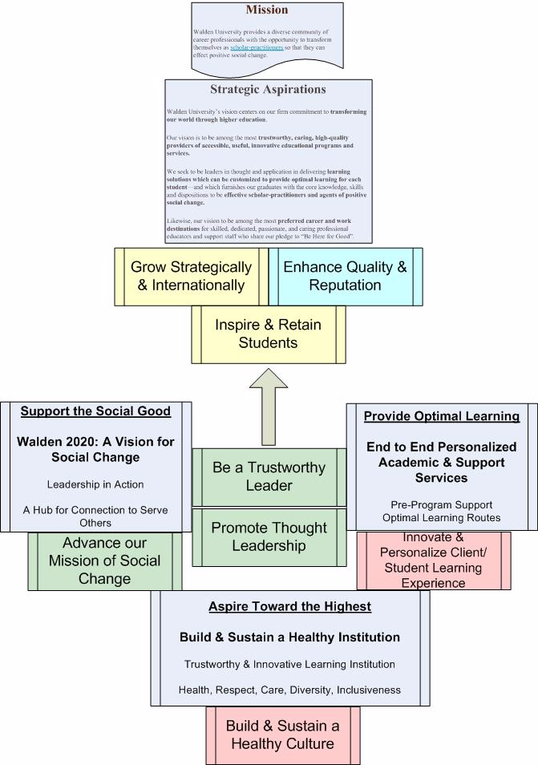

I. SUBMISSION
I hereby certify that the information contained in this form and any attachments to the form is true and correct to the best of my knowledge.

Signature of Authorized School Official:
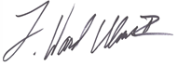
Print or Type Name and Title:  Dr. Ward Ulmer, Interim President |  | Date:  August 29, 2018

