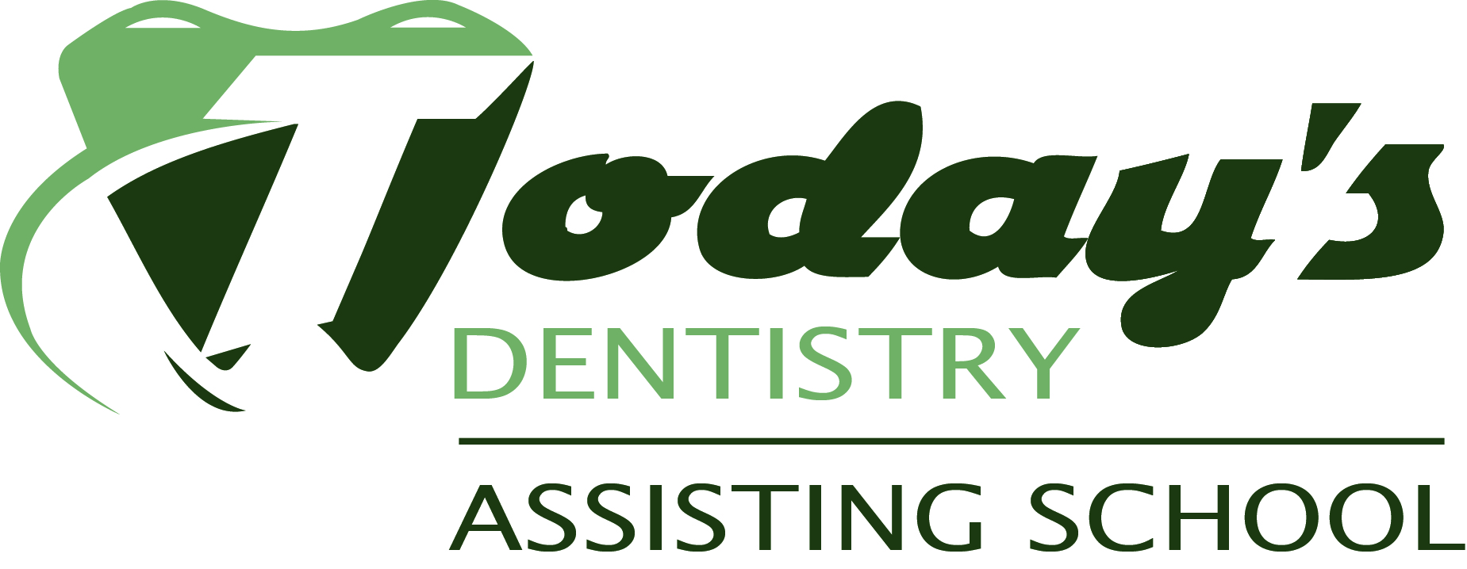***ENROLLMENT AGREEMENT***

DENTAL ASSISTING SCHOOL(88 Hours)

Welcome to Today’s Dentistry Assisting School where it is our goal to provide our students with

convenient and affordable Dental Assisting training. Please complete this agreement to enroll in classes.

1. ***DEMOGRAPHIC INFORMATION***

Name: _______________________________________________________ Nickname________________________

Address: ______________________________________________________________________

City: ____________________________________ State: _______ Zip Code: ____________

Phone Number: __________________________ Email: ________________________________________________

Date of Birth:_____________________________ Last four of SSN: _________________

High School attended ___________________________________________________________________________

Submit transcripts and/or copy of diploma in person or by Fax # 262-375-1818 or by email at

todaysdentistrynda@yahoo.com

1. ***FINANCIAL AGREEMENT***

***Terms of Payment***

I understand that I am responsible for the tuition and fees associated with this course.

TUITION $3450

Tuition includes: Text Rental, CPR/AED for the Healthcare Provider training, the Class Syllabus

and Spiral, a uniform, clinic materials, whitening kit and all Lab Fees.

***Traditional Payment Plans***

* Tuition in FULL (enclosed) $3450
* Down payment of $862.50 (enclosed), then $862.50 per week for 3 weeks
* Down payment of $450 (enclosed), then $1000 per week for 3 weeks
* Care Credit Option financed up to 60 months



***Payment Method:***

Check (Make check payable to Today’s Dentistry– There will be a $25 charge for returned checks)

Visa, MasterCard or Discover Card

Card Number: _____________________________________________ Exp: ________________________

Cardholder Name:__________________________________________ Security Code_____________

Billing information (if different from above): ____________________________________________

I agree to the payment schedule for my Dental Assisting course with TODAY’S DENTISTRY ASSISTING

SCHOOL. I have read and understand the refund policy as outlined in the course catalog.

Signature of Student: ___________________________________________________________________

Signature of Enrollment Agent: ________________________________________________________

1. ***EMPLOYMENT GUARANTEE DISCLAIMER***

TODAYS DENTISTRY ASSISTING SCHOOL does not guarantee that all graduates will be placed in

their field of study upon graduation.

Signature of Student: ___________________________________________________________________

1. ***CANCELLATION & REFUND POLICY***

Should a student’s enrollment be terminated or cancelled for any reason, all refunds will be made

according to the following refund schedule:

Cancellation can be made in person, by electronic mail, by Certified Mail or by termination.

All monies will be refunded if the school does not accept the applicant or if the student cancels within

three (3) business days after signing the enrollment agreement and making initial payment.

Cancellation after the third (3rd) Business Day, but before the first class, results in a refund of all monies

paid, with the exception of the registration fee (not to exceed $100.00).

Cancellation after attendance has begun, but prior to 60% completion of the program, will result in a Pro

Rata refund computed on the number of hours completed to the total program hours.

Cancellation after completing 60% of the program will result in no refund.



***ENROLLMENT AGREEMENT***

DENTAL ASSISTING SCHOOL(88 Hours)

Termination Date: In calculating the refund due to a student, the last date of actual attendance by the

student is used in the calculation unless earlier written notice is received.

Refunds will be made within 30 days of termination of students’ enrollment or receipt of Cancellation

Notice from student.

***Please sign below that you have read the above cancellation and refund policy. By signing below***

***you also understand that you are entitled to a copy of this document along with the current course***

***catalog.***

Student Signature: ___________________________________________________ Date: _________________________

Thank you! Please allow 5-7 business to receive confirmation materials by mail.

You should receive email confirmation shortly!

For office use only:

|  |  |
| --- | --- |
| Date of session | Date of acceptance |
| Acceptance letter sent | Administrative initials |
| Referral source | Tuition paid in full |

Scrub Size: Top: _______________ Bottom: _____________

Today’s Dentistry Assisting School/ W68 N101 Evergreen Blvd/ Cedarburg, WI

262-375-1800/ 262-674-0260