

**The Twisted Warrior Yoga Studio**

School Catalog

200-Hour

Teacher Training Program

September 2019- June 2020



*Publication Date May 2018*

*Welcome,*

*On behalf of The Twisted Warrior, it is my privilege to welcome you to our 200-Hour Yoga Teacher Training Program. I am honored to assist you in fulfilling your personal and professional goals of developing your yoga path. This program is open to anyone wishing to teach a dynamic, and safe yoga practice or to those who want to enhance their own personal practice.*

*I hope you are undertaking this adventure because you are passionate about yoga and want to learn and share your yoga passion with everyone around you. After all, we can never have to many yogis in the world. I hope you are excited and open to experiencing yoga as a way of living life to its fullest, and sharing and contributing to your community.*

*Successful completion of this program will result in a 200-Hour Certification from The Twisted Warrior. You will then also have the credentials and opportunity to register with Yoga Alliance for the status of RYT (Registered Yoga Teacher).*

*I look forward to working with you and getting to know you better.*

*Lucy*

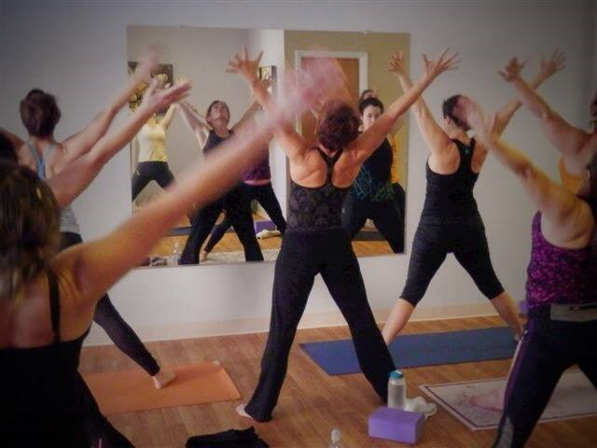

**School Information**

The Twisted Warrior Teacher Training Program will be held at the Twisted Warrior Yoga Studio located in downtown Fond du Lac. We offer over fifteen classes each week, a 600 + square foot studio, and a warm and inviting atmosphere. The studio is equipped with mats, bolsters, blocks, blankets, and straps. There is plenty of free parking on Main Street.

As an enrolled student in the training, you receive free classes from the first day of YTT to the last day of YTT.

The Twisted Warrior

61 North Main Street

Fond du Lac WI, 54935

Website-Thetwistedwarrior.com

Phone-920-251-6833

[Email-Healthy_1@charter.net](mailto:Email-Healthy_1@charter.net)

**Program Mission**

The Twisted Warrior Teacher Training Program is committed to helping you deepen your practice on and off the mat. Our teacher training program will teach you the philosophy, history and practice of yoga, and will provide you with the tools to teach, lead, and inspire.

We strive to provide exceptional education to our students and to maintain an environment conducive to safe and effective learning. During the course of this training, we offer all students confidentiality and the support you need to experience personal growth and development.

**History**

The Twisted Warrior Teacher Training Program was developed in 2016 by Lucy Mathers, E-RYT. The first training was held in January 2017. The Training Program will be hosted at the Twisted Warrior Yoga Studio in Fond du Lac WI.

**Approval & Regulation for The Twisted Warrior**

The Twisted Warrior is a 200-hour Yoga Teacher Training Program regulated by the Wisconsin Educational Approval Board and registered as a 200-hour Yoga school with Yoga Alliance. As such, we are governed by the rules, regulations, and standards set forth by these two organizations. Our Teacher Training program meets the minimum requirements described by Yoga Alliance to become a Registered Yoga Teacher (RYT) at the 200-Hour level. Yoga Alliance requires 180 Contact Hours(classroom) and 20 non-contact hours. Our program is comprised of 198 Contact hours and 30 non-contact hours. Contact hours are earned through regular attendance and non-contact hours are accumulated through completing all required reading, homework assignments and community service.

**Program Details**

This teacher training program is designed to give you the tools to teach all-levels of Vinyasa /power yoga classes. During your training, you will be teaching something every day, starting with your first day. Sometimes in small groups, sometimes in front of a full class, you will learn to feel confident and able to guide a safe yoga practice. You will study anatomy, yoga philosophy and history, meditation, yoga nidra, pranayama, restorative yoga, SUP Yoga and learn how to design a yoga class to achieve the greatest impact. This program is very comprehensive and intense, and it can seem overwhelming at times, but it all comes together in the end.

There is no right or perfect way to teach yoga, and we want you to try new ways and experience different styles of yoga just to help you find your true fit. This is very important to your learning and your personal growth and it will expand your teaching skills. It’s important that you are sincere and authentic in your teaching style, and we will help you develop your unique style

Our program delivers

* Personal growth and development as a teacher and leader through discussions, journaling, and exercises.
* Understanding of the philosophy of yoga; integrating it in your life and bringing it to your students.
* Understanding the origins of yoga and modern-day ethics in the application of teaching yoga.
* Techniques for hands-on assisting and modifications for physical and emotional needs.
* Exploration of anatomy and physiology and how it applies to each asana.
* Development of sequencing of postures for 60-90 minute classes.
* Methodology and techniques of teaching yoga to all skill levels to enhance practice and avoid injuries.
* Practice teaching classes with direct feedback.
* Enhanced confidence in personal presentation, as well as gains to listening and communication skills.
* Introduction to the business of yoga, including establishing yourself as a credible teacher.

What we expect from you

* Honest, open, clear communication.
* Timeliness. Please try to arrive on time and we will get you out on time. Respect each other’s time and don’t make others wait on you.
* 100% attendance.
* Feedback.
* And a willingness to be open to new and different ways of thinking and doing.

**Curriculum Hours**

* Techniques, Training and Practice-include asanas, pranayamas, kriyas, mantras, bandhas, mudras and meditations. Hours in this category include both training in the techniques and practice of them. These hours will be a mix of guided practice of the techniques as well as analytical training in how to teach, assist, modify, demonstrate and practice the techniques. 100 hours.
* Teaching Methodology-includes principles of demonstration, observation, assisting/adjusting, instruction, teaching styles, the basics of sequencing, qualities of a teacher and the students process of learning. 46 hours.
* Anatomy and Physiology-includes the study of the physical anatomy and physiology, including bodily systems and the application of its principals to yoga practice (benefits, contraindications, healthy movement patterns, common injuries and risks.) 26 hours.
* Philosophy/Ethics/Lifestyle-will expose students to the history of yoga, yoga philosophy based on the Yoga Sutras, and the eight limbs of yoga. Students will demonstrate an understanding of ethics and yoga principles for yoga teachers. Students are encouraged to practice yoga off the mat and to explore their personal connection to the reading and teachings. 44 hours.
* Practicum-includes practice teaching, assisting, receiving feedback, observing other teachers and giving feedback. 16 hours
* Homework and Exams-there is required reading/videos each week followed by exams in an effort to measure your progress. Journaling is highly suggested through this experience to enable you to realize and determine your own personal growth.
* One-on-One-is a farewell meeting at the end of your program with the Program Director to discuss your progress, your yoga teacher training journey, and your yoga future. 30 minutes.

**Admissions and Entrance Requirements**

* Applicants must be at least 18 Years of age and have at least one year of consistent yoga practice. However, exceptions will be considered for individuals meeting other requirements. Students will not be discriminated against based on race, ethnicity, gender, age, sexual orientation, religion, or physical ability.
* Must complete application for admission, and a 1-page essay on why you want to teach yoga. Application to the program does not guarantee acceptance. Most program correspondence will occur electronically, so applicants should be computer literate and have access to e-mail.
* How to Apply: please submit the online application and $100 application fee due with application. **Deadline**: Please try to submit your application at least two weeks prior to the start date of the program as spaces are limited, and fill as applications are approved.
* Once your application is received, an interview with Lucy will be scheduled. We are looking for teachers with a passion for yoga and a willingness to share that passion. This interview is a perfect opportunity to discuss any questions about the program that you may have.
* Applicants will be notified of acceptance by e-mail and receive the details/assignments for the first class.
* Upon acceptance, applicants must sign an Agreement and Liability Release form.

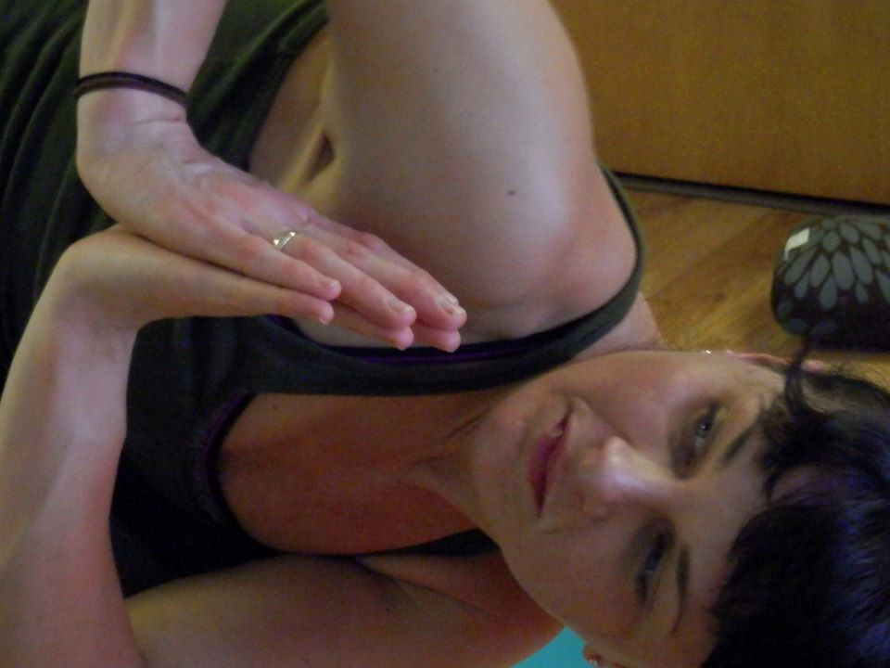

***“The best way to find yourself is to lose yourself in the service of other.”-Mahatma Ghandi***

**Advanced Standing**

The Twisted Warrior Teacher Training Program does not offer advanced standing for any previous trainings or coursework.

**2019-20 Calendar Program Schedule**

Each Month, training sessions will meet one Saturday and Sunday 8am-5pm. Exception: January there are 2 weekends. We have a lot to cover during our time together. Lunch will be 30 minutes, please bring a bag lunch and plan to stay at the studio.

Students may receive the training manual once the required paperwork and payments are made, but no later than their first day of training. The manual will include a syllabus with detailed information regarding the dates, topics, readings, homework assignments. There will also be a guide to the sequence you will be using and teaching throughout the training program.

September 7/8

October 5/6

November 2/3

December 7/8

January 4/5

February 1/2

March 7/8

April 4/5

May 2/3

June 6/7

**Student Conduct Codes**

Ethics are of the utmost importance and are the very core of a yogic lifestyle. This topic is discussed many times throughout the program and is taken very seriously at The Twisted Warrior. Students are expected to follow the school rules and policies outlined in this catalog.

Students are expected to behave as mature adults. Any student that is disruptive may be terminated from the program at the School’s discretion. Disruptive behaviors include tardiness, harassing other students, defamatory statements orally or written, in person or on social media, breach of confidentiality, possession of or under the influence of drugs or alcohol during training sessions, destruction of school property, abusive language, or behavior creating an unsafe environment. The school will issue one written warning, continued disruptive behavior will result in termination from the program.

**Dismissal, and Re-admittance**

Students who are not respecting the Student Conduct codes will receive a written warning. A second conduct violation will result in termination from the program. There is no appeal process, and students will be refunded a pro-rated amount based on the refund policy.

**Attendance, Tardiness, and Attendance Probation**

**One Hundred percent attendance is desired and your class hours will be logged. In order to graduate, you must complete at least 200 hours. It is your responsibility to schedule accordingly. Any missed hours must be made up prior to graduation.** If you need to miss hours, you may still graduate from the program, but please call Lucy at least one week before the absence, so we can make arrangements to make up the requires assignments.

**Tardiness**. All classes will start on time and students are expected to be present and ready to participate. Tardiness means showing up late for the scheduled start time. Students will be considered tardy for class if he/she arrives within ten (10) minutes after the scheduled start of class, and this will be counted as one (1) hour absence. If a student misses more than ten (10) minutes he/she will be marked absent for an hour and for the time absent rounded to the next fifteen (15) minute increment.

**Attendance Probation.** Students are required to maintain a minimum of 90% attendance over the length of the program. Students who fall below 90% attendance will be placed on attendance probation until they reach 90% attendance. If they cannot achieve the 90% attendance by the end of his/her training program completion date, the student must make arrangements with the school to complete the required hours. If the instructor must spend extra time with students to make-up the required hours, the student will be charged $80 per hour due at the time of make-up session.

**Leaves of Absence**

Leaves of Absences are not provided with this program. If a student needs to discontinue the program, the refund policy will apply to the unused tuition and the student will have to begin the program again at another time if they desire.

**Student Progress**

Whether the student passes or fails is based on completion and participation in the following areas:

* Attendance for all required class work totaling a minimum of 180 hours contact hours.
* Completion of all written homework assignments, including three 1-2 paragraph book reports, anatomy videos and corresponding tests with a passing score of 70%
* Attendance of 3 required classes outside of the Twisted Warrior and a written report of each.
* Performance evaluation based on practicum teaching and assisting (teach a safe class, demonstrate teaching techniques, use of clear and concise language, create and deliver a class that flows smoothly).
* A written exam that covers Teaching Methodology, Anatomy and Physiology, and Yoga Philosophy and Ethics. A score of 70% or above is needed to pass the exam. The written exam will be handed out the last week of class, and be due within two weeks following the last class. Corrected exams will be returned the following week. Exams may be retaken once.
* A practical exam will be the last week of class, and be graded pass/fail. If a student fails the practical exam, they may re-take it within the following week, but only after meeting with Lucy to discuss the issues resulting in the failing grade.

Within two weeks of completion of requirement, students will be notified of their certification status.

Students are encouraged to maintain a Journal of their personal practice throughout their yoga journey. Some class time will be allowed for journaling.

Students are asked to attend a minimum of two yoga classes per week. If not at The Twisted Warrior, a signature from the teacher will be requested. Students enrolled in this program are welcome to attend any classes at The Twisted Warrior for Free.

Students are required to volunteer teach 10 hours. This may be done at the Twisted Warrior, at a workplace, gym, yoga studio, school or community programs. A letter from the facility documenting the volunteer time is required.

**Satisfactory Academic Progress/Academic Probation**

Grades are based on required assignments and quizzes that are given throughout the program as a way to determine the student’s progress. Satisfactory progress is defined as a passing grade is 70%. If students do not complete the coursework, or fail a quiz, they will be placed on academic probation. The probationary period is defined as the time set between module dates. This Probationary period allows the student to complete required assignments and retake the quiz, bringing them to good academic standing and ready to begin the next module.

If at any time throughout the program, a student seems to not be progressing, students will be immediately notified to schedule a meeting with the Lead Instructor to discuss ways to improve performance and complete requirements. If the student is unable to reach the established criteria, they will be allowed to present their extenuating circumstances and all efforts will be made to help the student improve their academic standing.

If the student is not progressing and their academic standing is unacceptable, students will be advised and failure to improve will result in dismissal from the program. Unused tuition will be refunded per the refund policy. A student may appeal academic dismissal by meeting with Lucy to discuss their failure to achieve a satisfactory academic standing. If they can satisfactorily complete required materials and have the required hours to bring them to acceptable standing, the student may be re-admitted to the program.

**Student Records**

We will maintain a copy of your application, attendance record, book reports, and Certificate of Completion for seven years, and official transcripts will be kept indefinitely. Electronic and paper records will be keep at The Twisted Warrior. To obtain copies of graduation certificates, requests must be made in writing and bear the signature of the student. This information will be made available only to the student. There is a $15 charge for replacement Certificates.

**Student Complaints**

Students having concerns, complaints, or suggestions are asked to bring them to the attention of the Program Director. The Twisted Warrior wants your experience to be pleasurable and safe, so please let us know if there is something amiss. If the complaint cannot be resolved the student may contact the Wisconsin Education Approval Board, http://eab.state.wi.us

Address:

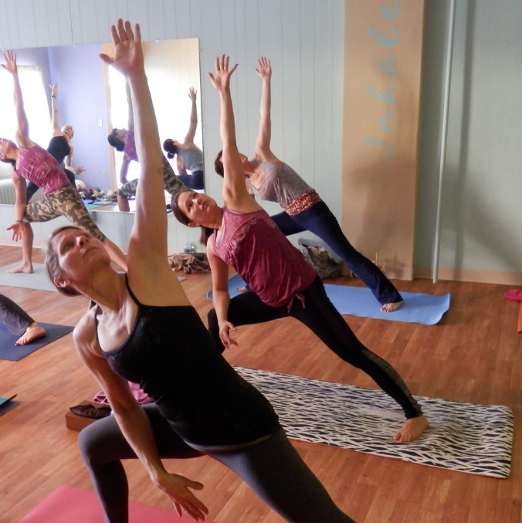

Wisconsin Education Approval Board

431 Charmany Drive, Suite 102

Madison WI 53719

Phone:

(608)266-1996

Email:

[eabmail@eab.wisconsin.gov](mailto:eabmail@eab.wisconsin.gov)

**Tuition and Fees**

Tuition for the entire program is $2300 if registered before July 31, 2019. After July 31, tuition for the entire course is $2500. You are also responsible to purchase the required textbooks which will total approximately $150. Once you are accepted into the program, and your agreement is signed and the tuition is paid, you will receive your Training manual, which is included with the training program.

We offer Payment options:

Option 1: Register before July 31, -Pay full amount ($2300). The $100 application will be applied to the tuition fee.

Option 2: Register after July 31 -Pay full amount. ($2500). The

$100 application will be applied to the tuition fee. The remaining fee is due before the first day of training.

Option 3: Two Payments. ($2600) The $100 application will be applied to the tuition fee. Make two payments, $1000 due upon acceptance and $1500 remaining fee is due before the first day of training. There is a $100 fee with this option.

Financial Aid is not Available through The Twisted Warrior for Teacher Training.

***“I have been a seeker and I still am, but I stopped asking the books and the stars. I started listening to the teaching of my Soul”. – Rumi***

**Refund & Cancellation Policy**

Full tuition and application payments made towards training may be refunded if:

1. The cancellation occurs 3 days or more prior to training. EAB 6.03
2. The student accepted was unqualified and the school failed to secure a disclaimer. EAB 9.04
3. Enrollment was accepted based on any false advertising or misrepresentation of written or oral representations of the school.

Students will receive refunds within 10 days of cancellation from the program.

A student who withdraws or is dismissed after attending at least one class, but before completing 60% of the course is entitled to a pro-rated refund as follows:

|  |  |  |
| --- | --- | --- |
| **After completion of at least** | **But prior to the completion of** | **The refund will be** |
|  | **The first day of class** | **100%** |
| **1 unit/class** | **10% of the program** | **90%** |
| **10%** | **20% of the program** | **80%** |
| **20%** | **30% of the program** | **70%** |
| **30%** | **40% of the program** | **60%** |
| **40%** | **50% of the program** | **50%** |
| **50%** | **60% of the program** | **40%** |
| **60%** |  | **No Refund** |

Once training is in session, refunds will be pro-rated based on the amount of time in training (see above) and students will receive their pro-rated refunds within 40 days of withdrawal or dismissal. Once 60% of entire 200-hour training is complete, no refunds will be granted including student withdrawal or dismissal. If a student must withdrawal after the 60% completion due to mitigating circumstances beyond the students control, the school may refund a pro-rated amount.

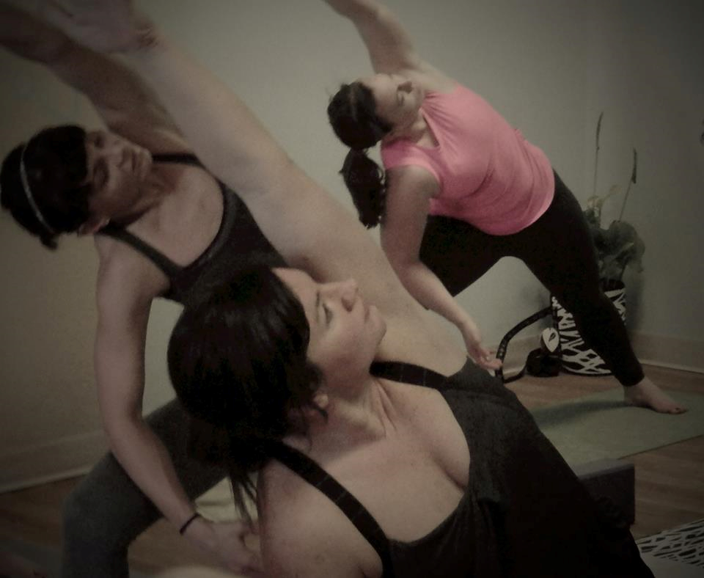

Students who miss one (1) weekend module **with no notice** will be considered to have withdrawn and will be dismissed from the program and the school will refund a pro-rated amount based on the hours accrued based on the last day of their participation.

*A written notice of withdrawal is not required.*

**Employment Services**

The Twisted Warrior Teacher Training Program does not offer employment services, nor do we guarantee employment. We will not pursue direct contact with employers to offer student referrals. We do offer suggestions for those pursuing a yoga career and spend class time devoted to the business aspects of operating a yoga studio.

**Catalog Changes**

The Twisted Warrior Teacher Training Program reserves the right to make changes or revisions to this catalog. We will make every effort to ensure accuracy of information presented in this catalog. However, class topics for specific dates may be changed to accommodate teacher scheduling.

**Faculty**

***Lucy Mathers, Director of Teacher Training***

Lucy Mathers holds an E-RYT 200-hour certification with Yoga Alliance and has been teaching yoga since 2011 accumulating over 2500 teaching hours. Lucy leads classes that are fun, inspiring, and challenging. She opened the Twisted Warrior in 2011 to provide a yoga studio for the local community, where everyone is accepted and encouraged to do their very best.

***Cathy Hendricks, RYT-200,*** Pre-Natal, Restorative, Assist or Resist

Cathy Hendrickson holds a RYT 200-hour certification with Yoga Alliance and is also certified to teach Pre-Natal Yoga, and Restorative Workshops, and Assisting Workshops. Cathy has been teaching in the Appleton area since 2011.

**Ownership and Governance**

*Lucy Mathers, owner of The Twisted Warrior, LLC is the Program Director and Lead Trainer.*

**The Twisted Warrior Yoga Teacher Training Application**

Applicant Name: __________________________________________________

Address: _________________________________________________________

City/State: __________________________________ Zip code: _____________

E-mail: __________________________________________________________

Cell phone: _______________________________________________________

Day phone: _______________________________________________________

Evening phone: ___________________________________________________

Best way to contact you: ____________________________________________

Date of birth: _____________________________________________________

Gender: _________________________________________________________

Emergency contact Name: ___________________________________________

Relationship to you: ________________________________________________

Address: _________________________________________________________

City/State: __________________________________ Zip code: _____________

E-mail: __________________________________________________________

Cell phone: _______________________________________________________

Day phone: _______________________________________________________

Evening phone: ___________________________________________________

Best way to contact them: ___________________________________________

**About You**

How long have you been practicing yoga?

How long have you had a consistent practice (practicing yoga 4–7 times per week)?

Within the past year how many times, on average, do you practice per week?

What style(s) of yoga do you primarily practice?

**Education**

Have you received a high school diploma or equivalent?

Yes / No

Advanced/College degree? (please describe): ___________________________

________________________________________________________________

Please list any other body-centered training you have completed (e.g., other yoga trainings, massage therapy, dance, Pilates):

________________________________________________________________

________________________________________________________________

**Work**

Current occupation: ___________________________________Number of years: _________

Previous occupation: __________________________________Number of years: _________

Any other occupation information you wish to provide?

____________________________________________________________

________________________________________________________________

________________________________________________________________

**Health Information** (All information strictly confidential)

(Please indicate yes or no)

Are you under medical treatment for any physical condition?

Are you currently pregnant or trying to get pregnant?

Do you have any chronic pain, physical limitations, or disabilities?

Have you had a serious illness or major surgery within the last five years?

Do you have a communicable disease?

Are you under medical treatment for any psychiatric condition?

Have you ever been hospitalized for a psychiatric condition?

Are you in recovery from an addiction?

Have you ever been in a treatment program for alcohol or substance abuse?

Do you currently have or have you had any of the following conditions in your lifetime?

* Environmental or food allergies
* Respiratory conditions
* Heart conditions
* Diagnosed mental-health conditions
* Seizures or strokes
* Chemical sensitivities
* Diabetes
* High blood pressure

If you answered yes for any of the above questions, or if you have any other health condition that could impact your full participation in the program, please describe fully (if you need more space to answer this question, please attach additional sheets of paper):

________________________________________________________________

________________________________________________________________

________________________________________________________________

Please list any symptoms/conditions being treated:

________________________________________________________________

________________________________________________________________

________________________________________________________________

**Your Personal Application Letter:**

You must include a one-page personal letter with this Application. We would like to know who you are as a yogi and who you are as a person. Feel free to include any significant events or people who have shaped who you are today. Talk about your yoga practice, meditations, or trainings, and tell us what inspires you. What are your expectations of this Teacher Training Program? What do you hope to achieve by the end of this Program?

**The Twisted Warrior Yoga Teacher Training Application Acknowledgement**

I acknowledge that all information submitted in this application is true and accurate. I understand that incomplete or inaccurate information may result in my non-acceptance or dismissal from the program. I acknowledge that I have read the certification criteria, and, should I be accepted to attend the Twisted Warrior Yoga Studio’s Teacher Training Program, I understand I will be evaluated using these criteria.

Signature: ________________________________________________________

Date: ___________________________________________________________

Print name: ______________________________________________________