INSTITUTIONAL PLANNING

Wis. Stats. 38.50 (10) (a)

Form EAB 2.04 (New 2/09)

STATE OF WISCONSIN

EDUCATIONAL APPROVAL BOARD 30 W. MIFFLIN STREET, 9TH FLOOR

# MADISON, WI 53703 (608) 266-1996

The Educational Approval Board (EAB) is a postsecondary education agency that employs a regulatory model focused not only on compliance, but also institutional effectiveness. To facilitate an environment in which schools seek to be effective organizations that improve over time, the EAB requires schools to submit an institutional plan during the annual renewal process. Although similar to a strategic or business plan, the institutional plan schools must submit will enable the EAB and school officials to engage in a dialogue over time about the future of the school.

Schools that already have some type of strategic or business plan (e.g., schools that have either a corporate or accreditation plan) must adapt these documents to the following requirements and focus on Wisconsin operations and students. The EAB does not expect anv school to divulqe anv sensitive, proprietary business information in the institutional plan. Institutional plans must address the five elements identified below and provide the information requested.

# SCHOOL INFORMATION

Name of School:

Serenity Now School of Massage

11. INSTITUTIONAL PLAN ELEMENTS

1. MISSION. Describe your school's mission and vision, which identifies its purpose and its core values.

Serenity Now School of Massage is dedicated to providing a Massage Therapy program based on up-to-date material, knowledge, training, and best practices used in the field. Its all-inclusive approach to the art and science of massage, balances professional skill with personal development in a caring environment.

1. MARKET. Discuss the nature of your school and the business in which it is engaged. Describe who your existing and/or potential customers are and what motivates them to enroll in your school. Explain how you let these customers know you are in business. Finally, identify who your competitors are and how you are different from them.

Serenity Now is engaged in the education of massage therapy. Our current and potential students are motivated to enroll in our program due to our project-based learning environment as well as our convenient work and family friendly classroom schedule. We advertise on social medial, such as FaceBook, radio advertising, and building location signage. Our competitors are no longer Globe University due to their enrollment freeze. We are unable to confirm if Health Touch School of Massage is continuing business or not. They do not have an internet presence. We continue to be unsure what, if anything, is happening with that school. We are different from Health Touch because we have doctors teaching our sciences and we focus our student clinicals on having our students work on many different body types within the community and not just on fellow students and chair massage events.

INSTITUTIONAL PLANNING

1. MANAGEMENT. Describe your management team and how it functions to lead, administer and position the school. If your school has advisory boards, describe how the school uses them for program and school improvement.

Our management team consists of owners and instructors who discuss program development and student progress three times per year prior to each rolling enrollment session.

1. SWOT ANALYSIS. Identify your school's strengths, weaknesses, opportunities and threats (SWOT). Based on the results of this SWOT analysis, provide the following:

 3 to 5 goals for strengths/weaknesses and how they will be addressed by your school.  3 to 5 goals for opportunities/threats and how they will be addressed by your school.

The goals should have specific objectives, defined results, a timeline for completion and metrics (some type of evaluation or measurement) by which the institution can evaluate/measure their success. In developing its goals, the school may wish to refer to the Elements of Effective Institutions graphic that is included on the back page of this form.

Our previous Goal for strengthening curriculum by comparing Mark Beck - theory textbook was completed. We didn’t decide to go with Mark Beck. After the mBlex change, we have decided to make the textbook change to Salvo’s Massage Therapy Principles and Practice along with Salvo’s/Mosby’s Pathology. This is a big undertaking and our current goal will be to learn these textbooks and develop presentations and quizzes.

Our previous goal for strengthening curriculum was to look into textbooks which dive deeper into firing order of muscles. We have found those textbooks, which we teach from, and they are the set of Physiology of the Joints. Our current goal will be to use these textbooks to help teach kinesiology as well as our kinesiotaping class.

Our previous goal for developing our weakness with regard to quality of student body continues: We are developing a much more stringent interview process, such as length of interview session, and who is involved in the interview session, which has been implemented and will continue to be evaluated on an on-going basis.

INSTITUTIONAL PLANNING

1. SWOT ANALYSIS (continued)

N/A

1. FUTURE THINK. Describe your school 5 years from now. What will it look like and how it will be positioned in the market place.

Long-term goals for our school include a much more extensive continuing education program for Wausau area massage therapists to attend hands-on education as well as ethics programs.

This continues to remain a goal and we have implemented continuing education classes for this coming fall.



I hereby certify that the information contained on this form and any attachments to the form is true and correct to the best of my knowledge.

|  |  |  |
| --- | --- | --- |
| Sig | re of Authorized School |  |
| Print or Type Name and Title:  Dennise Pagel | | Date: 7/18/16 |

INSTITUTIONAL PLANNING

Electronically signed: Dennise Pagel 7/31/18

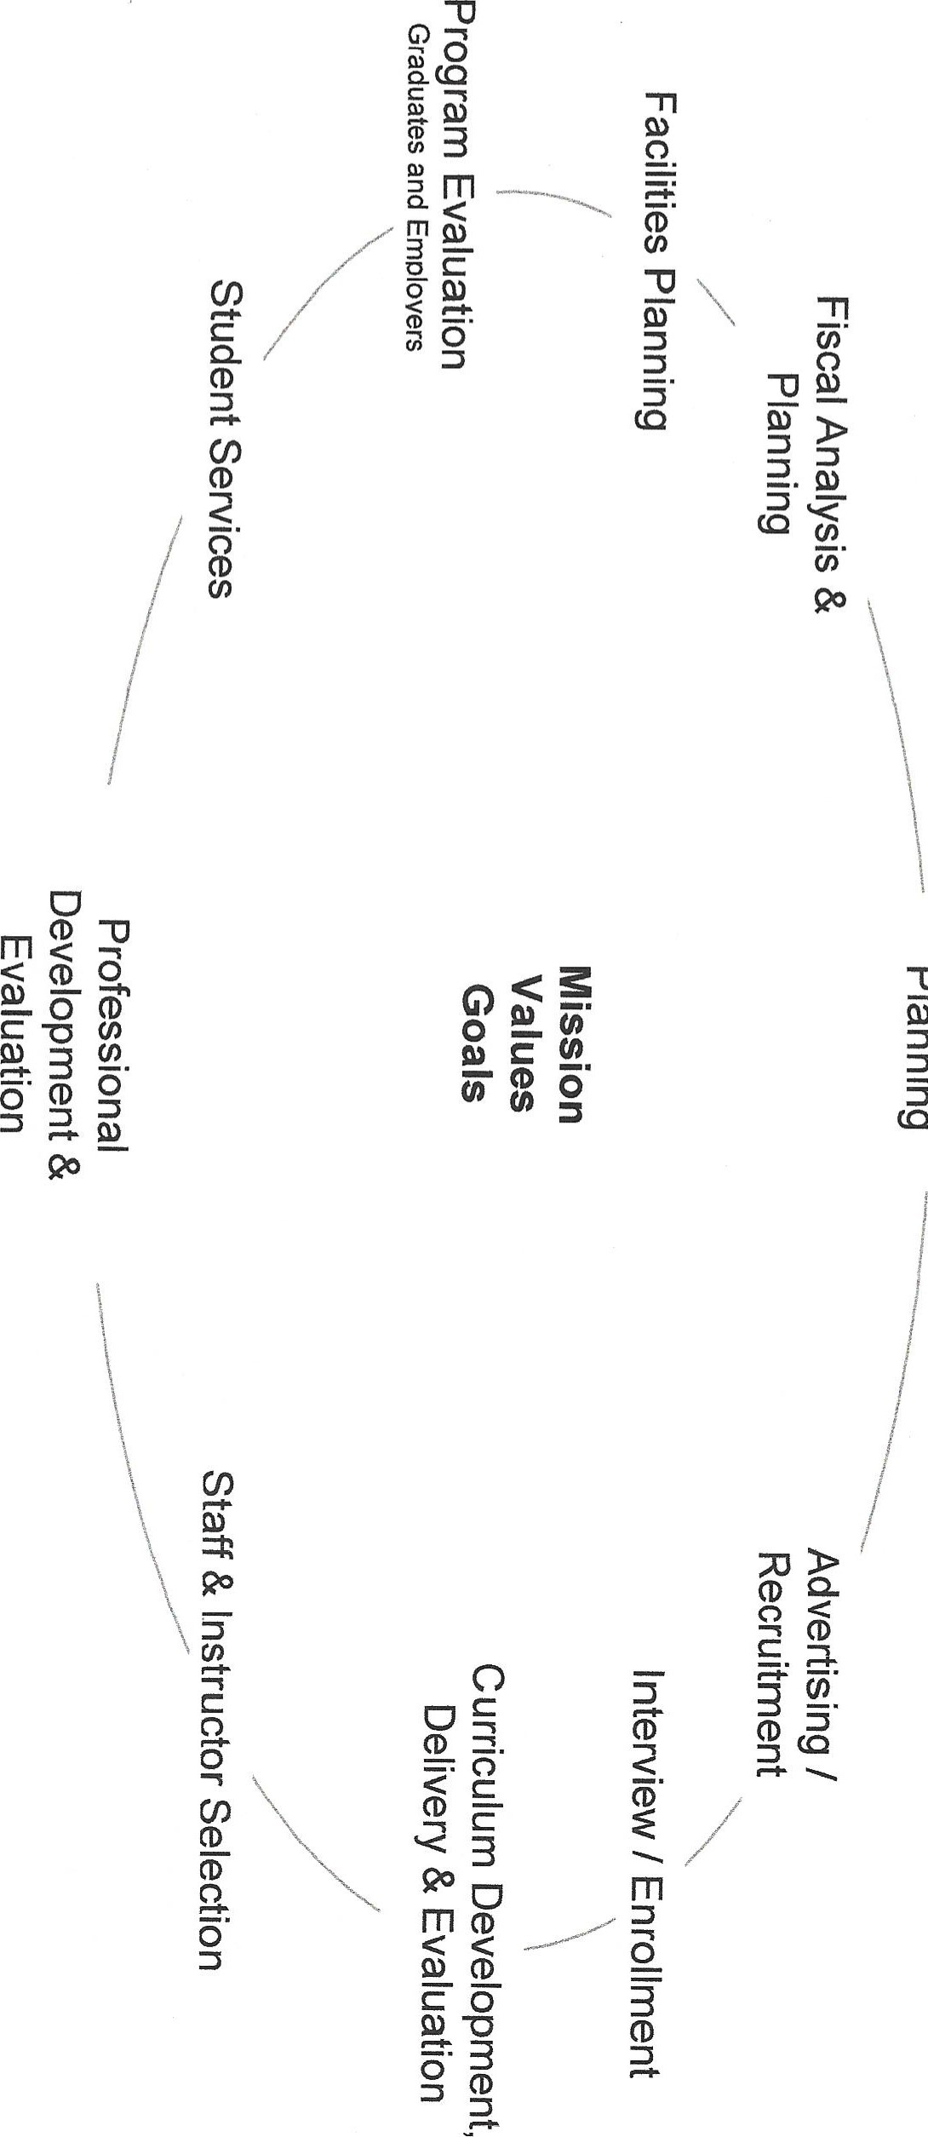그 C