**200HR YOGA TEACHER TRAINING**

Gain confidence, skills and experience to teach challenging, dynamic and FUN yoga classes for participants of all levels and ages!

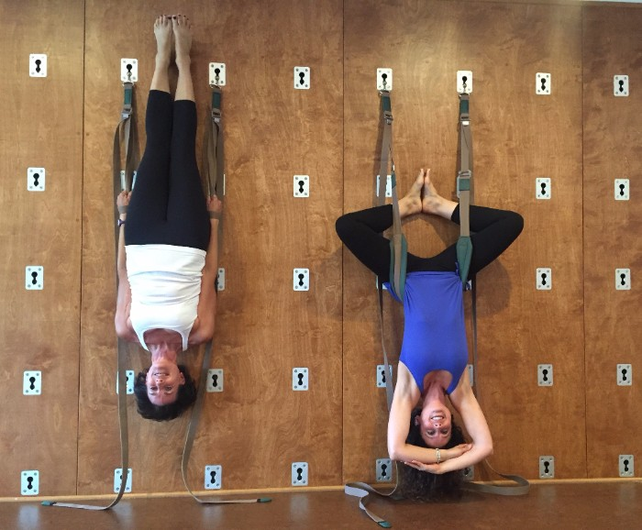

Graduates will be registered with Yoga Alliance as

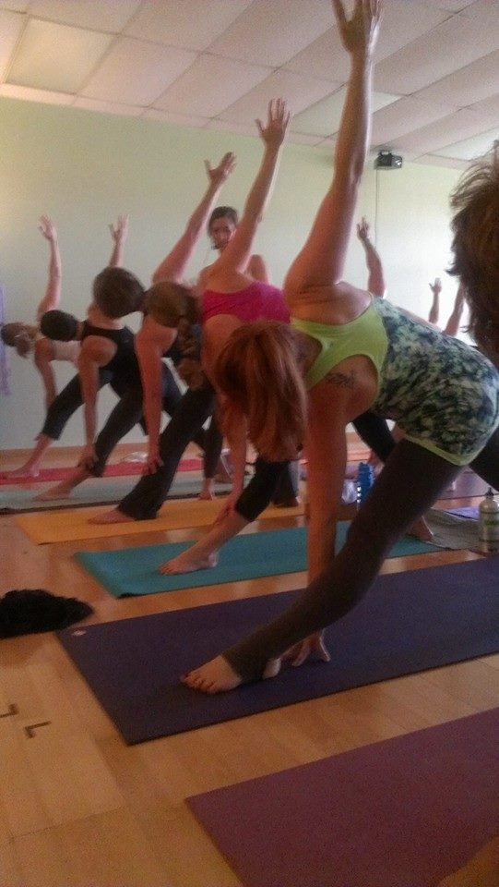200HR Certified Vinyasa Yoga Teachers.

**The Fall/Winter dates:**

Sept 7-9  
Sept 14-16  
Sept 28-30  
Oct 12-14  
Oct 26-28  
Nov 9-11  
Nov 30 - Dec 2

***For more information,***

***please contact:***

***puravidacrystal@hotmail.com***