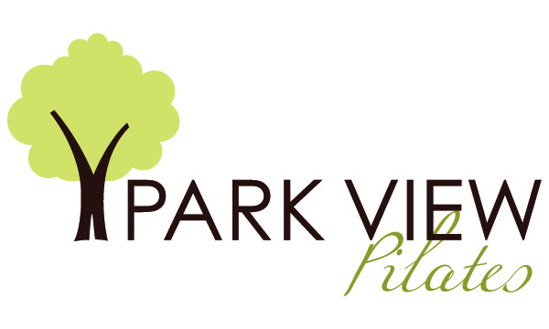

**Institutional Planning Update- September 2019**

**Mission**

The goal of elevating Park View Pilates (PVP), LLC to the status of a premier Pilates studio and educational center is currently moving forward as planned. Its mission is to increase the educational level and hence the quality of teaching, of teachers who are out in the community teaching Pilates. This is happening as the students in this program are all teaching even before they graduate. Park View Pilates is known as the educational center in the Milwaukee area. In addition, teachers from outside the state are also contacting PVP for mentoring and the most current information regarding movement and Pilates. This is measured by the Pilates teachers who have contacted PVP to attend workshops, as well as, PVP’s reputation as the studio where teachers take lessons.

The enrollment of students continues to increase over the past year. The reputation of this program is allowing potential employers to look to the school for their teachers. Park View Pilates will continue to reach out to the large fitness clubs in the area that are teaching their potential trainers to teach Pilates and see if a partnership can be established to provide a higher level of education.

The Pilates Center’s (TPC) Teacher Training Program continues to be offered and the program continues to grow. This is measured by the contacts made to PVP regarding information on the training program and the enrollment of students.

PVP will continue to grow as a premier studio in the Midwest attracting students from outside the state. During the last year, PVP has partnered with other Pilates studios in the area to recruit students.

**Professional Development and Evaluation**

To further enhance the studio, an increase in Master’s level workshops will be offered. Franklin Method workshops will also be presented. These workshops will be PMA approved and will be offered at outside studios as well. During presentations in outside studios, the training program will be marketed.

During the 2017-2018 year, there were Master’s level workshops were continued to be offered outside the studio, as well as in the studio. These workshops attracted potential students, as well as exposing current students to a higher level of training. The Franklin Method has been used to teach the students experiential anatomy and this has further enhanced the student’s ability to teach healthy movement within the Pilates Method. Debby Orlando, the director of the teacher training program has earned her Licensed Franklin Method Faculty title, which puts her in an elite field as there are only three with this title in the United States. Her knowledge will further advance the level of training within the Pilates teacher training program.

The online program, iTPC, through The Pilates Center enables the students to be more efficient as the information is on-line with a process to keep them on track. This eliminates the need for binders, as well as, gives student’s access to the Lectures on-line. Live lectures and classroom time are still provided at PVP.

Several of the trainees have started their own business at Park View Pilates, as well as working at other studios in the area.

In the next five years, the studio will be a place TPC trained teachers can see clients and build their own business. This will be done under the tutelage of Debby Orlando. PVP will continue to be committed to teaching the classical Pilates method and enhance the level of teaching throughout the Pilates community.

**Staff and Instructor Selection**

Graduates of The Pilates Center teacher training program will be recruited to participate in the internship of the students currently in the teacher training program at PVP. Former graduates are encouraged to give lessons to current students.

**Advertising and Recruitment**

Marketing through the PVP website, Pilates Method Alliance (PMA) website¸ as well as TPC website will be utilized. The PMA now has more strict guidelines as to what schools are considered PMA approved and this is enhance the quality of the schools. The Pilates Center is one of the first schools to be approved, and Park View Pilates will have the same approval as it is a licensed studio of The Pilates Center.