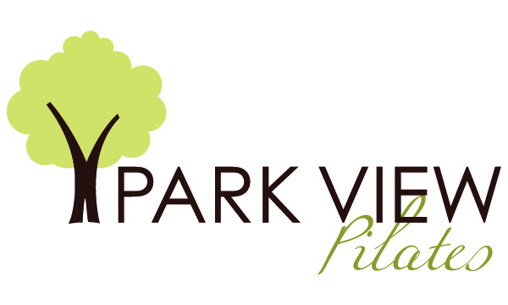

**Marketing 2019**

**Marketing efforts include website:** [**www.parkview-pilates.com**](http://www.parkview-pilates.com)

**Information for the school is found on The Pilates Center, Boulder, CO website at** [**www.thepilatescenter.com**](http://www.thepilatescenter.com)

**The Pilates Method Alliance (PMA) new school approval guidelines has approved The Pilates Center (TPC) as an approved school. As Park View Pilates is a licensed studio of TPC, it will also be listed on the PMA site.**

**Facebook page: Park View Pilates**

**Instagram account: debbyorlando**