***Alpina***

Truck Driving Academy

& Intermodal Training



**School Catalog – CDL Training Program**

**Volume 1, 2018 Class Schedule**

**CONTENTS**

I. General Information 3,4,5

II. Admissions and Entrance Requirements 5,6,7

III. Advanced Standing 7

IV. Student Progress 7,8,9

V. Student Records 9

VI. Academic Probation, Dismissal and Re-Admittance 10,11

VII. Student Conduct 11,12

VIII. Leave of Absence 12,13

IX. Attendance 13

X. Tardiness 14

XI. Student Complaints 14

XII Tuition and Fees 14,15

XIII. Cancellation and Refunds 15,16

XIV. Program Curriculum 17,18,19

XV. Employment Services 19

1. **General Information**

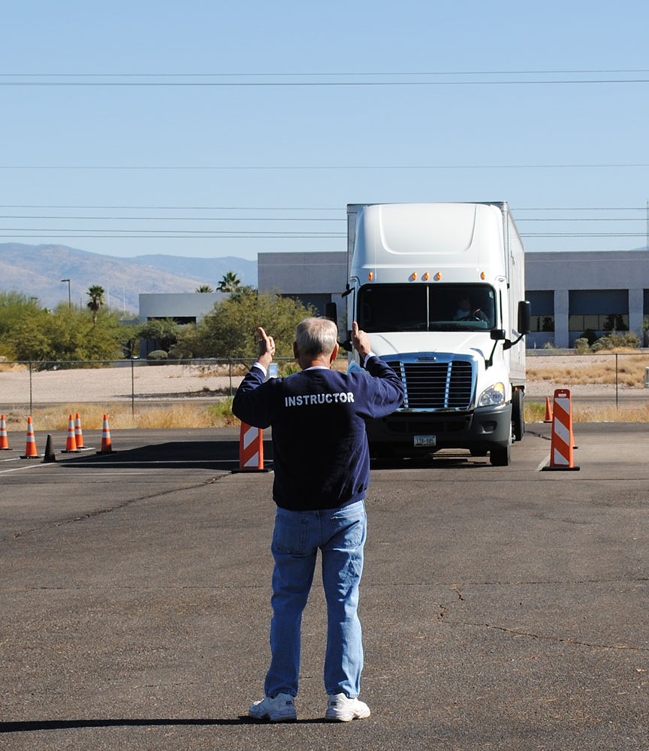

**Mission Statement:**

Alpina Truck Driving Academy & Intermodal Training (“Alpina TDA“) is dedicated to providing the best CDL training for our students with the hope that once they finish our course and obtain their CDL, the students will be turned over to a reputable trucking company for hire with the highest possible pay for their experience level and/or reach a higher job position in their current place of employment with better job security and pay.

Alpina TDA is a DBA under the legal entity Badger CDL, LLC.

The programs created by Alpina TDA are designed to train all our students into becoming safe and professional CDL holders, by implementing book knowledge, road rule law and CMV hands on training.

Students that attend our school that are former military or currently serving in the military will receive a discounted rate from all our CDL training programs. ***\*Please ask for details regarding discounts for military service members.***

**Facilities & Equipment:**

Our main classroom is located on 7760 S. 6th Street, Oak Creek Wisconsin, inside the premises of our primary start off lot. Our second classroom is located on 2020 W. Layton Ave. in Milwaukee Wisconsin inside the HH Tax Complex. There we have all our basic essentials, assigned computers/tablets, designated workstations, and study guides/DOT CDL manuals that we will use for reference. The CMV’s provided vary from single axel day cabs to tandem axel conventional sleeper semi-trucks with various trailer/container types. Our semi-trucks are basic 10 speed manual vehicles. Class B vehicles range from straight trucks to box trucks equipped with airbrakes and vary in transmission types from automatic to manual transmissions. Alpina TDA has two start-off lots. The primary lot is used for our pre-trip inspection training and backing exercises. The secondary lot is used for parking extra vehicles and the driving portion start off point. With both facilities in hand, we can maximize our training and our students learning experience.

**Chief Administrator:**

Sherif Hamdia is the chief school administrator for this facility. Mr. Hamdia is an authorized CDL instructor by the DOT and is a current CDL Examiner. He has 13 years of CDL Class A experience. As a CDL driver/trainer that has worked with schools, city, county municipalities, intermodal companies and CDL applicants, he knows exactly what it takes from A-Z to obtain a Wisconsin CDL. Mr. Hamdia has worked as a driver in the past and trained drivers for trucking and intermodal transport companies. He has also tutored dozens of Class D holders, in preparation to obtain their CLP. Mr. Hamdia has worked with and driven many different types of CMV vehicles and holds every endorsement on his current CDL. Mr. Hamdia also does safety administrative work for trucking companies, such as, DOT and MC number set ups, IFTA forms, Heavy Vehicle Tax work and provides company start up advice.

**Instructor:**

Carlos Miranda will be an assigned manager and one of the head instructors. Carlos M has many years of CDL experience. With past Class A and B driving experience, Carlos M has also trained many of past company drivers on how to be prepared to pass their CDL exam. With a high rate of success in passing exams, Carlos also has a reputation of being one of the most caring and driven trainers that our company has seen in the past. For these reason, Alpina has designated Carlos as a head instructor for our main facility in Oak Creek, Wisconsin.

**President and Sole Shareholder:**

Fek Besiri will be head secretary and she is currently the company owner, president and sole shareholder. Fek Besiri started this company over two years ago and has build up many cliental, company contacts and great experience in the CMV industry. Mrs. Besiri’s current CDL company has test over 650 + applicants and has formal experience on every type and class in the CDL categories. With a great reputation and highly regarded status, companies and applicants have asked for her company to uptake a CDL training course that we can offer.

**Holidays, Days Off and Vacation Periods:**

Alpina TDA does not hold classes on these following holidays: Memorial Day, Independence Day, Labor Day, Thanksgiving Day, or Black Friday, Xmas Day and New Year’s Day. Also, other religious holiday’s students or staff have will be considered and students will reschedule to do training on weekends to make up for lost days.

1. **Admissions and Entrance Requirements**

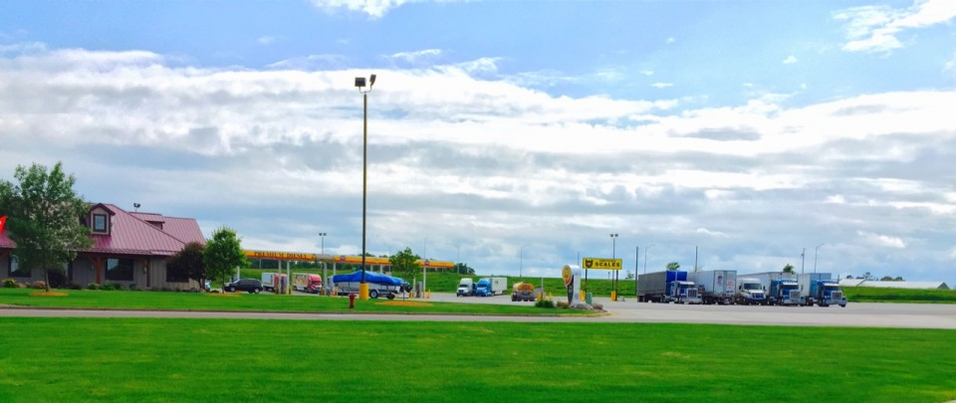

**ADMISSIONS REQUIREMENT:**

Entrance requirements include the following: Students must be at least 18 years old, have a valid Class D (regular) Driver’s license, must be able to pass a psychical exam and must be able to speak and understand the English language (there is no translating on CDL exams allowed by DOT). A clean driving record is highly recommended for students that attend our courses, but will not be a determining factor of their acceptance. Students will go through an interview process to decide which students will be qualified for our courses. Alpina TDA does not discriminate applicants regarding age, weight, gender, beliefs, ethnicity or any other matter. All applicants will be considered with our highest sincerity. After our interview, students will be told immediately if they are cleared for enrollment. Interviews are taken during or after the application overview is finished. Alpina TDA reserves the right to reject any applicant it does not feel is ready or capable to be successful at our Driving Academy.

***We have no additional entrance requirements for specific programs.***

**Training Provided At Our School:**

Alpina TDA will provide professional CDL training to students in hopes that they will obtain a Wisconsin CDL. Students will receive classroom study time, on-site basic pre-trip and safety training. Classroom time will be spent with study guides, on-screen material/data and main references will be used from the Wisconsin CDL Manual. There will be a pre-test and final book exam conducted based on the study guide material and in class time that the class spend in their first week. The classroom time and study time is meant to refresh current CLP holders and/or prepare students for their CLP exam that will be conducted at a local DMV station.

Once our final exam is completed, students will be tested by a Wisconsin authorized CDL examiner to receive a Wisconsin CDL. The final exam will be conducted for the students to obtain their commercial driver’s license. The BTW training will consist of live on road routes conducted with a on board instructor in one of our CMV’s. Basic control exercises will be practiced in our lot to prepare the students for the backing exercises. The exercises that will be practiced will consists of the straight-line backing, off set and alley dock parking. An instructor will be one site for this specialized training.

Our final exam that will be conducted for the four-weeks of the course, the instructor will release students that are ready to take their final CDL exam. Students will be tested by a Wisconsin Authorized CDL Examiner to receive a Wisconsin CDL. Students that pass this exam, will become CDL holders in the type of CMV class they tested for. Students that are not ready will be brought back for touch up work with their current instructor or weekend instructors to fix or break bad driving habits or touch up on areas that are problematic in the students driving.

The benefit of a student attending Alpina TDA is that they will finish the course achieving their Wisconsin CDL and hoping to enter a high paying career. Students that obtain their CDL are also likely to hold a stronger position with better job security if they currently work in a company that deals with any type of CMV’s. Wisconsin CDL holders are always without doubt at an advantage when applying in for many job positions in numerous job fields.

Our policy in enrolling and the consideration of ability-to-benefit students, is not applicable. Our only objective is that students benefit in achieving their Wisconsin CDL.

***Students that are accepted into our program will be contacted by email or phone within two business days following their application approval.***

Enrollment applications will be accepted until the first day of class for each class session.

**2018 Class Schedule (beginning and ending dates for each term):**

Beginning End

June 11 July 6

July 9 Aug 3

Aug 6 Aug 31

Sept 3 Sept 28

Oct 1 Oct 26

Oct 29 Nov 23

Nov 26 Dec 21

Classes are held weekdays only, Monday thru Friday. Holidays and vacation periods are shown above in section I. ***All classes and training will be held during daylight hours.***

1. **Advanced Standing**

Alpina TDA does not offer any Advance Standing from any other school, institution or truck driving company for any previous training or study guide work done by students in the past.

1. **Student Progress**

**Alpina TDA Grading System.** Alpina TDA will grade students based on 2 factors. Factor #1 is our final weekly exams given to the student at the end of the current training weeks. There will be one written exams on every Friday of each of the 4-week courses provided by the school. The exam will be designated to the study material that is referenced in our classroom or in the field training and practice. The exams will be graded with a passing score of 75% correct or more and unsatisfactory exams will be graded at a failing score of 74% or below. If a student fails there Friday exam, he/or she will be given study material to take home and prepare for a Monday morning re-test exam before they start the next week of training. They will be given one opportunity to pass the re-test exam or the student will have to be pushed back to study one on one tutoring sessions with their instructor before they can proceed on to the current week of training. This will be done after school hours, 1 hour each day, with a new re-test the next morning of the next class day.

Factor #2 is hourly class time and on field with BTW training. Each student must have a minimum of 30 hours of attended time with our school per week to be presented with a certificate once they pass their final CDL exam with an examiner. Meeting a minimum of 120 hours of classroom/and training combined. The maximum full classroom/and training combined hours will be 160 hours of attendance.

Students that miss class hours or time will have to make up the time by attending additional classes, after school missed session training portions or weekend training that is offered and scheduled for make up time with an instructor.

Students will receive their grades at the end of each week of the 4-week course. The grades will be given to each student on an individual report card.

**Students Final Evaluations and Reports.** Student Evaluations are based on their attendance, classroom work, field & BTW grading and weekly Friday exams. No student will be allowed to do their CDL Exam until the meet a minimum combined passing score of 75% or more on their Friday exams and have met the minimum hours of attendance that is require by our school. Only Assigned instructors and the students that feel ready and confident about passing the final exam will be scheduled for their CDL exam with an authorized examiner. Our academy will not force anyone that does not feel ready to perform an exam to schedule one, unless both parties are confident.

**Note:** Students by law can go and seek other authorized examiners out of the school to do their CDL exam on their own. If students decide to seek other examiners, the school will not fund their CDL exam. The student will be responsible to fund their CDL exam on their own at this point.

**Certificate of Training.** To receive a school certificate, students must meet a minimum score of 75% on their weekly exams and 120 hours of attendance to obtain a school certificate. Once the student passes their CDL Exam, they will receive an Authorized Certificate enabling them to obtain their CDL at a local DMV station. This will be their final passing grade of their course, the obtainment of the Commercial Driver’s License. Once the CDL is obtained, the school will issue the student a Certification of Completion from our Driving Academy.

**Testing Policies & Regulations.** Any instructor that is an Authorized CDL Examiner in the State of Wisconsin, will not be able to test any students that they have trained on any bases whether in classroom, in the field, BTW or any other type of training what so ever. These specialized Instructors will sign a waiver per student that they instruct and also the student will sign the same waiver that this Instructor is not allowed to test them for their Final Exam as an Authorized Examiner.

**\*Note:** Hourly Training Applicants will not receive a Certificate of CDL Training School Completion. They will receive a detailed receipt showing how many hours they have trained.

1. **Student Records**

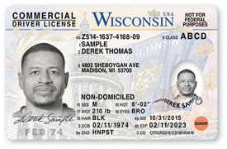

Student records consist of: report cards, attendance records, student driver performance sheets, student agreement forms, transcript of student progress, certificate of completion and all Class D, CLP and CDL info. These records will be kept for a minimum of 6 years and the transcripts will be kept permanently.

We maintain confidentiality for all students relating to all student information. Records are private and can only be accessed by school officials, school managers, or head instructors. With a written request by the student, their records will be released to others.

1. **Academic Probation, Dismissal and Re-Admittance**

Students that are involved in criminal activity associated with the course they attend such as theft or illegal drug possession, will be dismissed immediately from the program.

Students who violate our code of ethics will receive a written notice and will be sat down and talked to on how to proceed with a successful plan. If a second violation occurs, student, instructor and chief administrator will have a sit down to discuss the issues and sign a last warning agreement for the second violation. If a third violation occurs, the student will be dismissed immediately from the program by the head manager of assigned staff. Refunds will be applied according to refund policy. A student that is dismissed has a right to reapply for future classes, but is not guaranteed acceptance into our courses.

Alpina TDA does not grant any students probationary periods or put students under probation during a course or session.

***ALPINA TDA CODE OF ETHICS:***

*-OUR CODE OF CONDUCT/ETHICS IS THAT WE DECLARE TO PROVIDE ETHICAL AND PROFESSIONAL BEHAVIOR FROM ALL OUR STAFF AND INSTRUCTORS AT THIS ACADEMY. THIS APPLIES TO ALL CLASSROOM, ON THE FIELD, BTW AND ONE-ON-ONE TRAINING. WE WILL MAINTIAN A RESPECTABLE SOUROUNDING FOR ALL OUR STUDENTS AND FOR EACH OTHER AND UPHOLD A STRONG LEARNING ENVIRONMENT FOR ALL. AS FOR ALL STAFF, WE UPHOLD THE FOLLOWING ETHICAL PRINCIPLES…*

* **CONDUCTING MYSELF IN A PROFESSIONAL MANNER IN TEACHING AND TRAINING**
* **WILL REFRAIN ANY USE OF SUBSTANCES THAT IMPAIR MY LEARING OR JUDGEMENT WHILE IN CLASS**
* **LISTENING AND RESPECTING ALL THE STUDENTS IN OUR COURSES**
* **CREATING AND MAINTAINING A SAFE, CLEAN AND EASY GOING ENVIRMOENT**
* **NEVER TO MAKE EXAGERATED STATEMENTS TOWARDS OUR COURSES**
* **USE MY CREDENTIALS, QUALIFICATIONS AND ABILITIES ACCURATELY**
* **ENCOURAGING DIVERSITY BY RESPECTING ALL BACKGROUNDS, BELIEFS AND LIFESTYLES**
* **RESPECTING THE DIGNITY, RIGHTS AND PRIVACY OF ALL STUDENTS**
* **AVOID USING WORDS OR ACTIONS THAT CONSTITUTE SEXUAL HARRASENT**
* **NOT TO GOSSIP OR ACT IN A WAY THAT CAN HARM STUDENTS**
* **FOLLOW THE LOCAL GOVENRMENT AND NATIONAL LAWS THAT PERTAIN TO OUR FIELD AND COURSES**

Academic dismissal does apply for students that can not attain a passing grade in our course. These students will be placed on an academic dismissal status. Students that can not pass the course, because of unsatisfactory grades and performance have a right to stay in the course and finish the course without receiving a completion certificate. These students will have a right to still take the CDL exam with a Wisconsin Authorized CDL examiner to try to attain the CDL. Students that wish to stay will have to sign an agreement based on the information provided above.

1. **Student Conduct**

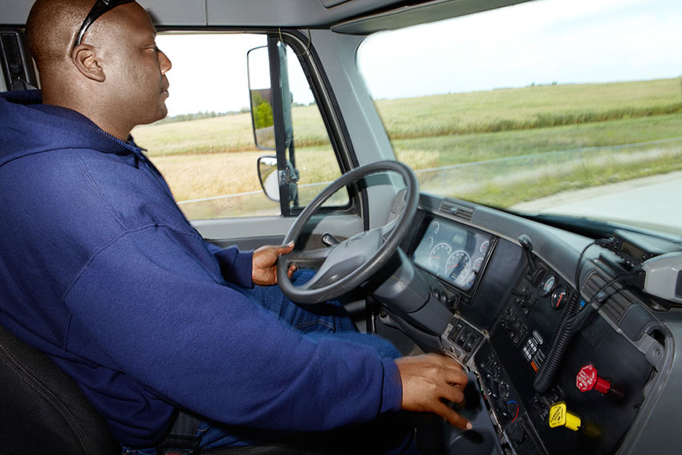

All students that attend our school must present themselves in a professional and eager to learn manner. Acts of aggression, swearing, bullying, or disruptive behavior are considered bad conduct and will not be tolerated. Harassment of any sort will not be put up with. Students must wear clothes that are not distracting or offensive to other students or to staff (e.g. clothing with swear words written on them or any images with symbols or signs that can be discriminating to others). All our students that attend must be honest and never cheat. Students are not allowed to bring any alcohol, drugs or weapons to our school. Also, students are not allowed to come into our class or any field training under the influence of any drugs or alcohol.

Smoking is not allowed inside any of our school buildings/or facilities. Students can not smoke in any of our vehicles. Smoking is allowed outside; all smokers must dispose of their cigarette butts or tobacco products in a disposal can (throwing cigarettes on the ground will not be tolerated).

Students can be dismissed for unsatisfactory conduct depending on the level of bad conduct. Students that commit any bad acts of conduct that are described above will be warned. The first warning will be a verbal warning by staff or their instructor. The second warning will be given to the student in a written format signed by the chief administrator and one more staff member. If a third warning is issued, it will lead to dismissal of the student from the course. The third warning will be a written letter of termination and dismissal from our programs. Student will be dismissed the moment they are handed this letter by a staff member.

Students that are dismissed for bad conduct have a right to appeal the termination. A student that receives their third letter of termination and dismissal will have 2 business days to hand in a letter of appeals describing why they think that the termination is not fair and must set up a meeting, that they must agree to attend and attend within two business days of the handed in letter of appeals. Students must hand in their letter to their instructor or any staff member. Depending on the reason of termination, the school will highly consider re-enrolling the student on site if we feel that the student is in a good standing with their appeals. If the students are terminated for harassing any student, staff or member of our facilities, having a weapon or coming in under the influence of any substance, the letter of termination will be handed to them with 2 witness signatures of the bad conduct that occurred, and the student will be expelled from our Academy and may not re-apply to the school until a period of 18 months has passed from the day they are officially dismissed.

If the student is dismissed for bad conduct they may re-apply to the school after a 30-day period for the next available class session.

If students are re-admitted to the school whether its under a appeal status or re applying for a future course after 30 days, the students will be cleared of all past warnings and will start off as a new student does. The same terms and policies on student conduct will apply to them.

1. **Leave of Absence**

If a student must discontinue their planned course with a reasonable excuse that is beyond their control, a Leave of Absence will be granted, and the student will have the right to re-enroll and finish the course where they left off, at no additional cost. Students that have a authorized leave of absence are also allowed to obtain a school refund based on our refund policy and re-enroll to a new class session. Max time limit for leave of absence is 12 months.

Re-enrollment must be made within 12 months following the last day the student attended the course where they had a Leave of Absence, if the student is seeking to re-enroll where they left off. In the event the student’s CLP expires in the meantime, the student is liable to renew or re-obtain a new permit before re-enrolling into the course. The school will not be liable for the costs of a new CLP.

1. **Attendance**

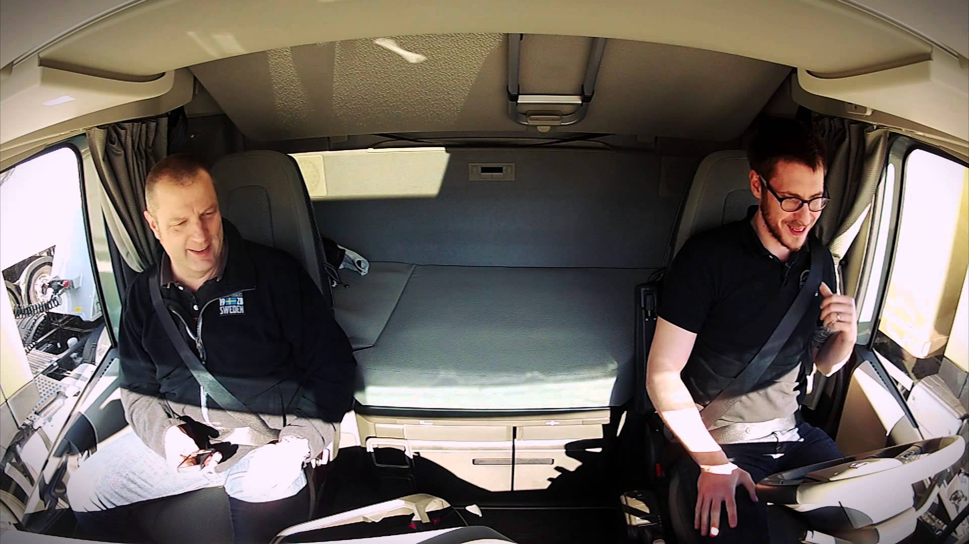

-Attendance will be taken at the beginning of every class day.

-In event that a planned absence occurs, or an emergency happens, the student must make up the missed hours by either one-on-one training with an instructor or enter in on a weekend class course or group training session, to get themselves back to minimum passing hours.

***\*Please see Probation, Dismissal and Re-Admittance page for un-excused absences and the way they are dealt with.***

1. **Tardiness**

Tardiness is marked if students are more than 15 minutes late to any class day. You will receive 4 excused tardy days with the one month training course. If tardiness is more than 30 minutes for any class day, the students will be forced to make up each 30 minute time frame they are late. If they are late more than thirty minutes to an hour, they will be forced to make up an hour of missed class time. Alpina will offer 2 free hours of missed class time to any student, any more than 2 hours missed, the student will be charged $60 an hour for one-on-one training.

1. **Student Complaints**

Student complaints will be dealt with as soon as issue might arise. An interview with their instructor and school manager and any other parties involved will take place with a written statement regarding the complaint. We handle student concerns in a professional manner by reviewing the written complaint, and then in involving the student and the staff member to address the complaint. Additionally, if necessary the student may contact the President of the company by email at alpinaschoola@outlook.com. The president’s name is Fek Besiri.

If your problem is still not resolved and student is not satisfied or does not feel at ease, they may contact the WI EAB at 1 (608) 266-1996, or their web site [www.eab.wisconsin.gov](http://www.eab.wisconsin.gov) or mailing them at 1400 E. Washington Avenue, Madison, WI 53703 for more help.

1. **Tuition and Fees**

**Tuition, Fees & Refunds:**

**4-week Training Program.** The tuition for our 4-week CDL training program is $3,999.99. This includes the cost of your CDL Permit, your DOT medical exam and DOT FED MED Card, your CDL Exam (paid for if taken by our Authorized CDL Examiners only, not outside examiners. Alpina TDA will only pay for the 1st exam that the student takes) and cost of your actual CDL obtainment from the DMV. No other fees are required. Student registration is free. Tuition is to be paid on or before your first assigned classroom date. Tuition can be broken down into payments. Here is a listed and details of installment arrangements that can be made:

**Alpina Plan, 1 Full Payment.** Student must pay the full payment of the entire amount of the tuition on or before the first day of class. The payment amount would be ***$4,250.00.***

**Gold Plan, 2 Installment Payments**. Student must pay 1/2 of entire amount on or before first classroom day. The 2nd half of entire amount must be paid on or before first day of class of the third week of training. Each payment amount would be ***$2,125.00*** for the Gold Plan.

**Silver Plan, 4 Installment Payments.** Student must pay 1/4 of the entire amount on or before each start of first day of class for every school week. We have 4-weeks for our training program. Each payment amount would be ***$1,062.50*** for the Silver Plan.

***Note: Hourly Training is exempt from installment programs.***

All items that the student may need to finish their 4-week course are included in the tuition costs for our school. ***Food, drink and extra daily essentials are not covered by our school.***

1. **Cancellation and Refunds**

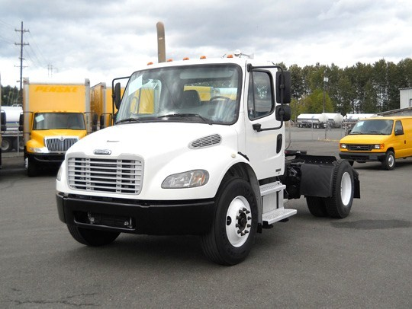

**Refund Policy.**

The student will receive a full refund of all money paid if the student:

1. Cancels within the three-business-day cancellation period under EAB 6.03;

2. Accepted was unqualified and the school did not secure a disclaimer under EAB 9.04;

3. Enrollment was procured as the result of any misrepresentation in the written materials used by the school or in oral representations made by or on behalf of the school.

Refunds will be made within 10 business days of cancellation.

A student who withdraws or is dismissed after attending at least one class, but before completing 60% of the instruction in the current enrollment period, is entitled to a pro rata refund as follows:

AT LEAST BUT LESS THEN REFUND OF TUITION

1 unit/class 10% 90%

10% 20% 80%

20% 30% 70%

30% 40% 60%

40% 50% 50%

50% 60% 40%

60% no no refund

As part of this policy, the school may retain a one-time application fee of no more than $100. The   
school will make every effort to refund prepaid amounts for books, supplies and other charges. A student will receive the refund within 40·days of termination date. If a student withdraws after completing 60% of the instruction, and withdrawal is due to mitigating circumstances beyond the student’s control, the school may refund a pro rata amount.

If a student decides to withdraw from our program, students should write a written letter of withdraw and hand in a copy to their instructor or chief administrator on site as soon as they can. Any other mode of withdrawal will also be recognized. Students will be administratively withdrawn after missing five days of consecutive class sessions. Students that stop attending a program altogether without notifying our school, will be administratively withdrawn on the fifth consecutive day they are not marked for attendance. These students will receive a refund based on their last day of attendance. ***A written notice of withdrawal is not required.***

1. **Program Curriculum**

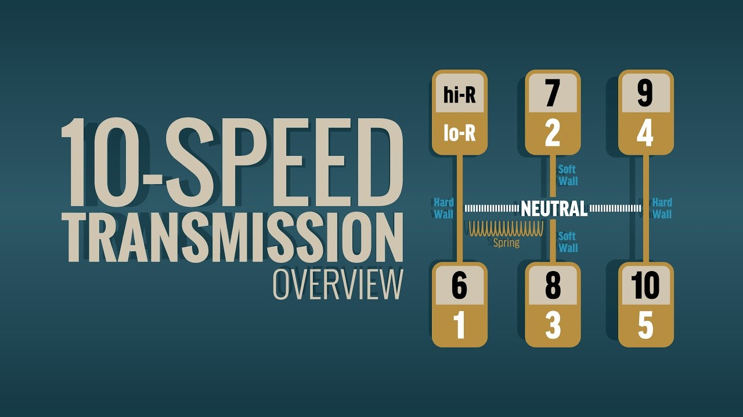

***Week 1: Classroom Studies of Excelled CDL Training (40 Hours)***

***Objective of the classroom studies are to update and brief the students on what the written CDL exam will consist of, for the students to obtain their CLP on their testing day. All of the items listed are main points and critical areas of study that are all found in the Wisconsin CDL Manual. The Wisconsin CDL Manual will be our main source of study during the Classroom Studies of Excelled CDL Training. All the items listed are the main keys of being familiarized with DOT knowledge, CMV safety and must know general info for CDL holders. Classroom time will consist the*** ***first week of our four-week session from 9:00am thru 5:00pm.***

***The items below are our main topics of study:***

-CDL General Knowledge (8 classroom hours)

-Combination Vehicles (4 classroom hours)

-D.O.T. Hazmat & Safety (2 classroom hours)

-D.O.T. Hours of Capable Service (2 classroom hours)

-Air Brake Systems (4 classroom hours)

-Pre Trip Inspections (8 classroom hours)

-D.O.T. Log Books (2 classroom hours)

-Accident Reporting & Situations (2 classroom hours)

-Fed Motor Carrier Safety Regulations, Rules & Laws of the Road for CMV (8 classroom hours

***Weeks 2 & 3: Field & BTW Training (40 Hours per week)***

***Field & BTW Training are the key essentials in training students for their CDL. Our students will be paired up with an assigned instructor and will be trained on the type of vehicle that they wish to obtain their Class of CDL. The items below are main points that the instructors will have the students focus on to learn how to safely operate their CMV. Each of these areas are critical in having the students attain a good skill level to become successful and safe drivers as they practice on road and in lot BTW training. Each area is designated to provide the student with the certain amount of skill needed to pass their final cdl exam that will be conducted with a Wisconsin Authorized Examiner.*** ***The Field & BTW Training will consist of the second and the third week of our four-week session from 9:00am thru 5:00pm.***

***The items below are our main topics of study:***

-Mirror Usage (2 hours per week)

-Backing Exercises “Basic Control Skills Training” (12 hours per week)

-Proper Braking with Air Brakes (2 hours per week)

-Proper Shifting “Up Shifting & Down Shifting in CMV” (16 hours per week)

-Speed to Gear Vehicle Control (2 hours per week)

-Gear Patterns Outlook (2 hours per week)

-Defensive Driving Techniques (4 hours per week)

***Week 4: Touch Up & CDL Exam Finals (40 Hours)***

***This last week of student training will present trial and error scenarios. We’ll work to fix bad habits the students might have demonstrated during their training and perhaps in their everyday driving. We’ll review the road rule law for CMV to prevent mishaps and auto fails during a conducted exam. This week is critical for the students to stay focused on what they have learned and to try to perfect their CMV techniques. Before they are scheduled with an Authorized Examiner, the students will take demo exams in their group with their assigned instructor. The Touch Up & Final CDL Exam Week will consist of the last and final week of our four-week session from 9:00am thru 5:00pm.***

***The items below are our main topics of study/ hours of training and activity will vary depending on student:***

-General Overview of Week 2 & 3 (estimated 12 hours)

-Trial and Error Editing (estimated 5 hours)

-Fixing Bad Driving Habits (estimated 5 hours)

-Perfecting CMV Driving Techniques (estimated 15 hours)

-Final: CDL Exam…Pre-Trip Inspection, Basic Control Skills Test (Backing Test) and Road Test (estimated 3 hours)

***\*Note: The CDL Exam will be done with an Authorized CDL Examiner and once the exam is passed, students will be able to obtain their Certificate to take to the DMV and get their CDL.***

***Hourly Segmented Training:***

***Hourly Training will be provided for current students, for extra training and practice outside their current 4-week sessions. Alpina TDA, will also offer hourly training to any applicants at their request. Items are listed below:***

-Book Knowledge Study/Tutor $35 an hour (2-hour minimum)

-Pre-Trip Training $70.00 an hour (2-hour minimum)

-Backing Training $80.00 an hour (2-hour minimum)

-BTW Training $80.00 an hour (2-hour minimum)

1. **Employment Services**

**Employment Assistance, Services and Results.** Students that fully finish the course provided by our Academy and obtain the CDL, will be awarded a Certificate of CDL Training School Completion. Alpina TDA will offer each completing student job leads and referrals to potential truck driving companies for employment. Alpina TDA assumes no responsibility for student placement and does not guarantee employment and will not make direct contact with potential employers. We will work hard for the students to build a good referral system but as a final assumption, the students are responsible for employment.

Alpina TDA will contact and survey all our graduates within 6 months to a year after graduation. We will also contact employers of employed graduates, if the students allow us to, to track how we did on our students training when they have reached the actual job field. As an Excelled Academy, we want to validate what we do for our students and learn what employers want.

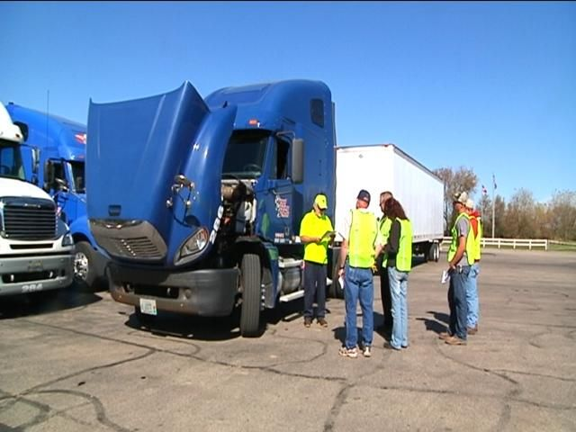

**Contact Info:**

**Direct Line: 1 (262) 902-6860**

**Email:** [**CDLTESTING@OUTLOOK.COM**](mailto:CDLTESTING@OUTLOOK.COM)

**Main School Office: 7760 S. 6th Street Oak Creek, Wisconsin 53154**

**Mailing: 2929 1st Street Unit #2 Racine, Wisconsin 53403**