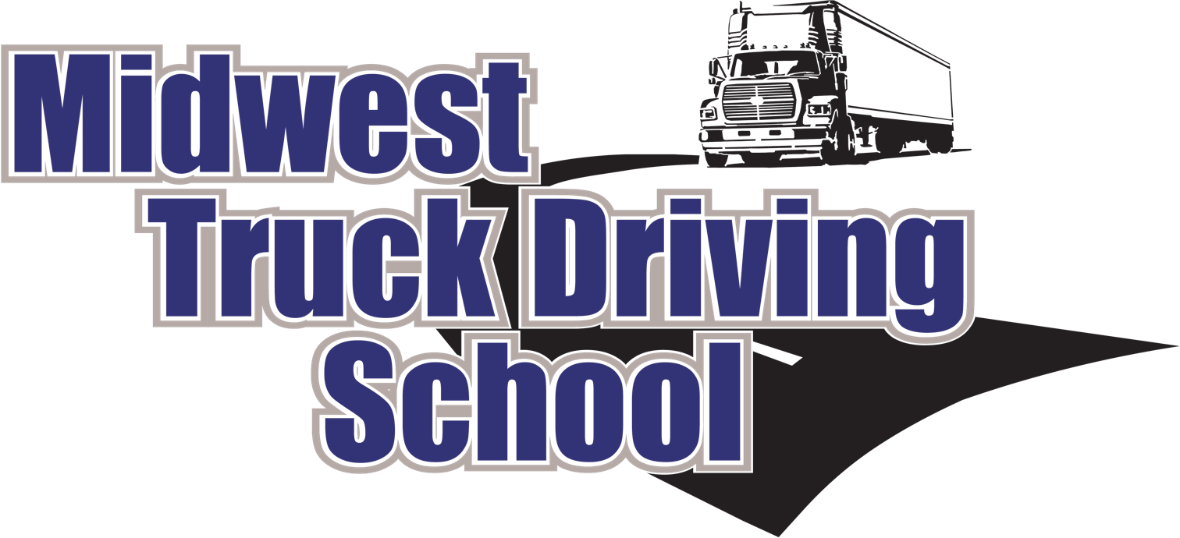

**Course Catalog**

**Date of Publication: April 2018 – Issue 11**

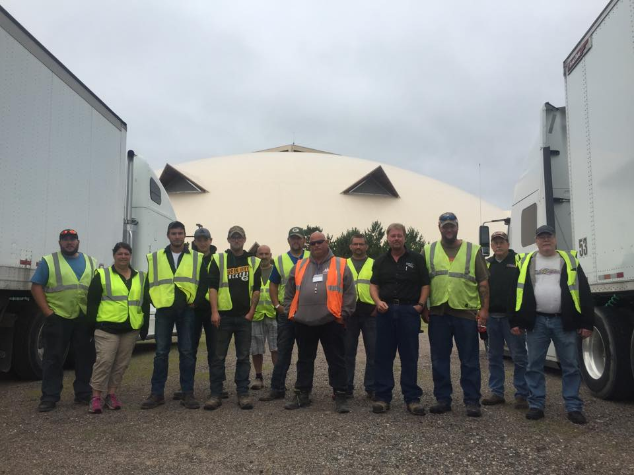

**1519 North 26th Street Escanaba, MI 49829**

**Phone: 906-789-6311 Toll Free 800-377-5567 Fax: 906-789-6317**

**info@midwesttruckdrivingschool.com**

**www.MidwestTruckDrivingSchool.com**

**CVTA Certified 160 Hour Four Week Tractor Trailer Class A CDL Course:**

**Class Start Dates 2018**

September 10th- October 5th October 8th- November 2nd

November 5th- November 30th December 3rd- December 28th

**Class Start Dates 2019**  
January 7th- February 1st February 4th- March 1st

March 4th- March 29th April 1st-April 26th

April 29th- May 24th May 28th-June 21st

June 24th- July 19th July 22nd-August 16th

August 19th-September 13th September 16th- October 11th

October 14th- November 8th November 11th- December 6th

December 9th-January 3rd

**40 hour One Week Tractor Trailer Class A CDL Refresher Course**

**Class Start Dates 2018**  
September 10th-14th October 8th-12th   
November 5th- 9th December 3rd-7th

Class Start Dates 2019  
January 7th-11th February 4th-8th  
March 4th- 8th April 1st- 5th   
April 29th- May 3rd May 28th -June 1st  
June 24th -June 28th July 22nd- July 26th  
August 19th-August 23rd September 16th- 20th  
October 14th- October 18th November 11th – 15th

December 9th-13

Institutional Philosophy

Midwest Truck Driving School is an institution that offers a truck driver training program. Individuals who understand occupational education and the trucking industry manage the school’s program. We have taken this valuable knowledge and experience and have made it available to you. We are committed to training professional truck drivers and feel we have one of the finest training programs in the country.

Institutional Mission

The mission of Midwest Truck Driving School is to provide a quality occupational learning opportunity for adults through its program that is innovative, convenient, accessible, and will allow students to gain the knowledge and skills necessary to enter the transportation industry as an entry level professional driver. This philosophy requires a commitment to our students, the transportation industry and to the motoring public. A commitment that mandates a careful screening to ensure that the students have the ability and aptitude to master the necessary knowledge and skills required to safely operate a Commercial Motor Vehicle, and to achieve employment in the industry.

Licensing and Approvals

The Education Approval Boards of Michigan and Wisconsin have approved Midwest Truck Driving School to operate as a truck training program for students in Michigan, Wisconsin, and several other states. We have also met the approval of several major transportation companies, GI Bill approved training facility, MSP Commercial Enforcement Division, and are members of the Michigan Driver and Traffic Safety Association, Women in Trucking, Michigan Center for Truck Safety, Michigan Trucking Association, Commercial Vehicle Training Association (CVTA), and have an A+ rating as an accredited business with the Better Business Bureau.

Location, Facilities, and Equipment  
Midwest Truck Driving School is located at 1519 North 26th Street Escanaba, Michigan 49829. The Corporate and Administrative offices are also at this location. The School is reached by turning onto 14th Avenue North which runs automatically into 26th Street. We are in the blue building next to the Penstar office center complex.

The Facility provides classrooms, offices, and a student lounge. The classroom seats 16 students and accommodates lectures, workshop activities, and general classroom instruction facilitated using various audio/visual equipment, television, projector, PowerPoints, educational videos, dry erase boards, and replica truck models. The adjacent range provides more than adequate room to accommodate our entire training fleet to instruct and perform pre-trip inspections, yard maneuvers, coupling/ uncoupling and drop and hooks.

Administration

Our Instructors are the most important assets of the school program. From their knowledge as experienced over the road professional drivers, our instructors are highly skilled and qualified to train students and assist them in meeting their goals of a new career. Midwest Truck Driving School utilizes and maintains its tractors and trailers like those units currently being operated in daily operations in the trucking industry. All street instruction is performed on designated routes selected to allow the student to progress through various degrees of difficulty as the core competencies and skills are mastered.

Admissions

Students meeting the admissions criteria as determined by the Department of Motor Vehicles will be admitted to the school without regard to Race, Color, Creed, Sex, or National Origin.

Individuals able to verify past training and/or experience by providing documentation to the school will receive credit for such training and/or experience.

All applicants must be at least 18 years of age, have an acceptable driving record, possess a valid driver’s license, and meet all driver qualifications of the Federal Motor Carrier Safety Regulations, which includes a DOT physical.

A High School Diploma or GED’s is preferred, but not required. All applicants must have the ability to read, write, and speak the English language and do simple arithmetic. Applicants who apply for the driver refresher program will be required to verify and demonstrate prior training or experience.

Persons interested in attending should contact the School and speak to t admissions representative. Admissions can be reached in Escanaba, MI by a toll-free call to 1-800-377-5567 or 906-789-69311.Applicants must be interviewed by an admissions representative, complete an enrollment application, complete an enrollment contract, and submit other information required to satisfy each of the admission requirements unless waived by the school. All prospective students are encouraged to visit the school for a personal tour.

Four-week classes begin every fourth week on Monday, and the cut off for admissions into a specific class is the Wednesday immediately preceding the Monday class desired. One week classes typically start on Mondays; however, we make every effort to accommodate our student’s schedules. The admissions staff will make every effort to enroll students who have not completed the admissions requirements by the Wednesday prior to the class.

Class Size and Instructor Ratio’s

The Courses are structured for students with the following instructor to student ratios:

Classroom 1:12 Instructor to Student Ratio  
Range (off road) 1:4 Instructor to Student Ratio  
Street (on road) 1:4 Instructor to Student Ratio

Course and Training Objectives

Midwest Truck Driving School offers the following course and training programs:

**CVTA Certified Four Week Tractor Trailer Course (CDL A):**

The objective of the Tractor Trailer Driver Training Course is to provide individuals with the skills, competencies, and knowledge necessary to pass the States licensing exam and enter the trucking industry as professional driver. This is a comprehensive training program that is ideal for all people interested in the trucking industry, whether they have had some prior experience or not. The curriculum includes both classroom and behind the wheel training, yet focuses primarily on allowing students as much hands-on training as possible. The license is a requirement for students to gain an entry level position as a professional driver with a Class A Commercial Driver License (CDL). The classroom training will also include presentations from Department of Transportation officials, trucking companies, and current professional drivers in the trucking industry. The program consists of 160 hours of training at the Escanaba, MI facility. The training program runs for 20 days, from Monday through Friday of each week (4 weeks). There is 40 hours of classroom training, 40 hours of range training and 80 hours of road training. (Additional time would be offered to the students, at no additional charge to complete the program due to adverse weather conditions).

**One Week Tractor Trailer-Refresher Course (CDL A):**

The objective of the One Week Tractor Trailer Refresher Course is to provide those individuals who have formerly held, or currently hold a Class A CDL with the skills, competencies, and knowledge necessary to pass the current States licensing exams, or to fulfill hiring requirements by a specific company. Students who do not currently hold a Class A CDL license are required to have a DOT physical and a commercial learners permit. Individuals should contact their personal physician for information regarding the DOT physical. Information on the commercial learner’s permit can be obtained from the Department of Motor Vehicles, or Secretary of State Office, depending upon which State you reside. Additional information can be obtained online.The program consists of 40 hours of training at the Escanaba, MI facility. The training program runs for five days, from Monday through Friday. There are five hours of vehicle inspection training, ten hours of range training and 25 hours of road training. (Additional time would be offered to the students, at no additional charge, to complete the program due to adverse weather conditions).

Curriculum Outline

|  |  |  |
| --- | --- | --- |
| Classroom Instruction | Range/ Class Instruction | Road/ Street Instruction |
| Regulations | Vehicle Inspection | Pre-trip Inspection |
| Vehicle Systems | Couple/ Uncouple | Shifting |
| Brake Systems | Turning Exercises | Expressway Driving |
| Skid Control | Backing Exercises | City Driving |
| Accident Procedures | Shifting/ Clutching | Lane Control/ Usage |
| Trip Planning | Slowing/ Stopping | Emergency Procedure |
| Drivers Logs and ELD’s | Signal Use | Speed/ Space Management |
| Hazard Perception | Safety Belt | Railroad Crossing |
| Visual Search DDC | Traffic Laws | Bridge/ Overpasses |
| Distractive Driving | General Driving Behavior | Obedience to Signs/ Signals |
| Signs | Traffic Checks/ Search | Rural Streets |

Tuition and Fees

|  |  |
| --- | --- |
| CVTA Certified Four Week 160 Hour Class A CDL Tractor Trailer Course | |
| Skills Test (State Test) | $175.00 |
| Use of Books and Supplies | Included |
| Job Placement Assistance, Skilled training | Included |
| Tuition | $3,975.00 |
| Total Cost | $4,150.00 |

|  |  |
| --- | --- |
| One week 40 Hour Class A Tractor Trailer Refresher Course | |
| Skills Test (State Test) | $0.00 |
| Use of Books and Supplies | Included |
| Tuition | $1,750.00 |
| Total Cost | $1,750.00 |

Use of all necessary books and supplies, including handouts is included in the cost of tuition.  
Textbooks are for the use of the student but remain the property of the school. All tuition and fees are payable prior to, or on the first day of class. Skills testing is administered by a third-party tester licensed under the state of residency of the student.

The training programs do qualify for various financial assistance programs. Students who may be paying the tuition through a private or public financial institution must make arrangements with the lender to have the monies at the beginning of the course. Tuition and fees are due and payable when the student starts the class.

Additional Costs.

Students are responsible for making arrangements for room and board, if necessary, while attending the course. The School will make a tractor-trailer unit available for Michigan and Wisconsin testing sites selected by the School, for the purpose of taking the road test for the CDL license. Students wishing to take the test in other states will be responsible for making their own arrangements for the testing and a tractor-trailer to use for the actual road test.

Student Services

Though the school does not have any institutional housing available, the admissions staff will assist the student in arranging any necessary housing. Every reasonable effort is made to help reduce the expenses for the students. Reference materials, supplement texts and other related materials pertaining to the course and program are available to the student. All students have access to these materials, which may be checked out upon request.

Student Records

The School maintains a permanent record for each student. The permanent records are confidential and only such agencies and individuals authorized by law are allowed access without written permission of the student. The school maintains these records for a period of seven (7) years. Students may review their permanent record upon reasonable written request to the School Director. All such requests will be scheduled during regular school hours under appropriate supervision.

A complete record of each student’s attendance and grades are maintained on their permanent records. A signed and dated photocopy of these forms represents an official transcript. One official transcript will be provided free of charge to the student. Students who have not satisfied their financial obligation to the school are not eligible to receive a transcript.

Attendance

Attendance is mandatory as part of the course requirements. Students are expected to attend all scheduled instructional hours. Please note no classes are held on the following holidays: New Year’s Day, Easter, Memorial Day, Independence Day, Labor Day, Thanksgiving, or Christmas.

The instructional day is from 8:00am to 4:30pm. Breaks are not to exceed 10 minutes per hour with 30 minutes for lunch.

Tardiness

Tardiness or the incident of arriving late or leaving early shall be recorded in the student’s record and accumulated as hours/days absent. Punctuality and time management are traits that the professional truck driver must possess. Three recorded incidents of tardiness shall be considered as one (1) day absence. Absences

Cumulative absences of more than two days (16 instructional hours) may result in termination, since such interruption may prevent the student from mastering the competencies essential to the course of study.

Leave of Absence

The school realizes that extenuating circumstances may arise where it would not be advantageous for the student to maintain enrollment. In such cases, upon written request and at the School Director’s discretion, a leave of absence may be granted. A leave of absence indicated that the student sincerely intends to resume his/ her vocation. The student who is granted a leave of absence will be terminated from the School if the student does not enroll at the start of the next class or on the predetermine date scheduled by the Student and the School Director. A student will be granted only one (1) leave of absence.

Withdrawal and Re-Entry

The School Director may allow a student to voluntarily withdraw from a class and re-enter at a later date that may not interfere with the students training and is acceptable to both the student and the school. Students terminated may be allowed (depending upon the reason for termination) to re-enter, at the School Director’s discretion, without losing any credit from prior training only one (1) time at a future date determined by the School Director, but no earlier than 30 days from the student’s last day of attendance.

Make-up Work

Any missed work must be completed by the end of the next instructional week.  
  
Student Conduct

Students shall, at all times, conduct themselves in an exemplary manner in and out of school. Midwest Truck Driving School is committed to the standard of professionalism required by employers in the industry and expects the same commitment from the students who are preparing for a career in the industry. As such, students will be terminated for any of the following incidents:

* Being under the influence of, or in possession of intoxicating beverages or illegal drugs of any kind while on School property or in or around School equipment or during any portion of the training period.
* Unsafe behavior or operation or equipment abuse.
* Possession of weapons, theft or stealing, fighting, vandalism, excessive absenteeism, failure to complete make-up work.
* Falsification of any of the School’s admission paperwork or applications for employment or applications for driver’s license or permits.

The school is not responsible for injury or property damage incurred by a student as a result of the student’s own negligence, unsafe behavior, or other misbehavior or failure to strictly adhere to the schools’ policies and procedures.

Student Grievance / Complaints

Student grievances / complaints will be referred to the School Director. Any grievances or complaints that cannot be resolved by the School Director, may be addressed to the President of the school. Complaints regarding training standards/methods, that conflict with published curriculum standards can be addressed with the Educational Approval Board. Wisconsin Students (608-266-3185) Michigan Students (517-241-6860).

Grading System

The students’ progress is constantly monitored and evaluated against the school’s performance standards and must maintain a cumulative grade average of at least 75% or better in each module (classroom, range and road) of instruction and pass all tests and examinations administered. Monitoring is performed through the use of written tests, instructor evaluation of range maneuvers, vehicle inspections and road training. Students must achieve a 75% or higher grade to pass. Any score under 75% will be a failing grade. A student is allowed to retake tests/examinations one (1) time. The grade achieved in the last examination will be the grade credited.

The grading system is as follows:

|  |  |  |
| --- | --- | --- |
| GRADE LEVEL | PERFROMANCE DEFINITION | GRADE POINT AVERAGE |
| Excellent – A | 94% - 100% | 4 |
| Above Satisfactory – B | 86% - 93% | 3 |
| Satisfactory – C | 75% - 85% | 2 |
| Unsatisfactory – D | 60% - 74% | 1 |
| Fail – F | Below 59% | 0 |
| Incomplete – I | Not Complete | 0 |

The minimum performance standards are:

* Students must maintain a cumulative grade average of at least 75% or better in each module (classroom, range, and road) of instruction and pass all tests and examinations administered on a pass or fail basis.
* Students must comply with the school’s admission, attendance, conduct, and other policies at all times during the course of instruction.

Graduation

The candidate for the certificate must have successfully completed all specified requirements for the certificate and be free from all indebtedness to the school or have made satisfactory arrangements for the payment of tuition and fees. Upon graduation, the student will receive a certificate as evidence of the student’s successful completion of the course of instruction, a Department of Transportation written test and road test certification.

Placement & Employment

Midwest Truck Driving School provides free placement and job counseling assistance and services to students and graduates. Satisfactory completion of the program course work and the development of personal qualities, in conjunction with the necessary aptitude, attitude and ability, are the first steps in the employment process.  
*State regulations prohibit the school from guaranteeing employment or set wages*.

Cancellation and refund policy

A student may cancel the enrollment agreement at any time. A written notice of withdraw is not required except during the three-business day cancellation period.

A student who does not attend classes or provide an explanation for seven (7) calendar days is considered to have voluntarily terminated. The school may terminate a student for insufficient progress, nonpayment, failure to comply with rules, and other items noted in the catalog. This catalog gives specific details.

Refund Policy

The student will receive a full refund of all money paid if the student cancels within a three-business day cancellation period. A student who withdraws or is dismissed after attending at least one class, but before completing 60% of the instruction in the current enrollment period, will be refunded a pro rata refund as follows:

At Least But Less Than Refund of Tuition

1 Class 10% 90%

10% 20% 80%

20% 30% 70%

30% 40% 60%

40% 50% 50%

50% 60% 40%

60% - NONE

The school will make every effort to refund prepaid amounts for books, supplies and other charges, when and if they should apply. A student will receive the refund within 30 days of termination date. If a student withdraws after completing 60% of the instruction, the school may refund a pro rata amount, if withdraw is due to mitigating circumstances beyond the student’s control.

For those students receiving funding under Title 38, United States Code

If a student fails to enter a course or withdraws, or is discontinued therefrom at any time prior to completion, the amount charged will be an approximate pro-rata portion of the total charges for tuition, registration fees less $10.00, and other charges that the length of the completed portion of the course bears to its total length.

Officials and Staff

Owner/ President – Patrick A. Barron

CEO – Kyle J. Barron

Instructor/ General Manager – Joshua P. Barron

Administrative Services Manager – Jennifer Bourdeau

Instructor – Thomas A. McKnight

Instructor – Steven A. Porath

Instructor – Chad Brown

Instructor – R.J Betzinger

(This statement is to certify that this catalog is true and correct in content and policy.)

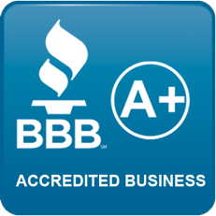

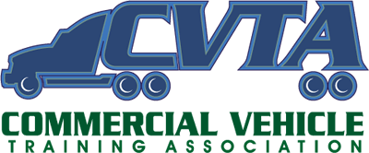

**Midwest Truck Driving Schools, LLC  
Veteran Student Addendum**

**This catalog addendum applies to those students receiving U.S. Department of Veterans Affairs education (GI Bill) benefits while attending Midwest Truck Driving School. Please acknowledge by your signature below that you have read and understand the information in this addendum, and have received and understand the polices, rules and regulations of Midwest Truck Driving Schools, LLC.**

**Prior Credit Policy**: Per 38CFR 21.4253 (d)(3), previous training and experience will be considered and granted if appropriate, for veterans and other eligible students. Veterans must submit a copy of their DD214 discharge certificate and submit to an evaluation road test.

**Attendance Policy:** Students are expected to attend all classes. If circumstances prevent attendance at a particular class, prior notification is expected in order to arrange make-up sessions. If attendance falls below 90%, VA benefits will be terminated. Students whose absences result from authorized mitigating circumstances, as determined by the school Director, will not be terminated. Students who have been terminated from the school for unsatisfactory attendance may be re-admitted at the discretion of the Director

**Conduct Policy:** Students must conduct themselves in a respectable manner at all times. Disruptive or inappropriate behavior deemed unsatisfactory conduct by school officials will result in termination or veterans’ educational benefits, and possible dismissal from Midwest Truck Driving Schools, LLC. Re-admittance after conduct dismissal requires reapplication to the school.

**Academic Progress Policy**: Students receiving VA education benefits must maintain a 75% or better grade average on each module of training (classroom, road, and range). Students also must complete all classroom assignments in a timely manner. Failure to meet these criterions will result in being placed on probation. If the criterions are not met by the end of the probationary period, VA education benefits will be terminated. Certification to VA for payment will not be resumed until the student has returned to a satisfactory academic status.

**Pro-Rated Refund Policy for Veterans and other Eligible Students**: Per CFR 21.4255, Midwest Truck Driving Schools, LLC has a pro-rata refund policy for the refund of the unused portion or tuition, fees and other charges in the event the veteran or eligible person fails to enter the course or withdraws or is discontinued there from at any time prior to completion.

**Equal Opportunity Statement:** Midwest Truck Driving Schools, LLC does not discriminate on the basis of race, color, religion, sex, disability or national origin.

**Program Completion:** The student must satisfactorily complete the academic requirements of their chosen field and satisfy all financial obligations to receive a certificate.

**Retention of Records:** Midwest Truck Driving Schools, LLC will retain records and accounts of students receiving VA Education benefits for a period of three years following course completion. These records will be made available to the student upon request and certification.

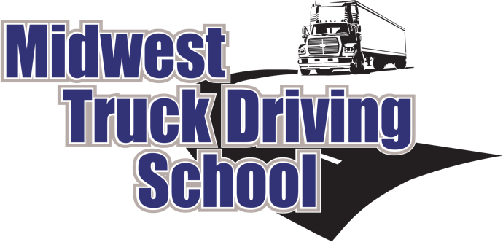

**1519 N 26th Street Escanaba, MI 49829**

**Office: (906) 789-6311 Fax: (906) 789-6317**

**Toll Free: (800) 377-5567**

**www.MidwestTruckDrivingSchool.com**

**info@midwesttruckdrivingschool.com**

I have received and reviewed Midwest Truck Driving School’s Catalog and contract any questions that I had have been answered.

Print Name ______________________________________ Date ______________

Signature ________________________________________Date ______________