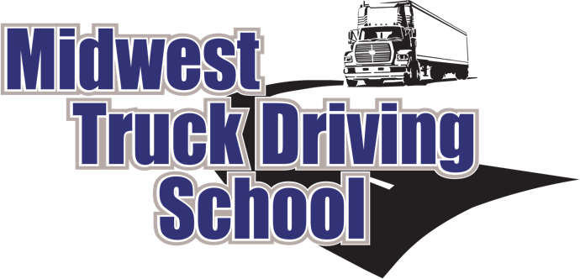
1519 North 26th St. Escanaba, MI 49829
Office: (906) 789-6311 Fax: (906) 789-6317
Toll Free: (800) 377-5567
www.MidwestTruckDrivingSchool.com
info@midwesttruckdrivingschool.com

Application for Admission – Transportation Program
Date: _________________How did you hear about the CDL course? ______________________________
I would like to obtain my Class A CDL I would like to obtain my School Bus Class B CDL
I would like to obtain my Class B CDL I would like a refresher course (Class A or B)
Personal Information
Legal Name in Full:
_____________________________________________________________________________________
Last First MI Other Name Used
Permanent Address:_____________________________________Phone:__________________________
City:_________________________________State:____________________Zip Code:________________
Email Address:_________________________________________Cell Phone #:_____________________
Mailing Address:_______________________________________________________________________
City:_________________________________State:____________________Zip Code:________________
Social Security Number:__________________________________Date of Birth:_____________________
In Case of Emergency:___________________________________________________________________
Mailing Address:_______________________________________________________________________
Phone Number:________________________________________________________________________
Education
Education Completed (Check all that apply):
 | Grade School |  | Junior High School |  | High School |  | GED
 | Vocational Training |  | Some College |  | College Degree
 | Special Training
School’s Attended City/ State Dates Attended
____________________________________________________________________________________________________________________________________________________________________________________________________________________________________________________________________________________________________________________________________________________
Driver’s License Information
I currently hold a Class A CDL
I currently hold a Class A CLP (permit)
I have never had a CDL

I currently hold a Class B CDL
I currently hold a Class B CLP (permit)
I have formally held a CDL

Current Driver’s License #:_______________________________________State:______________
Expiration Date:_______________________________
US Citizen: YES NO If no, Alien Registration Number:______________________________
Financial Assistance *Not required to fill out, information obtained only to help with potential funding
Do you have any tribal affiliation? YES NO If so which tribe?_____________________________
Do you have any military experience? (i.e. army, reserves, national guard, navy, etc.) YES NO If so were you honorably discharged? _________________Do you have form DD214?_________
Where would you like to be employed? ____________________________________________________
How do you intend to finance school expense? Any Student who is paying with cash, check or credit card is required to pay a 10% non-refundable down payment fee. This fee will be put towards the cost of tuition the first day of class, and is only non-refundable if a student does not come to class. Some exceptions may apply, so please call the office to set up payment.
______Cash, Check, Credit Card ______VA – GI Bill ______WIA
______Voc Rehab ______Facet ______WIOA

Midwest Truck Driving Schools, LLC
1519 North 26th Street
Escanaba, MI 49829
Phone (906) 789-6311
Fax (906) 789-6317
STUDENT CONTRACT
OFFICE & CLASS HOURS: Monday-Friday 8:00 AM-5:00 PM.
Provider Certificate Number P000613

THE DRIVING RECORD OF EACH INDIVIDUAL INSTRUCTOR IS AVAILABLE FOR REVIEW UPON REQUEST.
General Terms
- It is my responsibility to fully read all the content of school catalog provided to me. I understand that my signature on this document is acknowledgement of receipt of the catalog and also my clear understanding of all of its contents.
- Midwest Truck Driving Schools, LLC may assign this contract.
- All correspondence, inquiries, payments or other matter relating to this contract initiated by the student or their legal representative shall be directed to the school’s general office listed on the first page of this contract.
- I understand that there are physical qualifications for receiving a commercial driver’s license. A Department of Transportation physical and obtaining a Temporary Instruction Permit are prerequisites and must be completed before training can be provided.
- This contract may be mutually, in writing, rescinded when found to be in the best interest of both parties. Prorated refund amounts are listed within the school catalog.
- In order to stay current with potential employer’s needs, the training program topics and content, including types of equipment are subject to change without notice.
- Tuition due from students must be paid by Wednesday of the first week of class. Any tuition being provided by an approved funding source will be exempt from this requirement.
- Any student being funded, wholly or partially through a contracted future employer understands that they will be responsible for any balance not paid by their future employer for any reason.
- In the event of labor disputes or acts of God (i.e. fire, flood, tornadoes), the school reserves the right to suspend training at the resident sight affected for a period not to exceed 60 days.
- Midwest Truck Driving Schools, LLC is an alcohol/drug free zone. Therefore, any student thought by an instructor or staff member to be exhibiting irrational or dangerous behaviors while on the school premises can, at the request of the school, be asked to submit to drug testing. Refusal by the student to comply, will be cause for immediate dismissal.
- The school reserves the right to reschedule classes if necessary.
- The school does not provide food, lodging or travel costs.
- I hereby release, hold harmless and indemnify Midwest Truck Driving Schools, LLC along with its staff and representatives from and against all liabilities, damages, and other expenses, including attorney’s fees, which may be imposed upon and incurred by or asserted against it or them by reason of bodily injury or property damage which I may suffer, from any cause, while a student on the resident training site.
Midwest Truck Driving Schools, LLC provides free job counseling assistance and services to students and graduates. The school makes every effort to secure employment opportunities for all of its students. However, state regulations prohibit the school from guaranteeing employment upon completion of the school.
Notice: This provider is required to be certified by the Secretary of State. If you have any complaints which you cannot settle with the school, write to:
Michigan Department of State
Driver Programs Division
Lansing, MI 48918

DO NOT SIGN THIS CONTRACT UNTIL YOU HAVE READ AND FULLY UNDERSTAND THE TERMS AND CONDITIONS OF THE SCHOOL CATALOG AND THIS AGREEMENT.

You are entitled to a copy that has been signed by a representative of the school.

APPLICANT_____________________________________ DATE_____________________

SCHOOL
REPRESENTATIVE_______________________________ DATE_____________________

