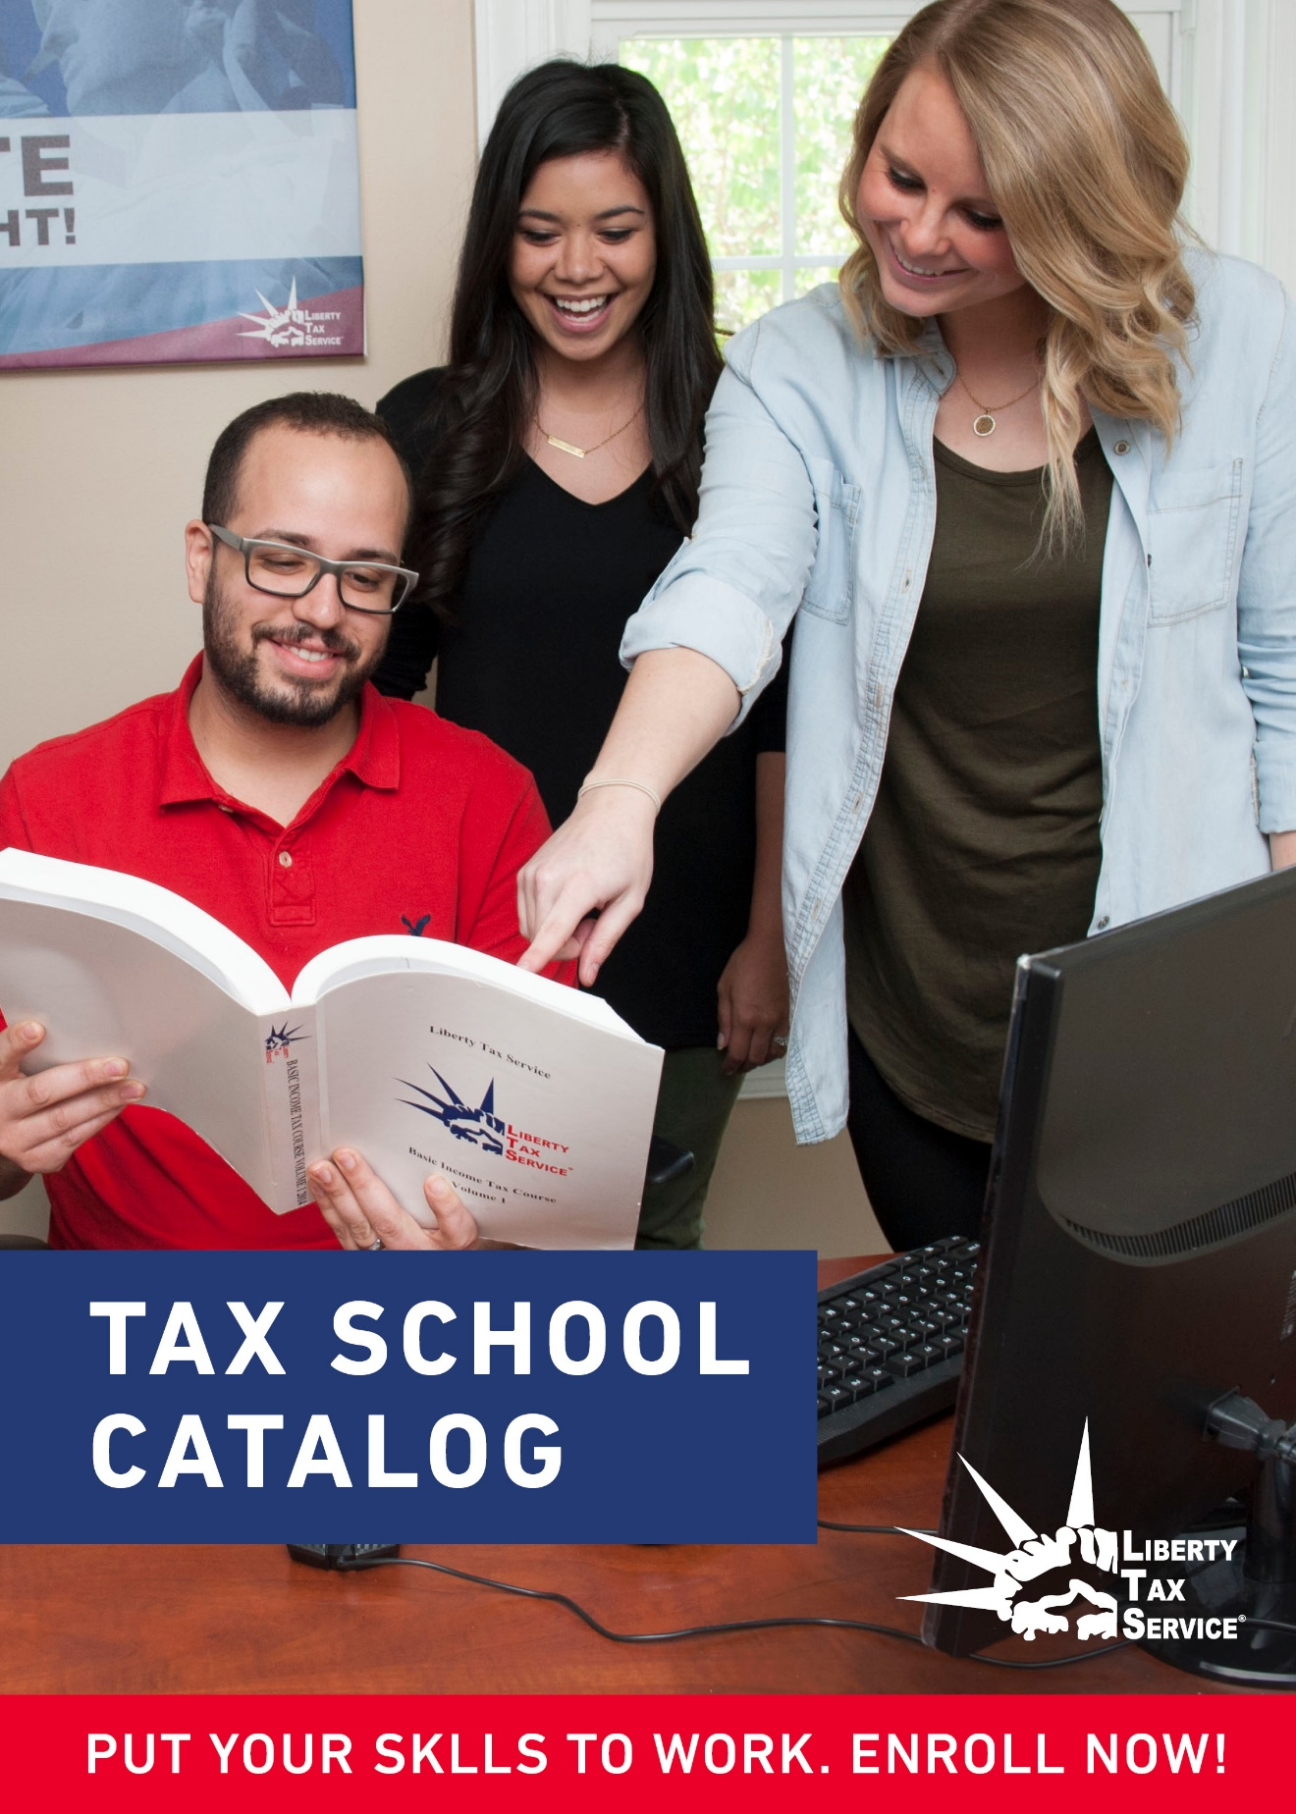­

**Liberty Tax School**

Insert address

City, State Zip

Phone:

Fax:

Email: taxschool@libtax.com

Owner: JTH Inc, d/b/a Liberty Tax Service and WeFile Inc.

**Liberty Tax Service Corporate Headquarters**

1716 Corporate Landing Parkway

Virginia Beach, Virginia 23454

Local: (757) 493-8855

Toll Free: (800) 790-3863

Fax: (800) 880-6432

[office@libtax.com](mailto:office@libtax.com)

Web Address

www.libertytax.com

Oregon Higher Education Coordinating Commission

255 Capitol NE, Salem, OR

97310-0203

(503) 947-5751

Oregon Board of Tax Practitioners

3218 Pringle Rd SE

Salem, OR 97302

(503) 378-4034

*Oregon Edition*

*Published: 08/15/2017*

*Effective dates: August 15, 2017 to June 01, 2018)*

[OAR 581-045-0019 (2) requires the effective dates of the catalog, not to exceed one.]

# Table of Contents

General Information 1

Mission Statement 1

Philosophy 1

Educational Objective 1

Admissions / Enrollment Process 2

Requirements 2

Acceptance Notification 2

Enrollment Agreement/Contract 2

Transfer Credit 2

Application Deadline 3

Beginning and Ending Dates and Holidays 3

Non-Discrimination Policy 3

School Staff 3

Administrative 3

Instructional 3

Registration & Book Fees 4

Classes 4

Eleven Week Course 4

Employment Assistance Services 5

Student progress Reports 6

Grading 6

Attendance 7

Tardiness 7

Leaves of Absence 7

Student Conduct 7

Probation & Suspension 8

Student Records 8

Confidentiality 8

Student Grievance Policy 8

ii

# General Information

## Mission Statement

The mission of Liberty Tax School is to educate and train people to provide a general understanding of, and training in, income tax preparation. Our curriculum maintains standards by which students, when successfully applied, may obtain rewarding employment. Faculty members are knowledgeable in tax law and tax preparation and are dedicated to providing quality training. We believe in providing an excellent educational experience for all of our students.

## Philosophy

Liberty Tax School seeks to instruct students in a thorough and efficient manner to prepare 1040 federal income tax returns including forms and schedules most commonly used in the preparation of tax returns. In addition, we wish to accurately instruct the Oregon Tax Laws, various forms associated with Oregon Income Tax and steps to becoming a licensed Oregon Tax Preparer. It is the intention of Liberty Tax School to facilitate the vocational goals of students who are interested in seeking entry-level positions in federal income tax preparation businesses.

## Educational Objective

Our basic tax course is designed to teach the fundamentals of income tax preparation. The course covers filing requirements and status, exemptions and dependents, income sources, adjustments, standard and itemized deductions, credits tax on retirement plans, sale of personal residence, and tax tables. The benefit of the course is to be qualified to work in the tax preparation industry. Successfully passing the Tax Preparer examination given by Oregon Board of Tax Practitioners would first be required. The tax course is a non-credited 80 clock hour course.

# Admissions Process

Liberty Tax School requires that applicants must be at least 18 years of age and possess picture ID to be considered for tax course training. .

The course requires reading of detailed tax materials and time for homework in preparation for each class to be effective. Successfully passing the Tax Preparer examination given by Oregon Board of Tax Practitioners is required for employment in Oregon

## Requirements

* Student must be at least 18 years of age.
* Students must possess picture ID to prove name and age.
  + Acceptable ID includes government issued ID with photo, such as driver’s license, military ID card or passport.

**\* Although having a high school diploma, GED, or another recognized equivalency certificate is not a requirement to enroll in this school, it is a requirement of the Oregon Board of Tax Practitioners to become a licensed tax preparer.**

## Acceptance Notification

If a student registers for a class in person, after the admission requirements are verified and documents submitted, the student is then advised of his/her acceptance or denial. If registration is done through the mail or online, a registration form is sent to the applicant. The student is notified by phone when the registration form is received that he/she is registered and has been accepted for the class selected.

A student, who is denied admission for failure to meet the requirements, must resolve any outstanding issue before being eligible to reapply.

## Enrollment Agreement/Contract

After a student is registered they will then complete and sign the school’s enrollment agreement. The enrollment agreement includes: school and student information, course name and length, class start and end date, cost for books and materials and refund information.

## Transfer Credit

Liberty Tax School does not grant advanced standing or transfer credit for prior education and training.

## Application Deadline

We permit students to apply to enroll in a tax course through the first three chapters of material covered. If a student inquires about enrolling after that time, the application is denied and it is recommended that the student attend the following year.

## Beginning and Ending Dates and Holidays

All tax school classes are to begin in September after Labor Day. The ending dates vary, depending on the exact start date of the course. See the accompanying course calendar for exact dates. The student is notified of the start and end date of the class they have selected on their registration form.

Holidays observed are Halloween, Thanksgiving and Christmas Day.

## Non-Discrimination Policy

Admission is not on the basis of sex, age, race, color, religion, ethnic origin, or sexual orientation. All students are treated under the same standards as defined in ORS 659.850.

Any person unlawfully discriminated against, as described in ORS 345.240, may file a complaint under ORS 659A.820 with the Commissioner of the Bureau of Labor and Industries.

The school’s policies governing all staff will be enforced in situations where instructional staff or other school personnel have been found to have engaged in discriminatory behavior.

# School Staff

## Administrative

Tracy Allford - Director of Training and Tax School

Sandra Stolich - Tax School Coordinator

Fred Bach - Area Developer

## Instructional

Jody Vaughn - Instructor (Roseburg, OR)

Robert Stein - Instructor (Lebanon, OR)

Sandy Law - Instructor (Portland, OR)

Tim Magerle - Online Instructor (Lebanon, OR)

# Registration & Book Fees

This course is offered without tuition or registration fees. Book costs for Liberty Tax School will be **$239.00**. This includes the cost of any additional materials needed. The books must be purchased from Liberty Tax Service as they are not distributed through retail vendors. A minimum of half of the book fees must be paid with cash, check or credit card (VISA, MasterCard, Discover) at the time of enrollment, the remainder must be paid by end of the 4th week of class.

**Cancellation and Refund Policies**

If cancellation occurs within five business days of the the date of enrollment, and before the commencement of classes, all monies specific to the enrollment agreement shall be refunded. Book are issue on the first day of class.

After commencement of classes, if student withdraws or is terminated and returns the purchased books to the office in their original condition, 50% of the book fee will be refunded. There will be no refund for used books or materials.

If the school decides to add a tuition cost the school will require the student’s approval via new enrollment agreement and the school will apply the refund policy as provided by OAR 715-045-0036.

# Classes

Liberty Tax School offers an 11-week course. The course teaches the fundamentals of income tax preparation using a Liberty Tax School text book and Oregon Supplement and IRS publications.

Classes are twice a week for 4 hours per session. Class time includes open discussion, questions and answers, class assignment, and review. The mid-term and final exams are open book. Students learn to look up information using class materials and IRS publications. Students will have a maximum of 120 hours to complete the course.

Classes will take place within a working tax preparation office, but will not use the tax preparation computers while doing classwork. There will be some calculators available for student use, but students are encouraged to bring their own calculators. IRS & State issued publications will be available for student use. All instructional areas are adequate to create a classroom safe learning environment where all supported equipment and materials are in good working conditions.

## Eleven Week Course

The 11-week course consists of twenty 4 hour class sessions (for a total of 80 clock hours) beginning in September. Each class session is devoted to one or more topics. The corresponding chapter of the text books and IRS publications are reviewed. The final class session is used for the final exam. The final exam consists of 200 questions, and students will have five hours to complete.

The following topics are covered:

Class 1: Filing Information

Class 2: Exemptions, Dependents and Filing Status

Class 3: Wages, Salaries, Tips, and Withheld Taxes etc.

Class 4: Interest, Dividends, and Other Income

Class 5: Standard Deduction and Your Income Tax

Class 6: Dependent Tax Credits

Class 7: EIC and Education Credits

Class 8: Retirement Benefits

Class 9: Social Security and Other Credits

Class 10: Basis of Property and Capital Gains (including Sale of Home)

**Mid-Term Exam**

Class 11: Depreciation

Class 12: Itemized Deductions

Class 13: Itemized Deductions, Part II

Class 14: Profit or Loss from Business

Class 15: Rental Real Estate, Royalties, Partnerships, etc.

Class 16: Adjustments

Class 17: Affordable Care Act and Other Credits & Taxes, Part-Year, Nonresident, and Military – OR State Specific & Elderly Rental Assistance Program

Class 18: Farm Income / Profit or Loss from Farming & Sale of Business Assets and Sale of Home / Installment Sales, Sales of Business Property, Abandonment of Property, and Cancellation of Debt

Class 19: Payments Penalties, Installment Agreement, and Injured Spouse, Estimated Tax, Extensions, & Amendments, Tax Benefits for Education

Class 20: Tax Return Preparers & the Oregon State Board of Tax Practitioners

**Final Exam or Review**

# Employment Assistance Services

Liberty Tax School offers its students assistance in job search techniques, résumé preparation, and interviewing skills if needed. Although we do not actively refer students to prospective employers, students are offered the opportunity to interview for a job as a tax preparer at Liberty Tax Service upon successful completion of the tax course **and** the State Board of Tax Practitioners board administered exam. Neither attendance nor successful completion of any tax course guarantees employment by Liberty Tax Service, but we do require students pass the course in order to be considered to work at one of the Liberty Tax Service locations.

Our commitment is to train individuals to prepare income taxes efficiently to work in the tax preparation industry. As such, we do evaluate the program’s success. The same Basic Income Tax course is offered all over the country. We have over 3,300 offices that utilize this course to train and educate new employees.

# Student progress Reports

Students can at any time inquire about the status of his/her grade. Homework is reviewed the next class date and grades on homework are known at that time. The instructor confidentially gives the student a written progress report showing their academic and attendance performance for the reporting period. Progress reports are issued at week seven and week fourteen.

## Grading

On tax forms, 10 points will be taken off for the first mistake which causes the bottom line of the return to be incorrect. Subsequent incorrect answers caused by this mistake will not be deducted. For example, if the student used the incorrect table for Earned Income Credit, 10 points would be deducted. That error causes the rest of the return to be incorrect, but no further points would be deducted.

Incomplete or resubmitted work will be accepted up to two weeks beyond the original due date. Any assignments left incomplete beyond the two weeks will be graded as an F and the final grade will be calculated as stated below.

In addition to grades on homework and exams, students will be graded on participation in class. Mid-term and final exams will each count 25% of the final grade, with homework accounting for an additional 25%, and classroom participation being the final 25%. Classroom participation includes group activities, answering classwork questions, providing homework answers, asking questions, etc. A minimum cumulative score of 70% is required for satisfactory progress.

Scale: Elements of Grade:

100-90 = A Mid-Term Exam 25%

89-80 = B Final Exam 25%

79-70 = C Homework 25%

69-60 = D Participation 25%

Below 60 = F 100%

An award of completion will be given to students having a final grade of 70 or above. This is the required grade for satisfactory completion of the program. At the end of the course, students receive written notification of their final grades.

# Attendance

Although Liberty Tax School maintains records for attendance, it is not for grading purposes but rather for instructors to learn who regularly attends the class. If a student misses more than 3 classes, the student will be dismissed from the course without re-admittance.

Any missed assignments will be given at the class following the absence and is expected to be completed before the next class.

## Tardiness

Tardiness is defined as arriving for class more than 15 minutes after the scheduled starting time. Arriving late affects the entire class so students are encouraged to be on time. If a student is consistently late for class, he/she may be encouraged to attend one of the other class times that will suit his or her schedule better. Five tardys will be considered one class absence.

## Leaves of Absence

Liberty Tax School does not grant leaves of absence.

# Student Conduct

Students are expected to conduct themselves in a positive and friendly way and show a positive attitude towards other students, the instructor and towards the property where the course is being held.

Certain conduct is not tolerated. Examples include, but are not limited to cursing, spitting, discriminatory conduct, hostile and/or any negative behavior that would be harmful to the student or others, disrespect of instructor or other students, or defacing location property. In most cases, students will be given a verbal and written warning on first offense for minor non-threatening actions. Upon a second offense and based on severity of the infraction, a ~~single~~ second violation of the student conduct policy can result in termination from the in-class course and offered the opportunity to finish the course online. Severity of the infraction is determined by the school instructor or director. *[Example: A student may curse once softly when they stub their toe. This infraction would not be considered severe enough for the student to be terminated. However, a student being disrespectful and cursing at others will be terminated.]*

If a student is terminated from the course due to conduct, he/she would not be readmitted to the school. Students may follow the grievance policy stated below if they feel they have been aggrieved. A follow up letter of explanation would be sent to the student with a copy of the letter being kept in his/her file.

## Probation & Suspension

This is a non-credit course and the student elects whether to participate. The Liberty Tax School course does not place students on either probation or suspension for inappropriate conduct, unsatisfactory grades or progress.

# Student Records

Complete student files are kept for a three year period regardless of whether the student has completed the course or not. After the three year period from a student’s separation from Liberty Tax School, all records except the student transcript are shredded. Student transcripts are kept for a period of twenty-five years from a student’s separation from Liberty Tax School.

The following information is kept in the student’s file:

Student academic record

Attendance sheet

Progress report

Tax school evaluation form

Registration form

Right to cancel notice

Transcript

## Confidentiality

Student records are kept in locked filing cabinets away from public access. Records are for the use of management only and not shared with employees, other students (prior or current), or the general public.

Students have a right to access their own student file. Students can access their records by contacting the school director or instructor in writing at Liberty Tax School – Tracy Allford or Sandra Stolich 1716 Corporate Landing Pkwy, Virignia Beach, VA 23454 or by phone 707-972-7335.The school will provide access to the student’s file within 45 days of receiving the request. The school will schedule a time that is convenient to both school staff and the student for the student to review his or her file. Oregon Administrative Rule requires a school to respond within a reasonable period of time, but not more than 45 days from receipt of request.

# Student Grievance Policy

Students aggrieved by action of the school must first attempt to resolve these problems with appropriate school officials. Should this procedure fail, students may contact the Liberty Tax Service Corporate office via phone, (800) 790-3863, via email, [taxschool@libtax.com](mailto:office@libtax.com), or by mail, Liberty Tax Service Headquarters, 1716 Corporate Landing Parkway, Virginia Beach, Virginia 23454. If the matter still cannot be resolved, the student can then contact the Oregon Higher Education Coordinating Commission, Private Career School Licensing, 255 Capitol Street NE, Salem, OR 97310 or by calling (503) 947-5751.

All complaints received by the corporate office will be addressed immediately. Primary contact is Tracy Alfred, Director of Tax School. All complaints will be followed up with a phone call to the student. Appropriate action will be taken according to the substance and severity of the issue. All parties will be notified in writing as to the complaint resolution.

All students complete a Program Evaluation Form for the purpose of ensuring the course they attended was conducted according to Liberty Tax Service expectations. Students are randomly contacted to validate the information on the evaluation forms.