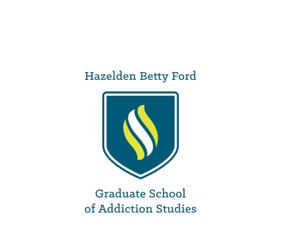

Marketing Resources – 2017 WI EAB Renewal

Website:

<http://www.hazeldenbettyford.org/education/graduate-school-addiction-studies>

Facebook:

<https://www.facebook.com/HazeldenBettyFordGraduateSchoolofAddictionStudies/>

LinkedIn:

<https://www.linkedin.com/school/4436590/>