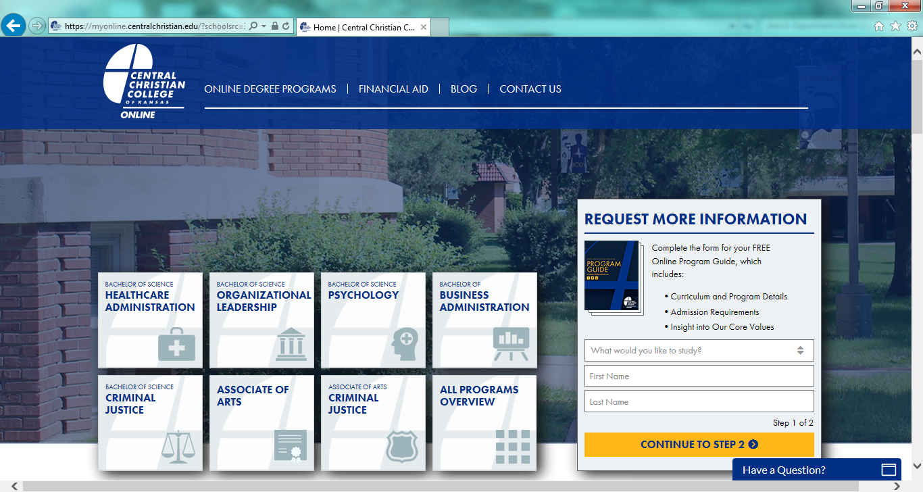

Central Christian College of Kansas does not specifically advertise in the state of Wisconsin. This is our online education website. We only utilize this website for recruiting Wisconsin students.