**Bryant & Stratton College**

**Website**  
<https://www.bryantstratton.edu/>

**TV Commercials** and student/graduate testimonials can be seen on our YouTube Channel  
<https://www.youtube.com/user/thebryantstratton/videos>

**Fox Focus TV segments**

[**https://www.youtube.com/watch?v=tlZ-aMs-CGc&feature=youtu.be**](https://www.youtube.com/watch?v=tlZ-aMs-CGc&feature=youtu.be)

[**https://youtu.be/M0cGf7rJPT0**](https://youtu.be/M0cGf7rJPT0)

[**https://youtu.be/YOrwbQ4Eo7I**](https://youtu.be/YOrwbQ4Eo7I)

**Social Media**

**Facebook**

<https://www.facebook.com/BSCBayshore/>

<https://www.facebook.com/BSCWauwatosa/>

<https://www.facebook.com/BSCMilwaukee/>

<https://www.facebook.com/BSCRacine/>

**Twitter**

<https://twitter.com/BSCBayshore>

<https://twitter.com/BSCWauwatosa>

<https://twitter.com/BSCMilwaukee>

<https://twitter.com/BSCRacine>

**LinkedIn**

<https://www.linkedin.com/school/15132305/>

<https://www.linkedin.com/school/15137298/>

<https://www.linkedin.com/school/15133907/>

**Facebook Events**

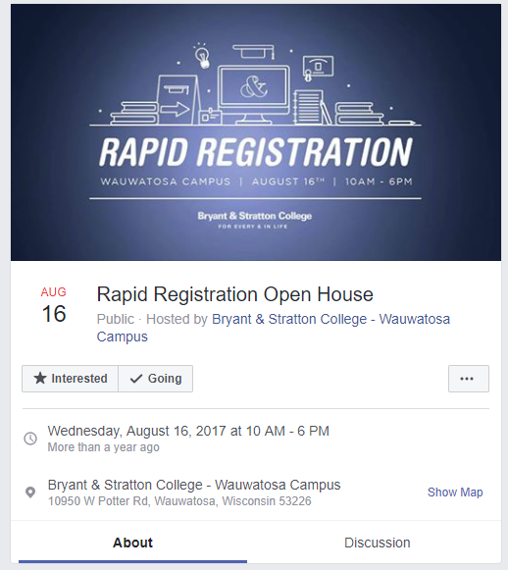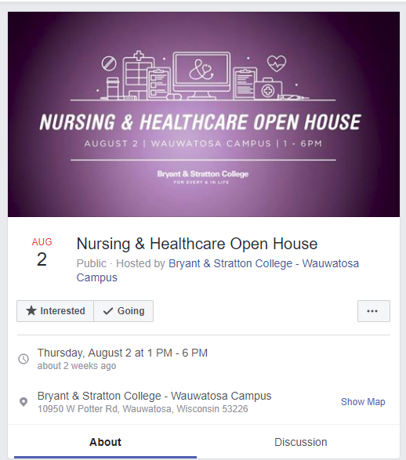

Facebook Ads





Outdoor

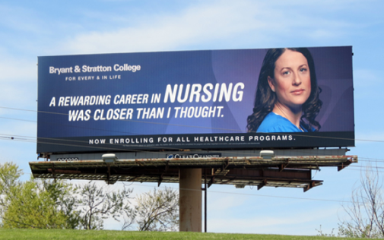



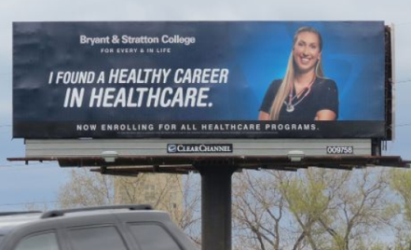

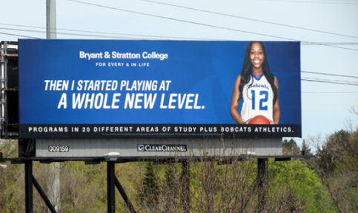

Transit – Racine

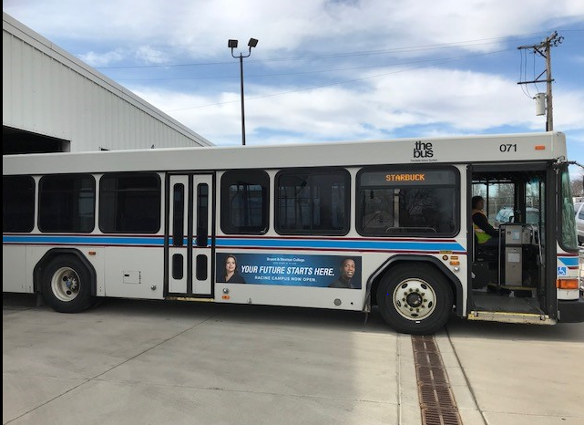

Print – Waukesha Freeman – 3/6/18

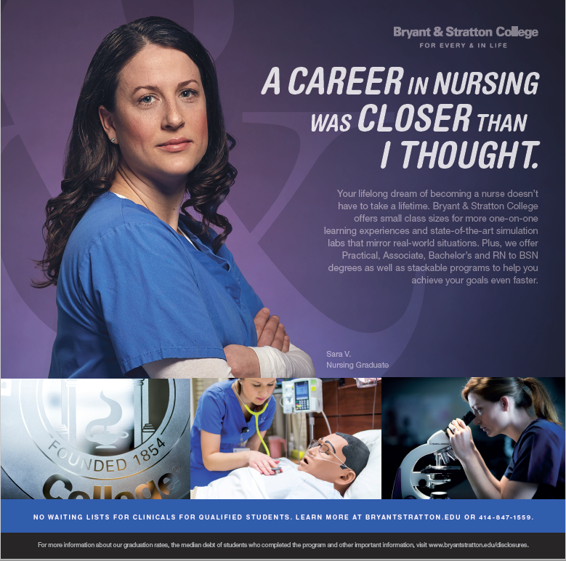

Radio – Open House



##

