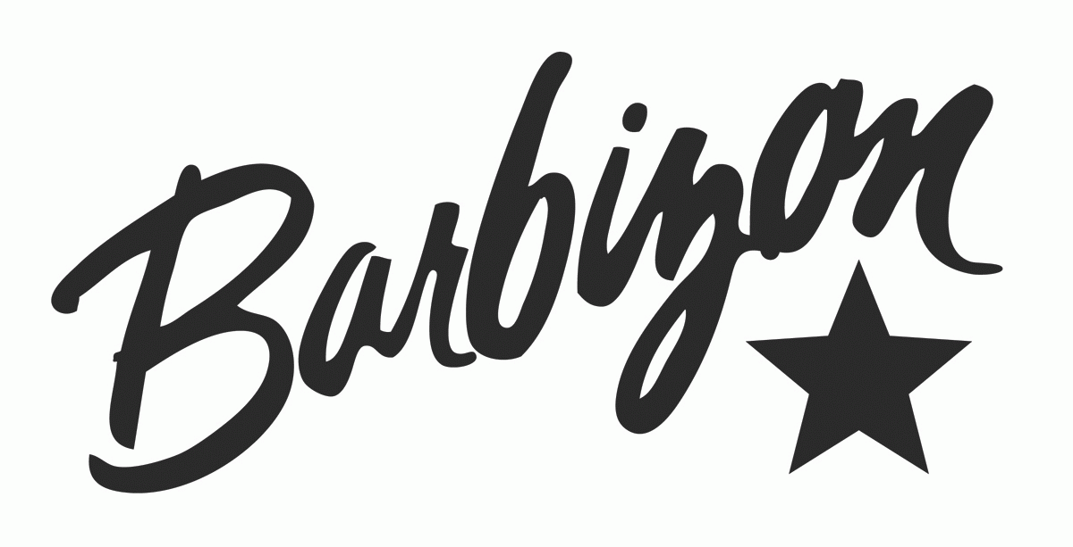

Barbizon USA LLC

Updated: February 15, 2018

1

SEVERE WEATHER POLICY..…………………………………………………….………………9

COUNSELING…………………………………………………………….…………………...….…9

SCHOOL CALENDAR…………………………………………………………….…………..….…9

OBSERVED HOLIDAYS…………………………………………………………….…………..….9

TRUTH AND LENDING STATEMENT…………………………………………….…………...…9

METHOD OF PAYMENT………………………………………………………………………….10

SPECIAL NOTICE OF PERSONS PAYING BY CHECK………………………….……….….…10

PLACEMENT POLICY…………………………………………………………...………….…….10

CORPORATE OFFICE   
(800) 330-8361  
FAX: (813) 282-3530

**HISTORY**

The Barbizon School has been a professional leader in the field of modeling, acting and personal development since 1939. It is Barbizon’s aim to develop and nurture in each student knowledge and training consistent with professional standards in the areas of modeling, acting and personal development. In addition to Wisconsin, we are state approved in Arkansas, Kansas, and Michigan.

3

**TABLE OF CONTENTS**

SCHOOL INFORMATION…………………………………………………………….……………3

HISTORY…………………………………………………………….…………………………....…3

SEMINAR TITLE…………………………………………………………….…………………...….4

COURSE DESCRIPTION…………………………………………………………….………….…4-5

CLOCK HOUR LENGTH…………………………………………………………….………...……5

ADMISSION REQUIREMENTS………………………………………………………….……..….6

MAIN SKILLS TO BE LEARNED…………………………………………………………………..6

TIME SPENT ON EACH MAIN TOPIC…………………………………………………………….6

SCHEDULE OF TUITION AND FEES………………………………………………………………6

TERMINATION POLICY…………………………………………………………….……...…….…6

REFUND POLICY…………………………………………………………….………………………7

SCHOOL REGULATIONS…………………………………………………………….……….…….7

NON-DISCRIMINATION POLICY…………………………………………………………….……7

WITHDRAWAL POLICY…………………………………………………………….………...….…7

ATTENDANCE POLICY…………………………………………………………….…………….…7

STUDENT CONDUCT…………………………………………………………….…………………8

LEAVE OF ABSENCE…………………………………………………………….………………….8

GRADUATION POLICY…………………………………………………………….…………….…8

GRADING POLICY…………………………………………………………….………………….…8

PERSONAL PROPERTY…………………………………………………………….……………….8

RETAKING COUSES…………………………………………………………….………………..…8

2

4 1-hour Acting 5 – Internet, Videos & Brand Building  
 1-hour Photo Movement 4 – Groups & Pairs  
 45 mins Outside the Box Industry Jobs  
 2-hours Acting 6 – Improvisation  
 1-hour 45 mins Makeup 2 – Eye Makeup & Eyebrows  
 1-hour 30 mins Acting 7 – Music Video

5 2-hours Runway 4 – Advanced Techniques  
 1-hour Runway 5 – On Stage Showmanship   
 1-hour 30 mins Acting 8 – TV Commercials  
 1-hour Makeup 3 – The Art of Contouring  
 1-hour 30 mins Photo Movement 5 – Practice Photo Shoot  
 1-hour Job Interviewing & The Art of Self Promotion

6 2-hours Career Savvy – Life After Barbizon   
 1-hour 30 mins Beauty Pageants  
 2-hours Acting 9 - Monologues  
 2-hours 30 mins Runway 6 – Fashion Show

CLOCK HOUR LENGTH

Modeling and Acting for Personal Development Course - 48 hour Curriculum

5

**SEMINAR TITLE**  
Modeling and Acting for Personal Development - Our focus is to educate our students in modeling, acting and personal development. We teach poise, etiquette and social graces.

**COURSE DESCRIPTIOIN**  
Day Subject

1 1-hour 30 mins Orientation – Welcome to Barbizon!  
 1-hour Runway I - Poise & Posture  
 1-hour Skin Care Basics  
 1-hour Projecting Self-Confidence  
 1-hour 30 mins Acting 1 – Effective Speech & Voice Projection  
 1-hour Photo Movement 1 – The Basics  
 1-hour Etiquette – Dining Out with Elegance

2 1-hour 15 mins Makeup 1 – The Basics  
 1-hour 30 mins Acting 2 – Presence & Public Speaking  
 1-hour Photo Movement 2 – Defining the Business  
 45 mins Personality Development  
 1-hour Runway 2 – Intermediate Techniques  
 1-hour Nail Care  
 1-hour 30 mins Nutrition & Fitness

3 1-hour Acting 3 – Actor’s Workshop  
 1-hour 30 mins Runway 3 – Casting Experience  
 1-hour 30 mins Hair Care & Style Selection  
 1-hour Photo Movement 3 – Mock Photo Shoot  
 1-hour Dress for Success  
 2-hours Acting 4 – Cold Reads & TV Show Hosting

4

**REUND POLICY**

1. Cancellation must be made by verified mail to the following address:  
 Barbizon USA, Administration Office, 4950 W. Kennedy Blvd. Suite 200, Tampa, FL 33609  
 2. All monies will be refunded if the applicant is not accepted by The Center or if the applicant cancels within three (3) business days after singing the Enrollment Agreement but before starting class  
 3. After attendance has begun, The Center will retain the $50.00 non-refundable supply fee, $100.00 non-refundable registration fee plus the percentage of the program cots as follows:

Percentage of Program Scheduled Program Percent Retained by The Center  
 Less than 10% 10% of the Total Program Price  
 10% up to but not including 20% 20% of the Total Program Price  
 20% up to but not including 30% 30% of the Total Program Price  
 30% up to but not including 40% 40% of the Total Program Price  
 40% up to but not including 50% 50% of the Total Program Price  
 50% up to but not including 60% 60% of the Total Program Price  
 60% or more No Refund

4. Refunds will be made within 30 days of termination or receipt of Cancellation Notice   
5. An enrollee can be dismissed, at the discretion of the director, for insufficient progress, non-  
 payment of program cost, or failure to company with rules and regulations.  
6. Students are considered enrolled regardless of attendance unless written notice of termination  
 is mailed to the school with return receipt requested. An enrolled student will be provided a  
 seat in all scheduled classes as well as supplies and make-up appropriate to the classes.

**SCHOOL REGULATIONS**

**NON-DISCRIMINATION POLICY**  
 Prospective students shall not be denied admission on the basis of color, national origin, sex, handicap, age or veteran status, except where age, sex, or handicap constitutes a bona fide occupational qualification necessary to proper and efficient administration.

**WITHDRAWAL POLICY**  
 Any student who wishes to withdraw must notify the school in writing by certified mail to the Administration Office. All refunds will be based on the date of receipt of certified letter. A student will receive a refund based on the amount paid and The Center’s refund policy within 30 days.

**ATTENDANCE POLICY**  
 Students are expected to be punctual and in attendance for all scheduled classes. If more than 30 minutes are missed from any class, the class must be repeated at no additional charge to the student. If an absence is necessary, a 24-hour notice is requested. The registrar will reassign a make-up class for any class missed.

7

**ADMISSION REQUREMENTS**

1. 9-17 years of age  
 2. Parental permission  
 3. A personal interview

**MAIN SKILLS TO BE LEARNED**

Modeling and Acting for Personal Development is intended to acquaint girls with all facets of the modeling and acting industry.  
An important note about modeling and acting: this course is not designed to qualify its participants and graduates for employment. It is intended for the avocation, personal development, enrichment and enjoyment of its participants.

**TIME SPENT ON EACH MAIN TOPIC**

Runway 9 clock hours  
Acting 14 clock hours  
Make-Up 7.5 clock hours  
Personal Development and Career Savvy 9.75 clock hours  
Photo Movement 5.5 clock hours  
Informal Fashion/Modeling 2.25 clock hours

**SCHEDULE OF TUITION AND FEES**

Tuition: $ 2295.00  
Supply Fee (Handbook, Make-up, Tote Bag, Handouts): $ 50.00  
Registration: $ 150.00  
 $ 2495.00

**TERMINATION POLICY**

The center can terminate a student prior to completion of the course for non-payment, failure to comply with published school policies or insufficient academic progress.

6

**SEVERE WEATHER POLICY**  
In most cases, classes will be held rain or shine. If severe weather jeopardizes the safety of our students or staff, class will be rescheduled. You will receive notice both by phone and mail regarding changes and make up sessions for missed lessons. You can reach the Barbizon Headquarters at 800-330-8361 for questions regarding class status, concerns or updates.

**COUNSELING**  
The Director of Education is available to all Barbizon students. Personal guidance assistance is designed to help students get the most out of their education and to see them through to graduation. It is the goal of our Director to give students the self-direction and encouragement which will enable them to reach their full potential. Any concerns from students will be counseled by the Director of Education.

**SCHOOL CALENDAR**  
New classes are scheduled at the discretion of the Director of Education based upon enrollment demands. Students meet once a month for class for a 4 hour period on Saturday and Sunday. We have morning and/or afternoon classes available. Classes are held form 9am-1pm and/or 1:30pm-5:30pm.

8 Hours a Month x 6 Months = 48 Hours

**OBSERVED HOLIDAYS**

New Year’s Day Fourth of July Christmas Memorial Day  
Easter Labor Day Thanksgiving

**TRUTH AND LENDING STATEMENT**

All prices for courses are as printed herein. Service charges will be applied for any payments returned to us by our bank. Contracts are not sold to a third party at any time.

9

**STUDENT CONDUCT**Students are expected to observe orderly and professional conduct regarding class participation in relationship to others and in accepting constructive criticism. The Center reserves the right to dismiss any student whose presence is not conducive to the best development of the student or that of other students or adversely affects the community image of the school. A student may be dismissed for failure to follow The Center’s attendance, academic and payment policies. The Center will dismiss any student under the influence of alcohol or drugs, in possession of a weapon, or for intimidating behavior or physical abuse. Smoking and gum chewing are not permitted in the school.

**LEAVE OF ABSENCE**  
A student who, for personal or financial reasons, finds it necessary to take a leave of absence can return to classes within a maximum of 30 calendar days. The Director will assess the student’s skills and recommend who point of trying the student can restart the classes and give credit for previous classes.

**GRADUATION POLICY**  
A certificate of completion will be awarded upon satisfactorily fulfilling the course requirements. All sessions need to be satisfactorily completed in order to receive a certificate of completion.

**GRADING POLICY**  
Students will receive a progress report in writing during their Barbizon course. A report is completed by each instructor rating, in comment form, every student’s progress. The instructor will view all students on their various modeling techniques and assign grades as follows:

Excellent (90-100) Good (80-89) Fair (70-79) Poor (Below 70)

A student must be rescheduled for class in any subject marked “poor”. Students can be rescheduled for subjects which they get a “fair grade if their time and interest so permit. Students are regularly advised of their progress and may request a counseling session with an advisor if necessary. A student may repeat any class which has given her difficulty at no additional charge. There is no limit on the number of classes a student can repeat. Records of academic progress will be kept by The Center.

**PERSONAL PROPERTY**  
The Center regrets that it cannot be responsible for the personal property of students.

**RETAKING COURSES**Any student who has successfully completed a course and received a certificate of completion can retake that course at any future date at no charge.

8

**METHOD OF PAYMENT**  
Students may pay by cash, check, money order and automatic credit or check card withdrawal.

Payment plans include the following:  
Paid in Full: $1995.00 within 30 days  
Payment Plan by Credit Card: $2245.00, which requires a $495.00 down payment + $350 per month for five months according to your payment schedule.  
 $2370.00, which requires a $495.00 down payment + $312.50 per month for five months according to your payment schedule.

**SPECIAL NOTICE TO PERSONS PAYING BY CHECK**  
We accept checks under these conditions, when you pay by check, you expressly authorize the merchant if your check is dishonored or returned for any reason to electronically debit your account for the amount of the check, plus a $25.00 processing fee if the face value of the check does not exceed $50.00; or $30.00 if the face value exceeds $50.00 but does not exceed $300.00; or 5% of the face value of the check, whichever is greater. Your usage of the check for payment is your acceptance of this agreement.

**PLACEMENT POLICY**  
Any student who graduates from Barbizon USA, LLC may use the Placement Assistant service of The Center. The school does not guarantee job employment or placement. There may exist potential barriers of employment upon completion of program that is determined by employer.

The information contained in this catalog is true and correct to the best of my knowledge.

Chantalle H Spencer  
Chantalle H. Spencer, Director

10