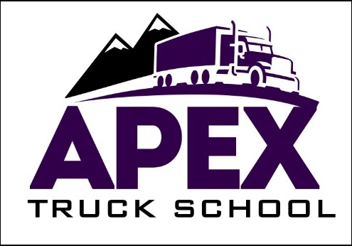

650 Brakke Drive, Suite 103

Hudson, WI 54016

**Wisconsin Curriculum**

Version 1 3.23.18



**APEX Truck School**

**MISSION STATEMENT**

APEX Truck School, a veteran owned business, is dedicated to providing the safest possible programs for new drivers to learn the skills necessary for them to secure employment in the trucking industry. APEX Truck School is owned and operated by Bill Collins, who has over 35 years of experience in the driver training field. Collins hires experienced drivers as instructors and incorporates the latest technology into the training program with state of the art truck driving simulators.

Students are welcomed into a safe environment that creates an opportunity for them to learn at a pace consistent with individual learning styles. A variety of equipment is available to accommodate differing goals of new drivers. Placement guidance is also provided to graduates with a demand for almost 50,000 new drivers nationwide (BLS).

APEX Truck School is a small family owned and operated Limited Liability Company, licensed to provide truck driver training in Wisconsin. APEX Truck School works with a variety of publicly funded and private organizations such as the MIND the G.A.P.P. and the YWCA. Some of our students have been homeless at the beginning of their training and gone on to secure jobs paying up to $33.00 per hour. APEX Truck School is approved by Veterans’ Affairs for those qualified to use their G.I. Bill Benefits to pay for tuition.

MISSION

STATEMENT





**Admission Prerequisites**

* Student must be at least eighteen (18) years of age to drive intrastate & twenty-one (21) to drive interstate.
* Student must have had a valid U.S. driver’s license and experience driving a personal vehicle for at least one (1) year. If the student has a suspended or expired license, they cannot attend until their license is validated.
* Have ability to obtain CDL permit for the class of vehicle in which they will be receiving training.
* Possess a clean criminal history.
* Student must have a social security card.
* Student must have an alien registration card if not a U.S. Citizen.
* Students are required to take and pass a USDOT drug test prior to any training and may be chosen to random drug screen testing during training, as required by the USDOT.
* Have the ability to successfully pass a DOT medical physical and have a current DOT physical card in their possession whenever operating school vehicles. A driver must be in good health and physically able to perform all duties of a driver.
* Federal Motor Carrier Safety Regulations require that commercial drivers speak and read Basic English, understand highway traffic and signals, respond to official questions, and make legible entries on reports and records.
* A Motor Vehicle Report (MVR) and criminal background check will be performed. It is understood that drivers with traffic offense on their driving record (which includes but is not limited to DUI/DWI, speeding tickets, accidents) and/or criminal history of felonies, gross misdemeanors or misdemeanors, will have limited employment opportunities in the truck driving industry. APEX Truck School provides employment placement services for its graduates but cannot guarantee employment.
* Student has read, acknowledged and understands the New Student Registration Process form.
* Student has read and understands the APEX Truck School Pre-Hire Application Form and Training Disclosure Statement. Student has researched the 160-hour course and takes full responsibility for determining this program will best suit their needs & level of previous experience.
* APEX Truck School does not offer credit under Advanced Standing in the 160-hour Professional A Tractor Trailer Program.
* For Veterans receiving VA Benefits: The non-refundable portion of the registration fee will not exceed $10.00.

**Academic Standards**

* Students are graded on a Pass/Fail scale for certificate completion purposes.
* Students will be graded on attendance, textbook chapter tests, pre-trip inspection and driving skills.
  + Attendance is tracked daily in eCampusLynx, student management software database. Each student is issued a name badge upon registration with a secure bar code and must scan time in and out each day they are in attendance.
  + Failing a chapter test will require the student re-take the chapter test and score 70% or higher. Failing the same test twice will result in dismissal from program. Students may appeal their dismissal with a request in writing to the Owner or Office Manager for a meeting to discuss options.
  + The student will be required to do a pre-trip inspection of the vehicle which includes explaining to the instructor what specific components on the vehicle to inspect and why. Each component has a point value assigned and failure to explain the component and its functionality will result in a deduction.
  + Students are required to perform specific basic driving maneuvers including; moving the vehicle forward, backward and turn it within a defined area. Students are also tested on their ability to drive the vehicle in a variety of traffic situations including; left and right turns, intersections, railroad crossing, curves, up and down grades, single and multi-lane roads and highways. Every maneuver has a point value assigned and failure to complete the maneuver satisfactorily will result in a point(s) deduction.
* Students are graded on a percentage scale:

A = 90% or above

B = 80% to 89%

C = 70% to 79%

D = 60% to 69%

F = 59% or lower

* Students that fail the pre-trip and/or driving skills portion of the tests will be required to re-take them until they achieve a passing score. If the student or instructor determines these skills are beyond the student’s capabilities the student may withdraw from the program and a refund will be issued based on the page detailing the Refund Policy.
* Students who fail the road test do not fail the course but will receive the opportunity to re-test before the end of course. Students will receive the opportunity to re-test under the Retest Policy, as detailed on the following page. The student is responsible for any additional testing fees as determined by the WI DMV. The course completion date may be extended accordingly at no cost to provide the student re-test opportunity as scheduling for DMV road tests is may take between 2-4 weeks in advance.
* Any student conduct violation, code violation and/or 2 unexcused absences will be subject to probation. Probation means a student will not be allowed to attend classes or schedule training until APEX contacts the student to arrange a face-to-face meeting with the Administrator or Scheduling Coordinator to discuss options and put together an individual training plan. *Please note an unexcused absence equals missing a scheduled appointment without providing one full business days’ notice to the school or showing up for a driving lesson without a valid Class D driver’s license and valid CDL permit.
* Driver Education programs are approved by the Wisconsin State Educational Approval Board. In accordance with EAB, those rules and regulations, any student who successfully completes the course hours will receive a Certificate of Completion with the exception in the case of non-payment.
* Student GPA is 50% based on participation, which is judged on attendance. When a student attends all required classes and scheduled driving sessions as outlined, they are given a passing grade for participation.
* Percentage grades are given for chapter tests. Per direction from the Department of Public Safety, percentage grades based on correct answers are not reason for refusing a student a completion certificate. Grades on chapter tests are used to compile 50% of final student GPA which will be used for measure of “satisfactory progress” and may be given to some carriers as requested during student verifications for hiring.
* A leave of absence request, for any reason, will be reviewed on a case-by-case basis. The student should submit the request in writing to the Office Manager.
* VA students must complete training within 8 weeks of starting the program.

**Registration Process**

* New Student Registrations are conducted every Monday, a half hour before the start of class or by appointment.
* At registration the student will be required to provide copy of their valid driver’s license and CDL permit, if the applicable. *Note: A CDL permit is not required at registration but strongly encouraged to obtain within the first two-weeks of classes.
* Fill out the *Student Registration* (print legibly) completely.
* Read and sign *Training Disclosure Statement.*
* Tuition is due in full at registration. Accepted methods of payment: cash, check, credit card, money order and WFC (or other third-party funding source) Authorization.
* APEX Truck School will issue study materials upon completion of the above items.
* Drug Screens will be conducted by one of our certified collectors. Results are received by APEX Truck School in 2-4 business days.
* Complete and return the *Pre-Hire Application* to the registration counter.
* Classroom Training begins at 8:00am Monday-Friday.
* APEX Truck School Contracts are printed upon registration. The student must sign their contract before beginning classes.
* **IT IS IMPARATIVE THAT EACH STUDENT READS THE FIRST CHAPTER IN THEIR STUDENT WORKBOOK WITHIN 24 HOURS OF STARTING THE COURSE. THE COURSE ROADMAP IS EXPLAINED AND MANY OF THE FREQUENTLY ASKED QUESTIONS CAN BE ANSWERED BY READING THE FIRST CHAPTER IN THE STUDENT WORKBOOK.**
* Students will receive notification during class from the Scheduling Coordinator when APEX Truck School receives acceptable USDOT drug screen results (usually 2-4 business days after collection). At this time an individualized driving plan will be scheduled.

**Training Objectives**

* APEX Truck School trains students with a progressive program that requires a level of reasonable competence prior to advancement to the next level of training.
* For Class A training, students begin the driver training by learning to back up trailers. Students will practice their backing skills at our facility until such time that they can back up a truck/trailer combination 150’ in a straight line using only mirrors and perform a driver’s side alley dock with a single pull up. When a student has achieved this level of backing competence they will begin on the road training as preparation for the road test in a Class A truck with an automatic transmission. Once a student has passed the state administered road test, training in manual transmission vehicles will be initiated for students enrolled in comprehensive programs.
* **Students need to demonstrate a reasonable level of competence with each type of transmission before moving onto a more complicated transmission.**
* Students will also work with different size trailers starting with a 28’ trailer and progressively working up to the larger trailers as the student progresses.
* The primary objective of our training system is safety. The safety of our students, our staff, and the public is paramount and will not be compromised. Some students may not progress as rapidly as they would like and not all students will achieve the level of training they might hope for. Our staff will put forth our best effort to provide as much training as possible within our safety policy.

### 

### **Training Objectives**

**Drug Screen & DOT Physical**

In order to allow the student to drive one of our trucks they must first successfully pass a USDOT controlled substance test. The collection is done here on campus. We will normally receive the results from the lab within 3 business days.

It is highly recommended that the student obtains a USDOT physical to make sure they are physically qualified to be a truck driver. Students do not need to have a USDOT health card with them when they take their driving lessons unless they are being paid by a firm while attending. Students will need the USDOT physical once they pass their skills exam and are ready to upgrade to the Commercial Driver’s License, if they want to earn income as a commercial driver.

Dr. Dan Buettner with Quality Physicals provides the USDOT physical to APEX Truck School students every Monday afternoon at the 499 Villaume Avenue address by appointment. The cost for the physical is included in the price of the program. Appointments may be scheduled by calling Dr. Dan @ 612-227-2746 or online @ [www.qualityphysicals.com](http://www.qualityphysicals.com). *Note: Make sure to keep the three-page report from the USDOT physical. Most employers will require it for review.

**Training Objectives**

**Classroom Training**

Classroom education meets Monday through Saturday. Classes are in session from 8:00 a.m. to noon (Wednesday’s classes go until 4:00p.m.) There are nine different classes in rotation. Students beginning on Mondays will complete the classroom instruction in two weeks. Tuesdays and Thursdays offer additional optional training from 1:00pm-3:00pm.

|  |  |  |  |  |  |  |
| --- | --- | --- | --- | --- | --- | --- |
| **Monday** | **Tuesday** | **Wednesday** | **Thursday** | **Friday** | **Saturday** | **Sunday** |
| 8:00-12:00 | 8:00-12:00 | 8:00-4:00 | 8:00-12:00 | 8:00-12:00 | 9:00 3:00 | **Closed** |
|  | 1:00-3:00 Permit Prep |  | 1:00-3:00 Haz Mat  Prep |  |  |  |

Students need to attend each of the classes. The program is structured to accommodate unlimited classroom attendance of any or all classes to ensure complete understanding and competency of the subject material. Students do not need to attend the classes in sequence as classes are offered in rotation.

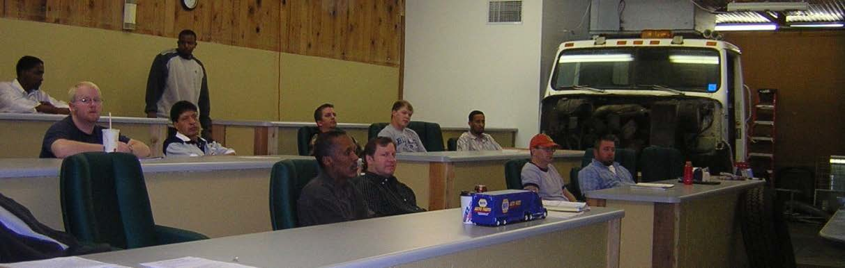

**Training Objectives**

**Text Study**

Each student is provided a Textbook to keep when enrolled in the 160-hour program. The book covers everything a student needs to know about driving a semi-truck. APEX Truck School encourages students to conduct independent coursework at the school in order to credit their time towards the program. Students should study at their own pace and answer the test questions at the end of each chapter. If there are any questions or concerns regarding any of the material covered in the textbook, please ask one of the instructors for assistance. Once a chapter test is completed the student should turn the test into the Office Manager to score. Upon completion of all chapter tests a final exam will be given. This final exam determines the student’s grade point average.

**Veterans using GI Bill Benefits, see the Office Manager for specific text study schedule.

**Training Objectives**

**Computer Based Study**

There are a number of training videos, tutorials and reviews available to our students in our Student-Use Computer Labs. These computers are first-come, first-serve and are restricted to training and job-search activities. Any time spent in the Student-Use Computer Labs will count as credit toward Course Work hours. Check with the Online Training Coordinator for computer-based projects if needed.

Available training videos and supplemental training aids:

* Practice DMV Class A and B Permit Tests
* Practice DMV Endorsement Tests
* Permit Test Prep
* Pre-Trip Inspections
* HazMat Training
* CDL Permit Training
* Wisconsin CDL Manual
* Accident Reduction – A Better Way
* Air-Brake Training
* Hours of Service
* Backing Maneuvers
* Additional videos and training available upon request

**Training Objectives Simulator Training**

Our *state of the art* Truck Driving Simulator will help students to learn how to shift

using the double clutch method that many trucking companies want new drivers to

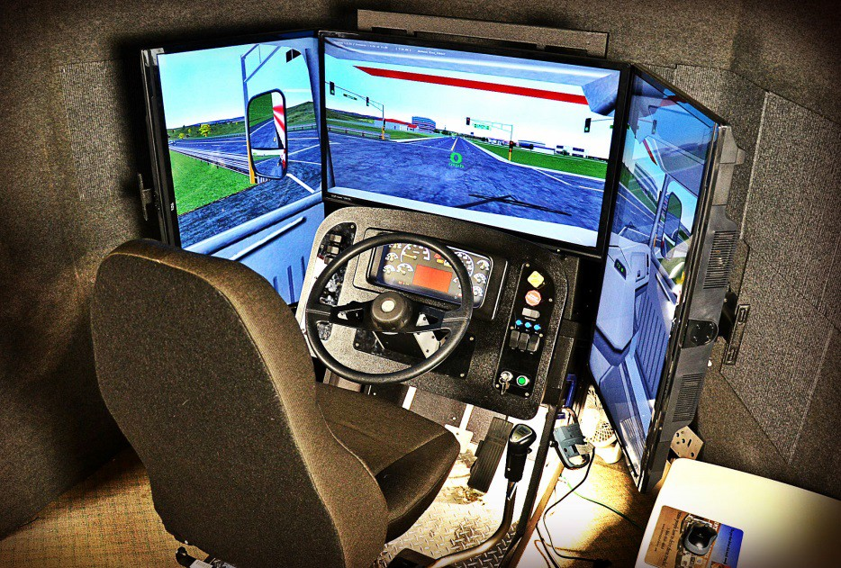

use. The simulator can also help

people learn backing and

maneuvering skills. Various driving

conditions and weather conditions

can be simulated. Time spent on

simulator training counts toward

coursework.

**Training Objectives**

**Backing Range Training**

In order to pass the CDL road test each student will need to demonstrate that they have mastered three different backing maneuvers.

* The straight-back: back up 140 feet in a straight line using just the mirrors
* The offset back: equivalent to a passenger vehicle parallel park maneuver
* The alley-dock: back into a parking spot that is 90 degrees to the driver’s side.

APEX Truck School encourages every student to spend as much time as the program allows on the driving range. When the student is certain they can perform the three maneuvers successfully that are a part of the CDL road test the student should inform the Scheduling Coordinator. At this point the Scheduling Coordinator will set up the next step of training which is one-to-one driving with an instructor in one of the school’s test trucks. The direct number to contact the Scheduling Coordinator is 651-444-1002.

After the student has passed the CDL road test APEX Truck School has the student perform additional backing maneuvers with longer trailers in real-world situations.



**1-on-1 Driving Instruction**

Each student will need to make an appointment with the Training Coordinator, Pat Ackerman (651-444-1008), for range practice and driving lessons. It is very important for the student to remember that when an appointment is made the student must give the office one full business days’ notice if the student needs to cancel the lesson. If a student fails to provide appropriate notice they will be charged that time against their allotment of one-on-one driving hours. Students are also required to bring their valid Class D drivers’ license and valid CDL permit with them for each driving session. Failure to bring the license and permit will also be counted as a charge against their one-to-one driving allotment.

It is the primary objective of APEX to keep all students and everyone else on the road safe!!!!! The system used at /APEX is very effective and it works. APEX encourages all students to spend as much time on the simulator as necessary to become very proficient with the double clutch shifting process.

**Observation**

It can be helpful for new drivers to ride along to observe what other student drivers are experiencing. Students will receive credit for all hours riding in the trucks. Observation time is only available when all parties agree (student and instructor). It is important to keep in mind that when a student is riding in the back for observation purposes, they should be mindful that the instructor will be focusing their attention on the student that is driving. Student observers will not be permitted to interfere with the driving lesson process and thus will need to be reasonably quiet while riding in the back. If a student observer has any questions about what is going on, the student should write them down and ask the instructor later when the truck is parked. The next student driver and student observer will follow the same instruction and be shown the same courtesy.

**Lesson Plan -Training Programs**

**READ THROUGH THE ENTIRE LESSON PLAN AS SOON AS POSSIBLE**

**Professional Class A 200-Hour Manual Transmission Tractor-Trailer Program:**

**There are 5 components to the training:**

* Classroom Training (10 hours minimum) *Please see attached curriculum
* Textbook and Course Work (100 hours minimum) *Please see attached curriculum
* Backing range practice (30 hours minimum)
* One-To-One Training (up to 20 hours)
* Simulator Training (40 hours minimum)

**Professional Class A 160-Hour Automatic Transmission Tractor-Trailer Program:**

**There are 5 components to the training:**

* Classroom Training (10 hours minimum) *Please see attached curriculum
* Textbook and Course Work (100 hours minimum) *Please see attached curriculum
* Backing range practice (20 hours minimum)
* One-To-One Training (up to 16 hours)
* Simulator Training (20 hours minimum)

**Intermediate Class A 120-Hour Manual Transmission Program**

**There are 5 components to the training:**

* Classroom Training (10 hours minimum) *Please see attached curriculum
* Textbook and Course Work (60 hours minimum) *Please see attached curriculum
* Backing range practice (20 hours minimum)
* One-To-One Training (up to 12 hours)
* Simulator Training (30 hours minimum)

**Intermediate Class A 100-Hour Automatic Transmission Program**

**There are 5 components to the training:**

* Classroom Training (10 hours minimum) *Please see attached curriculum
* Textbook and Course Work (60 hours minimum) *Please see attached curriculum
* Backing range practice (20 hours minimum)
* One-To-One Training (up to 10 hours)
* Simulator Training (20 hours minimum)

**Professional Class B 90-Hour Manual Transmission Program**

**There are 4 components to the training:**

* Classroom Training (10 hours minimum) *Please see attached curriculum
* Textbook and Course Work (60 hours minimum) *Please see attached curriculum
* One-To-One Training (up to 10 hours)
* Simulator Training (20 hours minimum)

**Professional Class B 70-Hour Automatic Transmission Program**

**There are 4 components to the training:**

* Classroom Training (10 hours minimum) *Please see attached curriculum
* Textbook and Course Work (60 hours minimum) *Please see attached curriculum
* One-To-One Training (up to 8 hours)
* Simulator Training (10 hours minimum)

**Detailed information about each component is available in the next section of the Student Workbook, under Training Objectives.**

**Step 1:** Enroll and submit to a DOT Drug Screen.

**Step 2:** Make an appointment thru Quality Physicals for a DOT Physical. DOT Physicals are required for the CDL permit and license (Appointment can be made at any point in the first week of training) Contact information is available at the front counter.

**Step 3:**

1. Complete any written tests to obtain a valid Wisconsin CDL permit. Written tests are submitted at any Wisconsin Department of Motor Vehicle office.
   * Classroom sessions begin on Mondays at 8:00 am. Classes can be repeated as often as the student feels is necessary to understand the subject. The student will get credit for each time they attend.
   * The air brake/pre-trip class should be repeated several times. It is a crucial portion of the CDL road test. The Hours of Service class is also complex and worth repeating.
2. Students should complete as many pre-hire job applications as they can. Please ask one of the office staff to fax. After review of the pre-hire application the carrier will contact the student directly by either phone or email.

**Steps 4, 5 and 6: All Three Components of Training listed in Steps 4, 5 and 6 can be worked on during the remainder of the program congruently.**

**Step 4:** Once the office has received a students’ successful DOT Drug Screen and has a copy of their valid CDL permit on file, the Training Coordinator will contact each student individually to arrange an appointment to create their training schedule.

**Step 5:**

1. Textbook study is independent and should begin immediately to ensure all the students training hours are completed once they have passed the CDL road test (any time spent at the school counts toward program hours).
   * Answer all the quiz questions in the Text Book Chapters. If there is anything the student is unsure about ask one of the instructors.
2. The student needs to make sure they are scanning their name badge whenever they are at the school, it all counts toward program hours.
3. When the student has completed the study of the textbook, then they can take the final exam on the information in the textbook (100 questions). When the student has finished their test, please turn it into the Office Manager for correction.

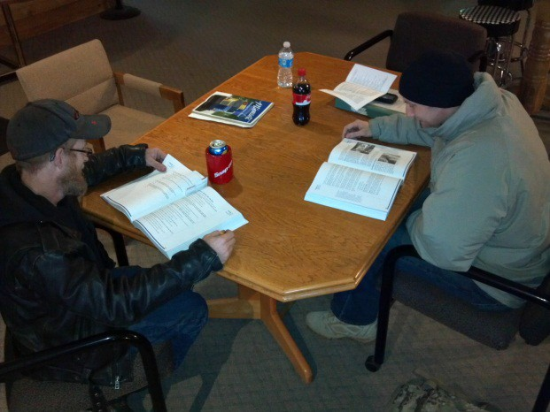

**Academic Probation**

To remain in good standing a student must:

1. Attend a minimum of 20 hours of classroom education each week for the first two weeks of the program.
2. Not miss any scheduled training appointments or be more than 15 minutes late to any scheduled appointments.
3. Be responsible to meet with the Training Coordinator to reschedule any missed training appointments prior to CDL road test.
4. Student must provide the APEX Truck School office one full business days’ notice if he/she is going to miss classes or scheduled appointments. The Office contact number is 651-735-9250.
5. Student must have in their possession for each driving lesson a valid CDL permit and valid state driver’s license. Students who do not bring their CDL permit or driver’s license with them for driving lessons will have their schedule canceled and will need to reschedule.

**Alcohol & Drug Use**

Students are not allowed to use alcohol within 24-hours of a driver training session. Students are not allowed to use any controlled substances not authorized by a medical physician during the duration of training at APEX Truck School. Students are subject to USDOT drug and alcohol testing rules for pre- employment, random, reasonable suspicion, and post-accident tests. Violations of this policy will result in immediate dismissal.

**Attendance**

* Students enrolled in any of the training courses are expected for the first two weeks to attend daily classes.

* Students are responsible to log in anytime they are attending school using the eCampus Lynx bar code reader system. Office staff reviews log-in data daily. Students who are enrolled but do not attend classes within the first three days and have not contacted the school directly will be contacted via email or phone. If the student does not respond he/she may be considered as withdrawn from the program. A letter requesting verification of enrollment status will be sent to the student. Please note: Veterans receiving VA Benefits through the GI Bill should confirm weekly attendance hours with APEX Truck School staff to make sure hours are being recorded properly.
* Any student who has not attended a minimum of 20 hours of classes each week for the first two-weeks will not be scheduled for additional training; backing range, simulator or one-to-one instructor.
* Students who are not meeting academic standards will be contacted directly by the Office Manager to determine next steps for the student to successfully complete the course. Options include possible online training, mentoring, additional videos of specific classes, and flexibility with scheduling if necessary.
* Appointments for driving sessions are made exclusively with the Scheduling Coordinator, not directly with the instructor. Students will receive a written confirmation of their appointment time and location.
* Students are required to provide the office one full business days’ notice (not counting Saturdays and Sundays) in advance to cancel any appointments for training in school vehicles. Failure to provide one full business days’ notice will result in a loss of those scheduled training hours. For students using GI Bill benefits for tuition; two unexcused absences from driving appointments will result in termination from the program.
* Students are required to attend each classroom session. Should a student miss a classroom session he/she should contact the classroom instructor to determine the date a session will come up again on the schedule.
* A certificate of completion for any training program will not be issued before the student has logged the hours designated in the course and received verification by APEX Staff/Instructors.
* Students requesting a leave of absence must submit this request in writing to the Office Manager. Leave of absence will be reviewed on a case-by-case basis.

**Student Records**

State and Federal regulations require APEX to report specific information to regulatory agencies and APEX does comply with these reporting mandates.

Student records are stored in locked files and kept confidential. Student records are maintained for 6 years from the last date of activity.

Student transcripts are scanned and kept permanently. Students will be provided copies of all records when requested in person and in writing with photo identification in our South St. Paul office.

USDOT regulations do require APEX to report drug test results to USDOT regulated firms considering employment of APEX students with student permission.

No other information concerning student information will be provided to any person or agency without express written request from the student wishing to share such information.

**Student Rights**

* The classrooms, training equipment, and facilities of APEX are essential to the learning environment. The freedom to learn in these environments is promoted by all APEX staff. Students have the right to access the faculty, academic technology, classrooms and other necessary resources for learning and training; have the right to access academic advising and clear expectations for completion; have decisions related to the pursuit of their training made clear; learn in an environment that encourages freedom of self-expression; participate in an exchange of ideas, pursuant with their constitutional rights and free of conduct that impedes an instructor’s ability to teach or the student’s ability to learn.
* Students have the right to receive a copy of the training syllabus in a timely manner; expect to interact with instructors who act professionally; provide clear stated goals and expectations; meet on time for reserved appointments; are accessible during regular business hours; expect a staff member or instructor to be sensitive to a student’s religious beliefs, and observances, and, upon notice, make reasonable accommodations for those observances.

* Students have the right to expect to learn, train, and interact in an environment of professionalism and mutual trust and respect that is free of amorous or sexual advances by a staff member or instructor. All amorous or sexual relationships between a student and staff member or instructor are unacceptable when the staff member or instructor have any professional responsibility for the student, even if both parties have consented, or appear to consent to the relationship.

* Students have the right to learn, train, and interact in an environment free of any discrimination that is in violation of the law. Students are expected to respect the rights and dignity of other students, staff members and instructors.

**Student Parking**

APEX location in Hudson, Wisconsin at 650 Brakke Drive, Suite 103 offers private student parking. APEX does not assume any responsibility for loss or damage to student vehicles or the contents of those vehicles when parked at the school.

**Student Dress Code**

Students are advised to dress according to prevalent weather conditions. Students will be expected to perform pre-trip inspections of the training vehicles on every training session and should dress accordingly, especially in cold or wet weather.

Students are encouraged to wear work boots whenever driving school vehicles. Open toed shoes and sandals are not allowed when driving school vehicles. Loose fitting clothing should not be worn around commercial vehicles.

Students are encouraged to wear gloves whenever performing pre-trip inspections, hooking and dropping trailers, or performing any mechanical functions outside of the vehicle. Sunglasses and brimmed hats are recommended on sunny days. Students are required to wear closed-toe shoes when driving any of the school vehicles. Students who are not wearing appropriate apparel will not be allowed in school vehicles.

**Student Conduct**

The code of student conduct is established to promote and protect APEX students in a safe and secure environment, and to protect the people, properties, and processes which support APEX. The code governs all students enrolled in training programs with APEX. Students continue to be subject to city, state, and federal laws while training at APEX and violation of those laws may also constitute violation of the codes.

As used in the code, the reference “APEX” means all land, buildings, trucks, trailers, equipment and facilities own, leased or operated by APEX.

The term student refers to an individual who has paid for and been accepted into a training program(s) or otherwise entered any contractual relationship with APEX to take instruction. Student status lasts until the individual graduates, is dismissed, or does not show up for a scheduled training/instruction appointment without making any attempt to provide the office one full business days’ notice of a missed appointment.

Members of APEX include, but are not limited to, students, instructors, staff and visitors to the training locations.

**Prohibited Conduct**

**Attendance:**

Enrolled Students who do not attend a minimum of 20-Hours per week for the first two-weeks of school will be considered delinquent and may be dropped from the program.

**Academic misconduct:**

Includes any activity that tends to compromise integrity or subvert the training and instruction process. Aggressive operation of the training vehicles will not be tolerated. Trucks are to be driven safely always and in such a way as to not risk damage from abuse. Observers will not interfere with the training of the student behind the wheel. Loud conversations & cell phone use is prohibited.

**Endangering health & safety:**

Taking or threatening action that threatens or endangers the safety, physical or mental health, or life of any person, whether intentionally or because of recklessness or gross negligence.

**Sexual misconduct:**

Any physical contact or non-physical contact of a sexual nature in the absence of clear, knowing and voluntary consent. For the purposes of this rule, consent shall be defined as the act of knowingly and voluntarily agreeing verbally or non-verbally to engage in sexual activity. An individual cannot consent who is obviously incapacitated by any drug or intoxicant; or who has been purposely compelled by force, or deception; or who is unaware that the act is being committed; or whose ability to consent or resist is obviously impaired because of a mental or physical condition; or who is coerced by a supervisory or disciplinary authority.

**Acts of dishonesty:**

Dishonest acts may include, but are not limited to, furnishing false information distortion, or misrepresentation including forgery, alteration, or misuse of any document, record or instrument of identification to any APEX Truck School staff member or instructor.

**Telephone harassment:**

Telephone harassment includes, but is not limited to, making calls containing lewd or obscene remarks; making calls intended to harass; making the telephone ring repeatedly with intent to harass; making repeated calls in which conversation ensues solely to harass.

**Conduct that is disorderly, lewd, or indecent:**

Disorderly, lewd or indecent conduct, includes, but is not limited to, breach of peace; or aiding, abetting, or procuring another person to breach the peace of any staff member, instructor or student of APEX Truck School on site.

**Destruction of property:**

Actual or threatened damage to or destruction of APEX Truck School property or property of others, whether done intentionally, or with reckless disregard.

**Dangerous weapons or devices:**

The use, storage or possession of dangerous firearms, explosives, weapons, or dangerous chemicals or devices per Minnesota Rules Chapter 7411and Wisconsin Rules 948.60(1) prohibits firearms in driver training vehicles and classrooms.

**Theft/unauthorized use of property:**

Theft or attempted theft, or unauthorized use possession of APEX Truck School property, or services, or the property of others.

**Failure to comply with APEX Truck School or civil authority:**

Failure to comply with legitimate directives of authorized APEX Truck School staff or instructors, law enforcement or emergency personnel, in the performance of their duties, including failure to identify oneself when requested; or violation of the terms of a disciplinary sanction.

**Drugs & alcohol:**

The use, production, distribution, sale or possession of drugs or alcohol in a manner is prohibited under law.

**Unauthorized presence:**

Any unauthorized presence to or entrance in or on APEX Truck School premises

**Disorderly or disruptive conduct:**

Disorderly or disruptive conduct that unreasonably interferes with APEX Truck School training and/or instruction.

**Code Violation Procedure** 

Person(s) witnessing or experiencing what they believe to be a possible code violation should provide the office manager or owner of APEX Truck School with the information.

The office manager or owner will proceed to investigate the matter. Upon completion of the investigation, the investigator will decide upon an appropriate course of action, which may include, but is not limited to, taking no further action, deferring further actions with or without conditions, or initiating charges with the appropriate authority.

Disciplinary sanctions may include suspension or dismissal from the program.

Students may appeal a decision to dismiss with a request in writing to the owner. The owner may reverse the dismissal decision based on specific conditions that will be determined and agreed to in writing by the student and owner.

**Refund Policy**

Student will receive a full refund of all money paid if the student:

1. Cancels within the three-business-day cancellation period under EAB 6.04. Student will be presented form 1.07 Student’s Right to Cancel;

2. All fees are refundable in the event the student drops or withdraws from the program within 3-business days.

3. Accepted was unqualified and the school did not secure a disclaimer under EAB 9.04;

4. Enrollment was procured as the result of any misrepresentation in the written materials used by the school or in oral representations made by or on behalf of the school.

5. Refunds will be issued within 10 business days of the student who drops or withdraws from the

course.

A student who withdraws or is dismissed after attending at least one class, but before completing 60% of the instruction in the current enrollment period, is entitled to a pro rata refund as follows:

***At Least but less Than Refund of Tuition***

|  |  |  |
| --- | --- | --- |
| ***1 unit/hour of training/instruction*** | ***10%*** | ***90%*** |
| ***10%*** | ***20%*** | ***80%*** |
| ***20%*** | ***30%*** | ***70%*** |
| ***30%*** | ***40%*** | ***60%*** |
| ***40%*** | ***50%*** | ***50%*** |
| ***50%*** | ***60%*** | ***40%*** |
| ***60%*** | ***No*** | ***No Refund*** |

**If *MORE* than 60% of the training has been completed: NO REFUNDS WILL BE ISSUED.**

As part of this policy, the school may retain a one-time application fee of no more than $100. The school will make every effort to refund prepaid amounts for books, supplies and other charges. If a student withdraws after completing 60% of the instruction, and withdrawal is due to mitigating circumstances beyond the student’s control, the school may refund a pro rata amount.

* **If a student wishes to withdraw from training and cancel his/her contract the following policies apply:**
* Requests for withdrawal: Written notice is not required but may be addressed to the South St. Paul corporate office via mail (499Villaume Ave, South Saint Paul, MN 55075), fax (651-735-9130) or email ([office@apexdriving.com](mailto:office@apexdriving.com)).
* Refunds are issued only to original payer (not student when paid by another party) except when tuition is paid by VA and VA instructs refund to student. Credit card payments will be credited to account used for payment (no exceptions).
* If training is not completed within 90 days, there will be an additional charge for a new drug screen.
* For Veterans receiving VA Benefits: The non-refundable portion of the registration fee will not exceed $10.00. The drug testing fee of $150.00 is non-refundable once a student has completed the USDOT drug screen. All other charges to the student including tuition, books and supplies issued by APEX Truck School, will not exceed the pro-rata portion of total charges that the length of the completed portion of the course bears to the total length of the course.
* For Veterans receiving VA Benefits: There may be penalties for cancellation and/or financial obligations to VA for refunded balance**.**

***\*SUBJECT TO CHANGE PER APPROVAL OF EAB AT ANYTIME WITHOUT NOTICE\****

**Student Complaints**

The Educational Approval Board (EAB) has the authority, under EAB 4.08(2), to investigate a student complaint, negotiate a settlement, or dismiss a complaint if it is found to be inappropriate. The following information is intended to help students file a complaint about a school that the EAB regulates.

Before the student files a complaint with the EAB, state law requires that they try to resolve the matter with the school. Every EAB approved school has a process to resolve student complaints. Please contact the Office Manager if there are any complaints regarding the school. If the matter is not resolved, the student may file a complaint with the EAB using the attached Student Complaint form.

Complaints must be filed within one year after the student's last recorded date of attendance. Upon receiving a student complaint, EAB investigates it. If preliminary findings indicate a violation by a school, the EAB shall attempt, through mediation, to resolve the complaint. If no agreement is reached, the EAB may dismiss the complaint or conduct a hearing. Under Wisconsin's Open Records Law (Wis. Stats., Ch. 19), complaints will generally be available for review on request from a member of the public after the EAB has acted.

Please Contact:

Educational Approval Board, 431 Charmany Drive, Suite 102

Madison, WI 53719. Ph: 608-266-1996 Fax: 608-264-8477 [eabmail@eab.wisconsin.gov](mailto:eabmail@eab.wisconsin.gov)

**Our People**

**Dedicated to Your Success**

* Owner/General Manager: Bill Collins
* Director of Training/Scheduling: Pat Ackerman, Jr.
* Director of Admissions/Media: Josh Winger
* Administrative Specialist: Matt Hacker
* Office Manager/Paralegal: Melissa Collins
* Administrative Assistant: Melissa Hacker
* Fleet Supervisor: Pat “Trick” Stair
* Shop Mechanic: Preston Molvig

Instructors

* + Gary Allman; licensed instructor
  + Bob Christensen; licensed instructor/former state examiner
  + Paul Holmquist; licensed instructor
  + Tim Hoskin; licensed instructor (WI)
  + Phil Kampa; licensed instructor
  + Mark Sanders; licensed instructor/former state examiner
  + Sam Winger; licensed instructor

**Organizational Information**

APEX Truck School works alongside it’s MN counterpart with 2 locations:

* The MN corporate office and training facility is located at 499 Villaume Ave, So. St. Paul, MN. This main campus covers 5148 square feet indoors, a 1-acre parking lot and a 2+ acre private yard where the Practice Backing Range is located. The classroom space is 1500 square feet.
* The Wisconsin training facility is located at 650 Brakke Drive, Suite 103, Hudson, WI 54016. The classroom space of 1068 square feet to train up to twenty students.
* Interstate Truck Driving School in Minnesota was founded by William (Bill) Collins in March of 1998 to provide the training necessary to obtain employment as a professional truck driver. Bill continues to be the sole owner and operator of the school. Bill is responsible for the day to day operation of the school. Apex Truck School is the Wisconsin extension of the training.

**Training Equipment**

Students are trained on a combination of automatic and manual transmission tractor trailers. Training vehicles located at the Hudson, WI location include:

* 2 manual 6-speed transmission Class A semi-tractors (WI)
* 2 automatic transmission Class A semi-tractors (WI)
* 1 manual 6-speed transmission Class B truck (WI)
* 1 automatic transmission Class B truck (WI)
* 4 28-Foot Pup Trailers (WI)

**Employment Services**

**Job Placement Job Placement**

Job Placement services are provided free of charge to APEX Truck School students. There are several options for those students seeking employment.  We work closely with many trucking companies recruiting our students. We try to have our various recruiters visit the school almost daily to explain employment opportunities at their businesses. These recruiters make time for question and answer sessions with our students. We deal with recruiters looking for local and over-the-road truck drivers. We screen and hand- pick only the best companies for our students.

APEX Truck School currently works with over 40 recruiters from various carriers who visit our campuses on weekly basis. These recruiters use this time to present various job opportunities offered at their businesses. Recruiter visits give students the chance to meet face-to-face to discuss job openings and ask specific questions about the company. Recruiters can provide detailed information.

Most of the companies we work with will accept a pre-hire application.  A pre-hire means the student fills out paperwork from the carrier before they even start their training and before receiving the CDL license.  These companies will provide students a written job offer based on the truthfulness of the application and completion of training with a CDL license in hand.  This system provides the student with the security of knowing they will have a job upon successful completion of the training program.

Our Director of Admissions and Senior Sales Director work closely with state workforce centers to post and attend job fairs throughout the state.

APEX Truck School has an active job boards located at both the South Saint Paul, MN and Hudson, WI locations. All potential employers are screened prior to posting any employment opportunities.

APEX Truck School offers all enrolled students a current recruiter list which contains the name and type of the trucking company, their website, and name and direct number for the recruiter.

The APEX website @ [www.apexdriving.com](http://www.apexdriving.com) offers many additional suggestions and ideas for those seeking employment opportunities.

***\* APEX Truck School does not guarantee employment\****



**APEX Truck School**

**650 Brakke Drive, Suite 103**

**Hudson, WI 54016**

**651-735-9250**

[**www.apexdriving.com**](http://www.interstatedriving.com)