APEX TRUCK SCHOOL
650 BRAKKE DRIVE, SUITE 103 HUDSON, WI 54016
Toll Free 1-866-860-4664
Fax: 651-735-9130
Email: CDLTests@aol.com website: www.apexdriving.com

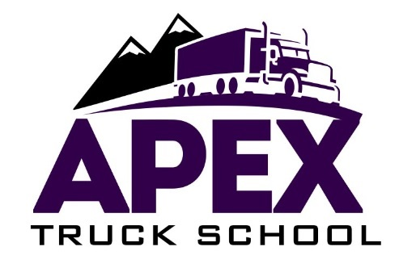

First Name | Middle Name | Last Name | DOB | Cell Phone #
Contract # | Start date | Address | City, State | Zip
CDL # | Permit Class & Date | WI DL # | Expiration Date | Home / Work #

Course: ________________ Fee: __________ Location: WI

CONTRACT TERMS
- Wisconsin Department of Public Safety Rules requires a contract be completed before any instruction is given.
- This agreement constitutes the entire contract between Apex Truck School and the student, verbal statements or promises are not binding.
- Appointments for training or road tests may be canceled without charge with one full business days’ notice provided during normal business hours (Monday through Friday 8AM to 4PM.
- Appointments are binding if one full business days’ notice is not given; student is obligated to pay for time scheduled when on full business days’ notice is not given.
- The school makes no guarantee that student will be placed in a position of employment after completion of training.
- Student agrees to allow Apex Truck School to video and/or audio tape during any training or use of Apex Truck School trucks.
- Apex Truck School will not charge more than $150 for each full CDL skills test: $50 for Vehicle Inspection, $50 for Basic Control Skills, $50 Road test.
- Please refer to the back page for Apex Truck School Refund Policy.

__________________________________________________________ _____________________________________________________________
STUDENT SIGNATURE Date Authorized Program Official Date

Date | Payment Received | Form of Payment

Effective: 2/19/2018

APEX TRUCK SCHOOL
650 BRAKKE DRIVE, SUITE 103 HUDSON, WI 54016
Toll Free 1-866-860-4664
Fax: 651-735-9130
Email: CDLTests@aol.com Website: www.apexdriving.com

Refund Policy

Student will receive a full refund of all money paid if the student:
1. Cancels within three-business-days.
2. Enrollment was procured as the result of any misrepresentation in the written materials used by the school or in oral representations made by or on behalf of the school.
3. Refunds will be issued within 30 business days for any student who drops or withdraws from the course.
4. Apex Truck School will not refund any tuition or part of tuition if the school is ready, willing and able to fulfill
its part of the Agreement.

A student who withdraws or is dismissed after attending at least one class, but before completing 60% of the instruction in the current enrollment period, is entitled to a pro rata refund as follows:
At Least but less Than Refund of Tuition
1 unit/hour of training/instruction | 10% | 90%
10% | 20% | 80%
20% | 30% | 70%
30% | 40% | 60%
40% | 50% | 50%
50% | 60% | 40%

Apex Truck School will not refund any tuition or part of tuition if the school is ready, willing and able to fulfill its part of the agreement".

As part of this policy, the school may retain a one-time application fee of no more than $100. The school
will make every effort to refund prepaid amounts for books, supplies and other charges. A student will receive the refund within 30 business days of written request to terminate. If a student withdraws after completing 60% of the instruction, and withdrawal is due to mitigating circumstances beyond the student’s control, the school may refund a pro rata amount.
- If a student wishes to withdraw from training and cancel their contract the following policies apply:
Requests for withdrawal: Written notice is required and must be addressed to Apex Truck School, 650 Brakke Drive, Suite 103, Hudson, WI 54016 or in writing by fax: 651-735-9130 or email at office@apexdriving.com.
- Refunds are issued only to original payer except when tuition is paid by VA or VA instructs refund to student. Credit card payments will be credited to account used for payment (no exceptions).
- If training is not completed with 90 days, there will be an additional charge for a new drug screen.
- Veterans receiving VA benefits: the non-refundable portion of the registration fee will not exceed $10.00. The drug testing fee of $150.00 is non-refundable once a student has completed the USDOT drug screen. All other charges to the student including tuition, books and supplies issued by Apex Truck School will not exceed the pro-rata portion of total charges that the length of the completed portion of the course bears to the total length of the course. There may be penalties for cancellation and/or financial obligations to VA for refunded balance.

*This constitutes the entire agreement between the school and the student and no verbal statement or promises will be recognized.

Agreed to by: _________________________________ Date: _____________

Effective: 2/19/18

