

Academy of Art University  
Online Component Overview

2018

Table of Contents

Online Education at Academy of Art University 4

Alignment of Degree Programs Onsite and Online 4

Online Course Approval 5

Online Course Development 5

Online Course Improvement 5

Faculty Involvement 6

Conceptual Design of Online Courses 6

Online Academic Roles and Qualifications 6

Student Access to Faculty 6

Services in Support of Online Learning 7

Student Access to Support Services 7

Monitoring Effectiveness 7

Course-Level Assessment 7

Grading 7

Student Course Evaluations 7

Program-Level Assessment 8

Annual Assessment Data 9

Program Review 9

Spring Show 9

Presidential Advisory Board 9

Online Retention 9

Online Enrollment 10

Online Resources and Planning 11

External Evaluation 11

Internal Evaluation 11

Improvements to the Learning Management System 12

User Home Page 12

Attendance Tracking 14

Art Supply Lists 14

Degree Breakdowns 14

Software 15

Class Discussion Redesign 15

Mobile 23

Bring the University Together: Online + Onsite Campuses 23

Notifications 25

Synchronous in the Online Classroom 25

Integrated Gradebook 25

Lessons from Delivering Online Learning 29

Appendices

1. Online Class Components 32
2. Faculty and Support Staff for Online Programs: Roles and Qualifications 35
3. Using Technology to Improve Teaching and Learning 40
4. Student Access to Support Services Online 44

Online Education at Academy of Art University

Since 2002, the Academy of Art University has been committed to an educational model that offers students both onsite and online delivery of art, design, and communications curricula. This dual delivery system of virtually identical programs was fully in place at the time of the Academy’s initial WSCUC accreditation in 2007. Currently, most courses that can be taken onsite have been translated to the online environment. For Academy students, these classes represent the same content and quality as onsite classes, with more flexibility. Two-thirds of all Academy students now complete at least some of their coursework online, and approximately one-third complete all their classes online.

The Online Education Department has developed a proprietary Learning Management System (LMS) designed for teaching art and design online. Online education facilities include development, staging, and production environments. A 24/7 Help Desk is available for online students and faculty. Online Education also provides support for live two-way video/audio graduate midpoint and final reviews, portfolio reviews, class presentations, instructor and director online office hours, online student Town Hall meetings, and online faculty meetings. All servers are located on Amazon Cloud, staged in multiple geographic regions for protection against regional outages. All systems are clustered on redundant servers and load-balanced for optimal performance and failover. A professional outside development company handles 24/7 server administration and monitoring.

Alignment of Degree Programs Onsite/Online

The Academy has ensured alignment of online offerings with onsite offerings in the following ways:

* It is university policy that academic programs shall be offered both onsite and online wherever possible (subject to accreditation approval for new online programs).
* Program design, mission and objectives, and program and course learning outcomes for each academic program are identical.
* In many cases, online classes are designed, taught, and continually improved by the same faculty members who teach the classes onsite.
* Online directors or coordinators (faculty) work with academic department directors to oversee the onsite and online versions of the same program.
* The online learning environment uses innovative technology to mirror the onsite campus learning environment.
* Extensive academic support systems are offered equally onsite and online. (These services were commended by WSCUC Visiting Teams in 2005, 2007, and 2014.)

WSCUC Visiting Team Reports and the official *WSCUC Commission Letter on Initial Accreditation* (May 2007) commended the quality and innovation of the Academy’s online program*.* Visiting peer review teams from National Association of Schools of Art and Design (NASAD) and Council on Interior Design Accreditation (CIDA) have also officially recognized the effectiveness of the Academy’s online delivery of academic programs (*NASAD, 2006 site visit for online education; CIDA, 2008 reaccreditation visit for Interior Architecture and Design program*). CIDA approved the Academy of Art University as the first school in the nation to offer an online, programmatically-accredited BFA degree in Interior Architecture and Design. In 2012, CIDA approved the MFA degree in Interior Architecture and Design, for both on-campus and online.

*Online Course Approval*All courses developed online have first been approved for on-campus delivery by the Chief Academic Officer. The approval process mandates specific and measurable course learning outcomes, explicit assessment strategies, and department-approved course content. The intended course learning outcomes, syllabus, course content, assessment features, and pace of learning are the same for onsite/online courses and are determined by the faculty and academic department directors.

Online courses are reviewed and approved by the faculty member, the academic department director or online director/coordinator, and the relevant Online Education staff members before the course goes live. The overall online build and course approval process is overseen by the Vice President of Online Education, working with the online academic director/coordinator. Course rebuilds are also approved through the same channels.

*Online Course Development*The Online Education Department provides substantial resources and ongoing quality assurance practices for the development, approval, and refinement of online courses.

Academic departments use an online form in our Learning Management System to request new online class builds or for rebuilds of existing online classes that need updating. These requests are vetted by the Online Education Department, which then either approves the request or, if necessary, contacts the academic department for more details on the specifics of the build.

Before developing an online course for the first time, faculty complete a special online training covering the build process and effective collaboration with the online course build team (Instructional Media Producer + Editorial Project Lead). This team works with the faculty member throughout the course development process.

The faculty member writes the content of the course (online lectures, assignments, tests, discussion topics, and other course activities). An Editorial Project Lead and Instructional Media Producer from the Online Education Department collaborate with the faculty member to refine the course content and build the web pages and other visual media through which the content will be presented online.

The Online Education Video Team works with the faculty member to produce demonstration videos. The Video Team oversees the video production cycle, working with the faculty member to create a tailored visual experience for every class. Course videos present content in short segments, which allow students to follow the processes step-by-step and to work alongside the instructor.

*Online Course Improvement*   
Online courses are updated at least every few years, to ensure that the content is kept up-to-date and relevant. How frequently course material is updated depends on the amount of “churn” there is in the industry. For example, software-related classes may require updating — with revised content and new demonstration videos — every 6-18 months, to take account of new software releases. Online classes whose content is more static in nature (e.g., History of Art in the 15th Century) require less frequent revisiting. However, as technology progresses, these older classes are also rebuilt to take best advantage of advances in both hardware and software.

Feedback for course improvement comes from: faculty teaching and reviewing the course; student course evaluations; director review; the Course Updates team, Editorial Project Lead and Instructional Media Producer teams at the Online Education Department; accreditor and program review recommendations. Student queries to the Help Desk are also factored into specific course modification decisions.

*Faculty Involvement*All online courses are developed and refined by academic directors and their faculty.

Conceptual Design of Online Courses

All online courses are designed within a standardized delivery format that mirrors the structure of onsite courses and uses solid instructional design principles. Innovative use of technology allows the instructor to demonstrate key skills in engaging video segments, publicly critique student projects, provide formative and summative evaluations, conduct graded class discussions, and assign live student presentations. Online class components are outlined in **Appendix 1**.

Online Academic Roles and Qualifications

The Online Education Department provides substantial technical training, support, and resources for online faculty. **Appendix 2** shows the roles and qualifications of faculty and support staff responsible for developing, teaching, and evaluating online courses.

Student Access to Faculty

Faculty are required to review and engage meaningfully in their online courses five days a week. This engagement is monitored and supported by the Online Education Department. Because faculty have prepared the weekly instructional material and assignments in advance, they can, during the semester, concentrate on asking meaningful questions, facilitating student discussion, substantively contributing to class discussions, and offering feedback on student work. Instructors can give feedback through any or all of the following: written comments, audio and/or video critiques, and visual mark-ups of student work. A robust critiquing environment provides tools for marking up the images that students have uploaded. This maximizes the instructor’s flexibility in critiquing student work.

Most interaction between faculty and students takes place within the online class discussion. Each week, students post written comments and upload their assignments. The instructor facilitates the learning occurring through the online discussion and provides commentary on students’ posted work. Students and instructor engage in focused discussions about particular student work through dedicated sub-threads.

Students in online courses can contact their instructors through a private messaging system (internal email) and the *Instructor’s Office*, a public space where students can post questions and receive answers from the instructor. Online instructors also have a virtual online office, where they can meet with students by appointment in real time.

Services in Support of Online Learning

Services in support of online teaching and learning are extensive. **Appendix 3** details the function of each area of online support. The effectiveness of these services is measured both directly (by teaching performance, by types, and number of inquiries to the online Help Desk) and indirectly (by course evaluations and surveys).

Student Access to Support Services

Support services for online students match those offered to onsite students and are outlined in **Appendix 4**.

Monitoring Effectiveness

Academy of Art University uses identical methods for assessing student learning online and onsite. Overall program effectiveness is determined by direct and indirect measures, using both qualitative and quantitative data, including student learning results.

*Course-Level Assessment*Online, as onsite, faculty use embedded assessment strategies that allow students to demonstrate how well they have mastered intended course learning outcomes (projects, presentations, essays, class discussions, progress questions, quizzes, and midterm and final exams). Faculty provide formative and summative critiques of student projects. Faculty also guide learning through participation in online discussions.

*Grading*Grade comparisons between the same courses online and onsite are conducted each semester and reviewed every 1-2 years as part of the President’s Academic Retreats. In cases where faculty members teach the same course onsite and online, equivalent grading standards are assured.

*Student Course Evaluations*The Department of Online Education administers regular surveys of student satisfaction with online courses, instructors, technology, and technical support services. These evaluations provide valuable indirect, qualitative data on course content, instructor performance, the online learning environment, and desirable technological changes to the online systems. Online course evaluations are conducted twice per semester in the spring and fall and once in the summer.

In addition, all courses in the Learning Management System provide an instant feedback button. Students and faculty are encouraged to use the feedback button to alert Online Education to problems in course material or with the interfaces, suggestions to improve the courses, and feature requests.

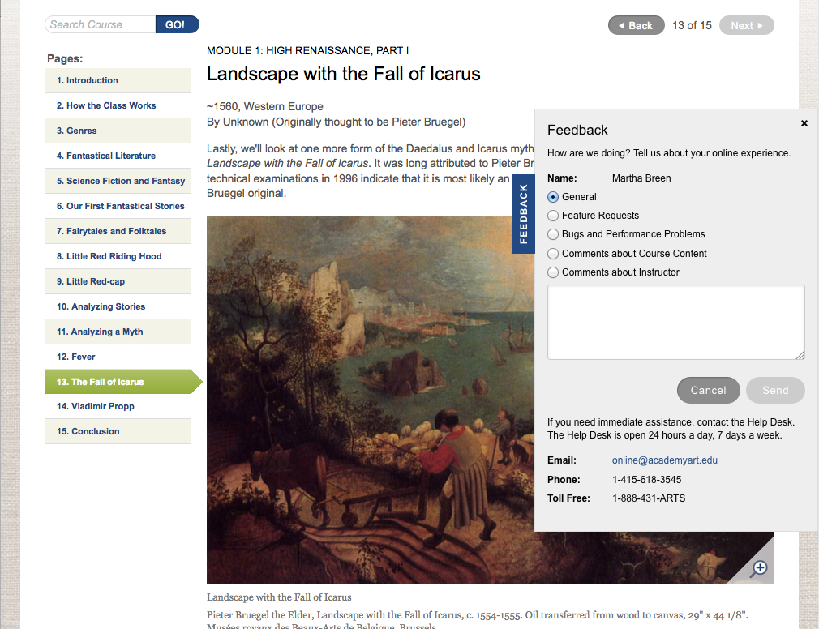

The Academy has examined rates of student satisfaction with online classes (teaching, technology, and technical support) across time and compared with onsite classes. These comparisons suggest that students are highly satisfied with their online classes and that the Academy has successfully managed online delivery of the curriculum.

*Program-Level Assessment*Each academic program has established intended learning outcomes at the program level. Required courses are mapped to intended program outcomes (curricular maps). To determine students’ actual performance in relation to intended program outcomes, faculty conduct midpoint (formative) and final (summative) reviews of student work, including portfolios and graduate thesis projects. Online, graduate midpoint and final thesis reviews are conducted using web conferencing technology, allowing students to present their work in real time to a faculty committee from their department.

Faculty members and department directors evaluate curriculum and learning results in targeted classes through Department Action Team (DAT) meetings.

Recommended improvements are usually implemented at the departmental level, with approval for curriculum changes coming from the Chief Academic Officer. Recommendations requiring executive approval are handled in meetings between the department director and the President or Chief Academic Officer.

*Annual Assessment Data*Assessment data is collated and analyzed by the Assessment Director, who meets with the department directors to review the findings and identify areas for improvement. Directors then meet with program faculty to implement improvements. Improvements made as a result of this process typically include: refining course sequences and prerequisites, refining assignments, adding or removing courses, and supplying additional academic support, such as workshops.

*Program Review*Every 5 years, departments undergo program review. This review process examines a range of departmental effectiveness indicators, including assessment results. Improvements made as a result of this process typically include: hiring additional faculty; adding track specializations; purchasing new technology and equipment; upgrading facilities.

*Spring Show*Annually, faculty and a large number of industry stakeholders evaluate the quality of student work through the Spring Show (an annual school-wide competition juried by external judges from the art, design, and communications industries). In the jurying process, no distinction is made between student work created online or onsite. Online students, competing in a non-differentiated way with onsite students, have consistently been awarded prizes in the Spring Show.

*Presidential Advisory Board*The President hosts an annual Presidential Board of Advisors meeting in conjunction with the Academy’s annual Spring Show, which showcases the finest student work from each department. At the Advisory Board meeting, industry professionals debrief the President on their findings and recommendations, based on viewing the work and talking to students over a full day. These advisors are looking at student work in terms of whether it reflects current trends in the industry, technical and aesthetic sophistication, and innovation. These meetings, therefore, are used to shape future program curricula.

*Online Retention*Increasing online retention remains a strategic priority. Student retention rates are analyzed over time (by program and degree level) for online-only students, hybrid onsite/online students, onsite students, and overall. At the institutional level, the Academy of Art University has noted that the retention rate for online-only students is substantially lower than the rate for onsite only or hybrid onsite/online students.

Online retention data is analyzed at the executive and the department level and results in policies and program changes designed to improve retention. Examples of evidence-based improvements in this area include:

* University-wide implementation of progress grading at weeks 4, 7, 11 and 15. Online students earning a D/F grade in weeks 4 and 7 are referred to the Academy Resource Center for free academic support. Online systems automatically refer with an option for the instructor to complete a form with additional information;
* Weekly online attendance reports (students with repeated absences are contacted by online student advisors to discuss a course of action);
* Revision of university course refund policy to discourage students from dropping classes after Week 2.
* Free online workshops for students (in specified areas) that are managed by Academy instructors. Workshops allow students to receive additional assistance outside of the online class.

The Online Education team collaborates with the university Student Success Committee to identify opportunities and implement strategies to improve the online student experience, academic success and retention rates.

The Online Education team constantly strives to provide the optimum experience for both students and faculty in the Learning Management System (LMS) by focusing on developing tools, functionality and resources that support academic success and improve the overall educational experience of all students. Initiatives enabling richer communication, consistent engagement, classroom management and instructional approaches have been deployed and continue to be assessed and refined.

The Online Help Desk was restructured to emphasize student/instructor support and communication across departments. The Help Desk works with academic and support departments to implement new and creative ways to increase its presence, provide friendly and efficient help, track identified issues or requests and direct students to the many services the Academy provides.

The Online Education Steering Committee, formed in 2016, serves as a teamwork-focused think tank, identifying and communicating online education-related opportunities, challenges and roadblocks, including issues and opportunities around student retention, persistence and success.

The Director of Online Student Relations focuses on improving the engagement and success of online students with a primary focus on first-year and other at-risk students; participates in the assessment and ongoing improvement of the online student experience, from pre-admissions through graduation and fosters formal and informal communication channels to better understand the needs of online learners.

The Online Education Team partners with the Academy Resource Center, academic and non-academic departments to assess and improve the university’s orientation program for new incoming online students.

*Online Enrollment*The Director of Institutional Research and the Department of Online Education track online student enrollment.

Online Resources and Planning

The academic, technical, budget, and administrative needs of the online program—as well as retention results—are central to the Academy’s strategic focus. Feedback from students and faculty is directly incorporated into the online department’s planning discussions with Executive Administration. This allows for effective planning for administrative and technological growth and for increased support services for students and faculty.

The Academy has a successful track record of providing increased budgetary resources and staffing to match growing enrollment in online classes. With faculty and students providing their own working space and equipment, direct costs are low. Salary expenses for faculty and staff are shared with the onsite programs (academic departments and the Academy Resource Center, which provides academic support, do not have separate budgets for online activities). The infrastructure for developing, improving, and supporting online classes and for supporting online faculty already exists within the Online Education Department.

*External Evaluation*The overall structures to support online education at the Academy of Art University and selected online student learning results were externally peer-reviewed by National Association of Schools of Art and Design (NASAD) in 2014 and Council on Interior Design Accreditation (CIDA) in 2008, 2011, 2017 and 2018. Both NASAD and CIDA reported favorable findings in regard to the Academy’s distance education programs. Recent reviews (2015, 2018) for the School of Architecture included online education, from the National Architectural Accrediting Board (NAAB).

In 2005 and 2007 and most recently in 2014, the WSCUC Visiting Teams also evaluated the structures and processes that support online education at the Academy of Art University, and selected online learning results. The official findings included commendations for the Academy's online education offerings and online support services for students and faculty.

*Internal Evaluation*Since its inception, the Online Education Department has employed continual self-evaluation practices to address:

* The process of online course development;
* The quality of online classes information delivery (media richness; appropriate visual delivery of course content; clarity), technological performance, and innovation;
* The process and results of online course improvement (continual rebuild process);
* Effective uses of technology to improve teaching and learning;
* Effective technical support;
* Effective training and support services for students and faculty (measured by student and faculty performance and by satisfaction with services and training).

The academic departments, the Academy Resource Center (academic support), and executive administration have addressed:

* Student achievement of intended learning outcomes;
* Online student retention rates;
* Student satisfaction with courses and instructors;
* Effectiveness of academic support services for students (measured by student performance after receiving support and by student satisfaction surveys);
* Faculty development for online instructors after the first year of online teaching.

Improvements to the Learning Management System (LMS)

*User Home Page*The student home page in the LMS has been redesigned with the following goals in mind:

* Communicate the dynamic Academy culture;
* Involve students in campus life;
* Create an online Student Union; a gathering place for students to see and be seen;
* Give students better access to tools to help them manage their academic careers;
* Provide improved access to enrollments: courses, workshops, and labs;
* Encourage excellence in student work;
* Inspire delight, curiosity, and wonderment.

Several tools provide feedback on a student’s progress throughout the semester, including:

* Improved access to all parts of online courses;
* Pulse: when they sign into their classes, online students see a red, yellow or green indicator reflecting their performance;
* Performance is measured as: assignment grades, exam grades, quiz scores, discussion activity, module progress, and absences. A substandard indicator in any one area turns the overall indicator to that color. Academic directors and instructors can also view the indicators for their students.
* For on-campus classes, time and location are listed, along with a link to the campus shuttle schedule.
* Links to the user’s profile, portfolio, and grades also appear on this page, as well as links to request support from the Academy Resource Center.

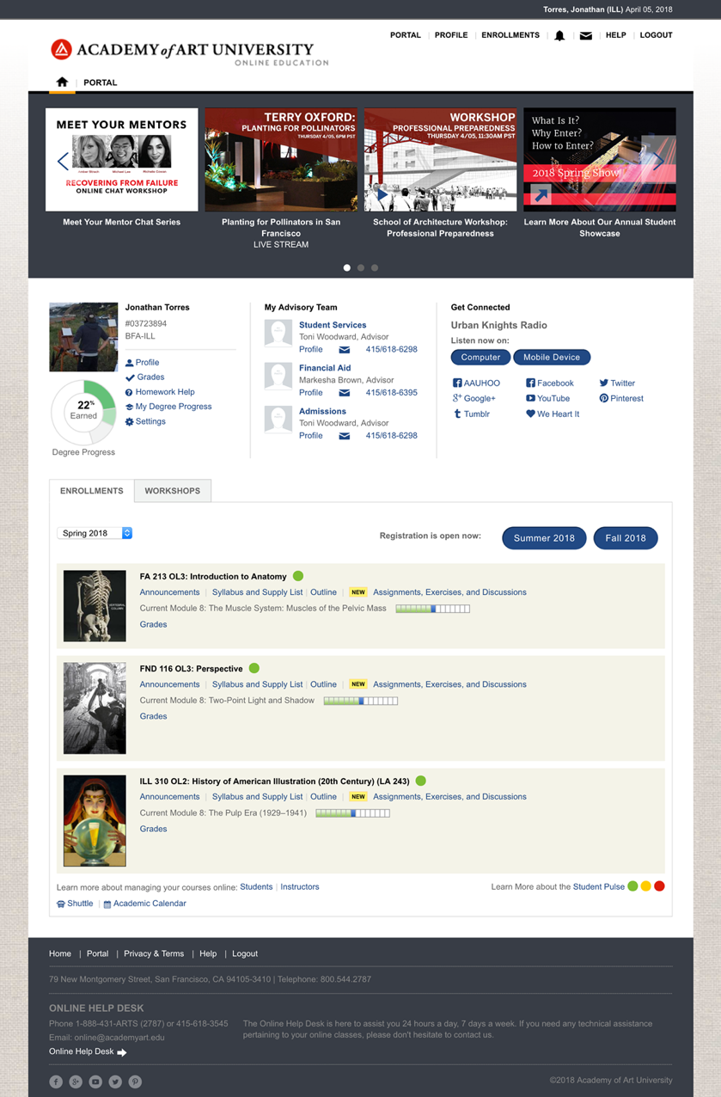

*Attendance Tracking*Student tracking reports, advisor reports, and reports for financial aid have been upgraded in the LMS to match the new federal online attendance guidelines.

*Art Supply Lists*The Academy of Art University has a contract with Dick Blick Art Materials. All courses in the catalog list their required art supplies. The supply lists are fully integrated with the Dick Blick catalog. Students can register for their classes and then view their customized supply lists in the Dick Blick catalog. The lists prepopulate a shopping cart, which students can edit before making their purchases. This process helps ensure that online students, who are scattered all over the world, get the correct supplies before the start of the semester. With the detailed supply descriptions, students can also purchase those supplies from local or alternative sources if needed.

*Degree Breakdowns*All semester breakdowns for degrees and degree sub-plans — including English for Art Purposes (EAP) sub-plans — are integrated into and managed in the LMS. Advisors can now populate degree plans with fulfilled course requirements and publish them to students. They can also provide internal and external (to students) notes for special cases and override rules (with approval) in certain circumstances.

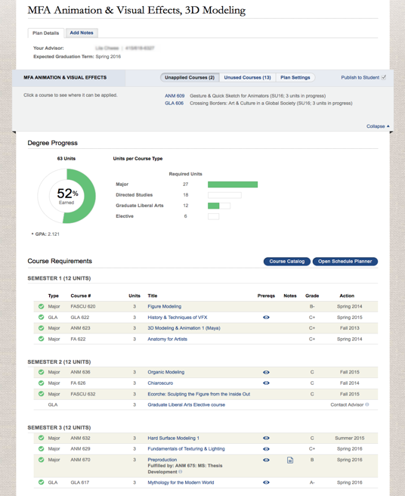

*Software*Students receive license keys for Adobe Creative Cloud (Photoshop, Illustrator, etc.) through the Portal free of charge as long as they are enrolled in a class.

*Class Discussion Redesign*The class discussion is the online classroom. It is where students and faculty meet and interact. Students use the class discussion to review their assignments, submit their projects, get both individual and group instruction, ask their questions, receive feedback on their work, conduct academic discourse with their instructor and peers, talk informally with each other, and more. Instructors use the class discussion to teach their students, review student work, offer help, grade, and more.

The class discussion is one of the oldest features of online education at the Academy of University and arguably, one of the most important. The interface had remained largely unchanged from its inception in 2002 until 2016. In 2016, a completely new, modern interface was successfully launched for all online courses. The new interface is a radical improvement over the old one. It has been well received and embraced by the University as a whole.

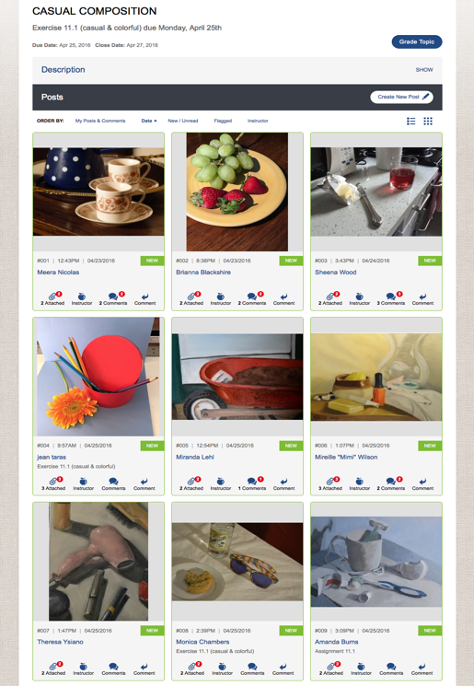

The new interface is designed for arts education. It is a visual interface for visual learners. It is flexible and robust enough to support the three different kinds of courses taught at the University: studio, software, and discursive courses. The following is an overview of the many interfaces that were affected and their intended purpose:

* **Improved Navigation and Wayfinding**
  + The entire assignment and discussion is displayed on one page. People can close the assignment description and focus on the discussion. The choice to close or open the description is persistent.
  + Instructor update box is a new feature. The Instructor update box provides faculty a special place to present additional content and assistance for assignments, exercises, and discussion topics.
  + Persistent filter and sort orders: Topic posts can be sorted alphabetically, by date, with unread posts first, or filtered for instructor comments.
  + In-context menu: all student names in the LMS are “hot.” Clicking the name launches a menu for the instructor to email an individual student, or to refer him or her to academic support.
  + All posts are visually marked to show new activity, whether the post has been read or not, or if the post has been edited.
* **The Visual Classroom**  
  Class discussions can be viewed in a list or as a visual grid. List view supports free flowing discussions. The grid view functions like a gallery and highlights student work.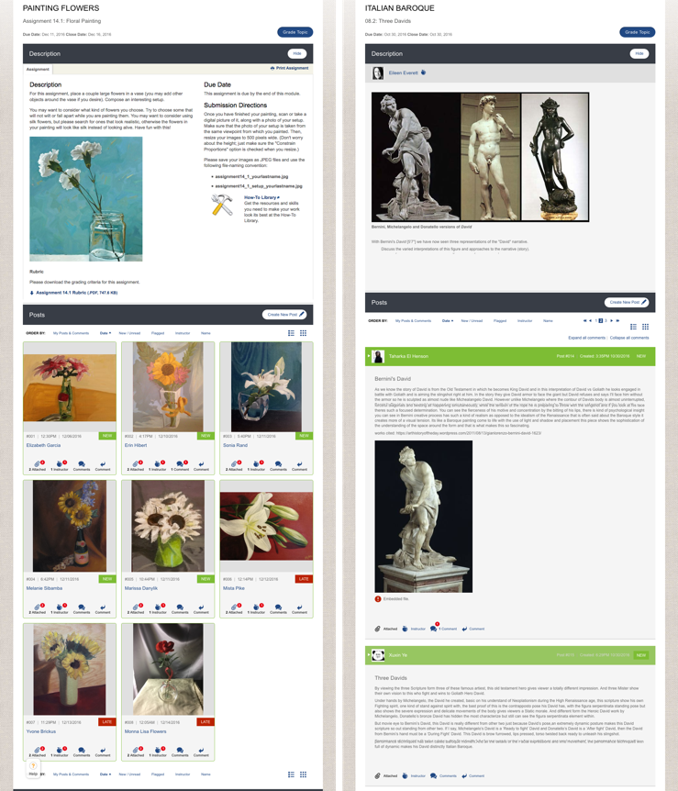
  + List view can be expanded to allow users to scroll through an entire discussion and get a clear overview of all the activity. The list view emphasizes written language.  
      
    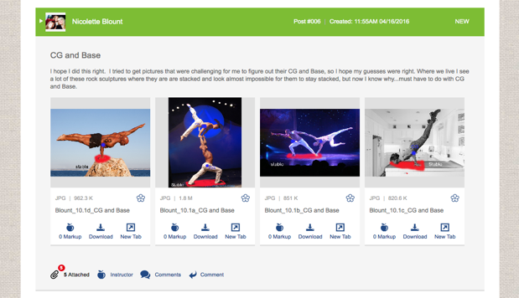
  + Grid view is visual; it emphasizes student artwork. It allows students and faculty to focus on one student at a time for a deep dive.  
      
    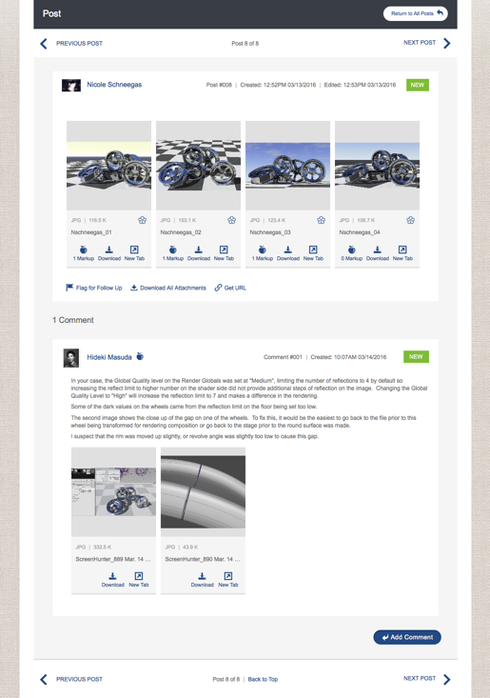
* **Threaded Discussions that Encourage Participation**
  + Threaded discussions improve organization.
  + Posts can have comments, creating a sub thread for a deeper discussion of a particular student’s work or thoughts.
  + Due date vs. Close date: assignments can stay open past the due date. This allows students time to discuss each other’s work after scrambling to meet their deadlines. Late submissions are marked as late for grading purposes.
* **Robust Authoring Tools**   
  Students and faculty author posts and comments in the class discussion; one of the biggest improvements to the class discussion is in the authoring tools that are now available. The authoring toolset has been greatly expanded to support robust, media-rich posts that can be customized in many ways based on user preferences. It allows the instructor to better highlight and reinforce portions of their posts as well.   
    
   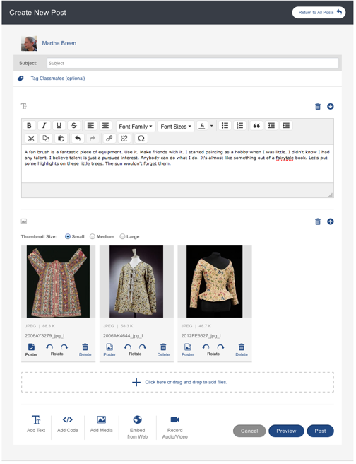  
    
  Students and faculty can write text, post links, and attach files, and in addition, they can also:
  + Embed files from across the web including video, 3D models in working 3D viewers, slideshows, animations, and much more;  
      
    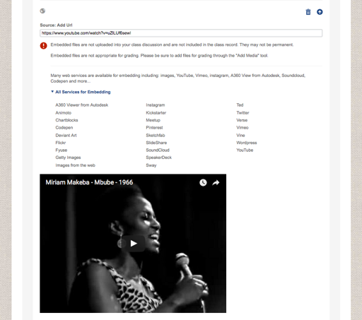
  + Use a code editor for courses that teach programming;
  + Record audio and video directly into the browser;
  + Photograph work from within the class discussion;
  + Control how the attachments display, and add caption to individual works.  
      
    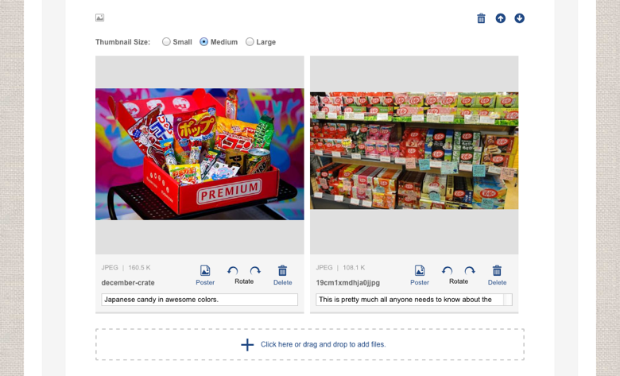
* **Mobile-Friendly Critique Tools**  
  The class discussion has always featured proprietary tools for critiquing student work. These tools included annotation tools and the ability to record audio feedback; because of their highly interactive nature they were built in Flash. Flash is a dying technology. Currently, the annotation tools are being migrated out of Flash and into HTML5. The first tools build in HTML5 were callouts, comments, and the ability to record video comments. In Spring 2017, the annotations tools migration will be complete. This includes the following features:
  + Freehand, straight lines, curved lines, and arrows;
  + Rectangle and ovoid shapes;
  + Zoom and pan;
  + Full screen;
  + Comparisons, and more…

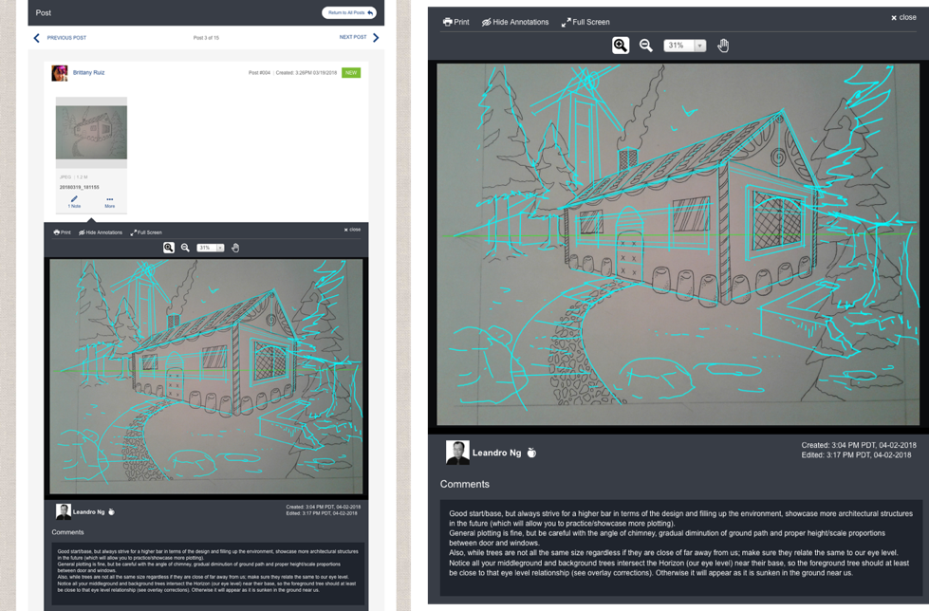

* **Mobile-Friendly Critique Tools for Video**

In the Fall of 2017, the HTML5 annotation tools were extended to mark up video. The annotation and drawing tools available to the instructor are the same as the ones used to comment on static art. The video player has been rethought. The instructor can advance or rewind through the video one frame at a time. They can drop a timeline marker on the play bar, which stops the video. All the annotation tools are available to the instructor to annotate the frame.

The markup can be created and viewed on mobile devices. The old Flash-based whiteboard has been replaced with the completion of the video markup tool.

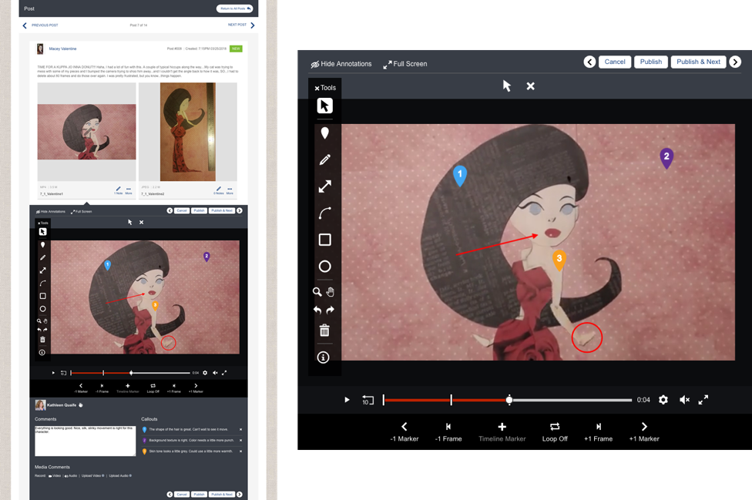

* **Grading/Activity Interface**  
  The assignment grading interface and the discussion activity reports for discussion topics have been completely redesigned to allow faculty to see students’ entire participation within a given topic.

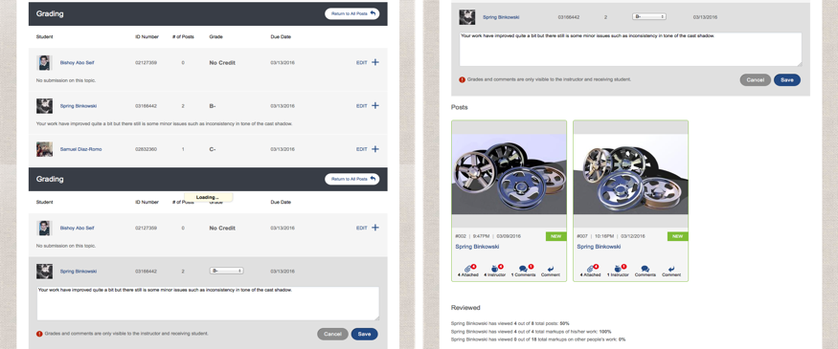

*Mobile*All of the new class discussion interfaces are touch-friendly and device-agnostic. They work equally well on desktop, laptop, tablet, or phone.

Online Education makes apps for iOS and Android with thumbprint verification available for all students and faculty.

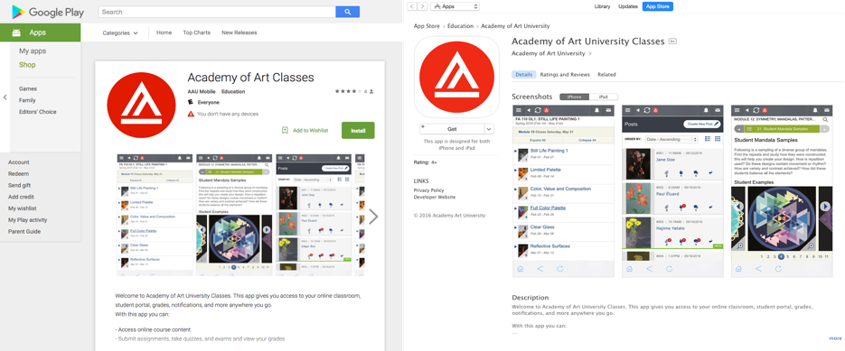

*Bring the University Together: Online + Onsite Campuses*From the beginning, the online and the onsite campuses were kept separate. The barriers between the campuses are being taken down. The first interfaces to be shared are:

**Media on Demand**: As of Spring 2017, the online video demonstrations will be made available to onsite courses. Additionally, content created for the onsite campus will be extended and shared with the online campus.

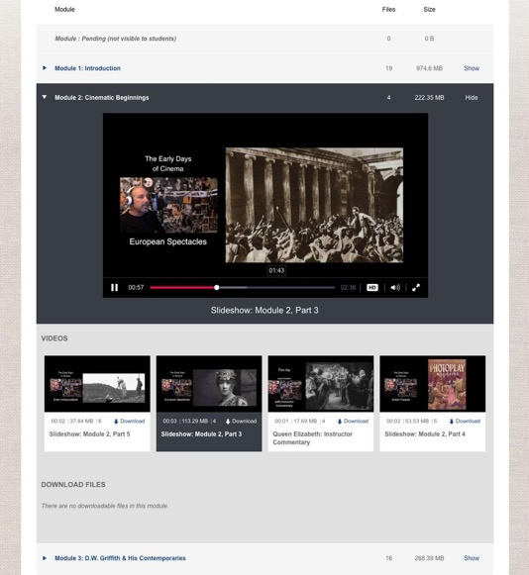

**Global Topics**: The robust tools of the online class discussion are also being extended to onsite courses. Onsite courses can use the online tools for students to turn in their work, make additional resources available, and more.

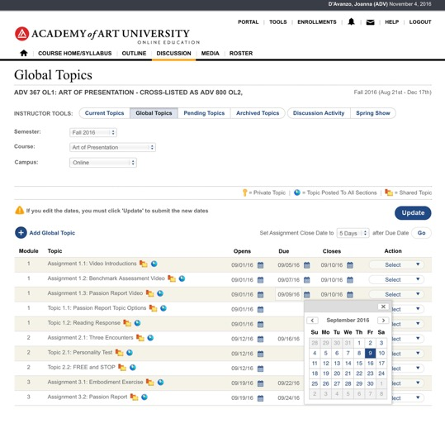

**Resource Sites**: Online Education has produced and continues to produce resource sites that can be shared by all students across a given department. These sites provide technical support, inspiration, and additional tools.

*Notifications*The Learning Management System has been extended to send notifications. Students are notified when an instructor comments on their work, when someone tags them in a conversation, and more. All notifications “live” in a notification center, and individuals can manage their settings. Notifications can appear on the lock screen of users’ devices, or be emailed, depending on individual preferences.

*Synchronous in the Online Classroom*All online degrees at the Academy of Art university can be completed asynchronously. Synchronous events are offered in online classrooms as optional enrichment. Students are encouraged to sign up for live critiques of their own and other students’ work. Additionally, some courses offer live guest speakers, or instructors might host live office hours. All these events are recorded and made available to all students for review.

*Integrated Gradebook*A pilot of the new integrated gradebook took place in the Spring of 2018. An integrated gradebook that calculates grades based on weighted categories was one of the most frequent requests made by faculty. Final development will be completed and the gradebook made widely available beginning in Fall 2018.

Every course has a grading breakdown. The grading breakdown describes how students enrolled in the course will be graded. It shows the categories of activities and behaviors that will be taken into account. Each category is weighted; the weights are reflected in percentages. The percentages are used to calculate the grade. Each assignment and gradable event is assigned to a category. Categories can include projects, assignments, exercises, presentations, papers, exams, quizzes, participation, and more. The grading breakdown is displayed on the Syllabus.

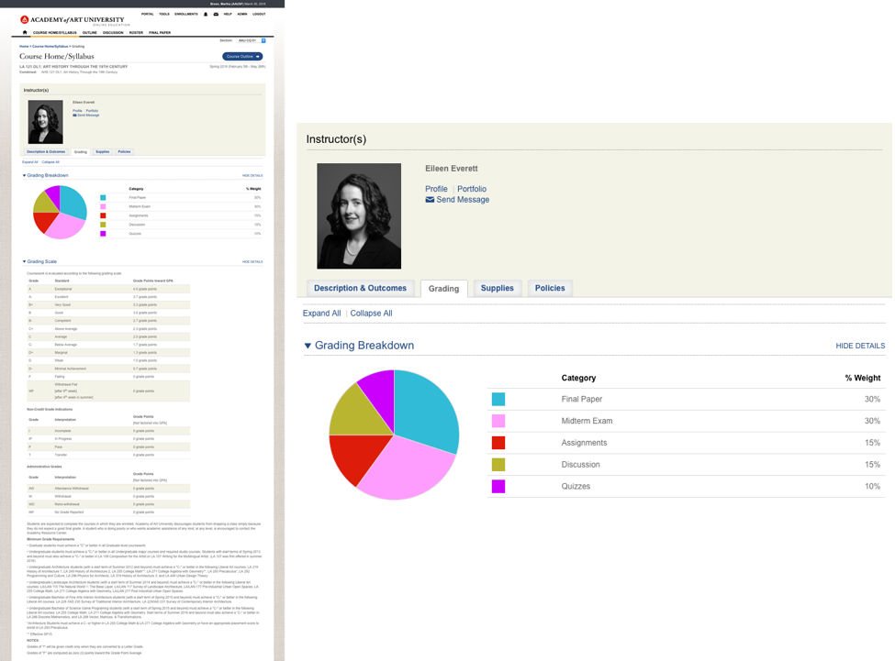

The integrated gradebook pulls together the grade breakdown, all the gradable events, and the class roster. Official grades are calculated on a quarterly basis. The Official Grade Form list the entire class and provides a form for grading along with the calculations. The instructor reviews the calculations and is presented with a clear graphic display that details the results. The instructor is free to accept the calculation as is, or adjust the grade as if needed.

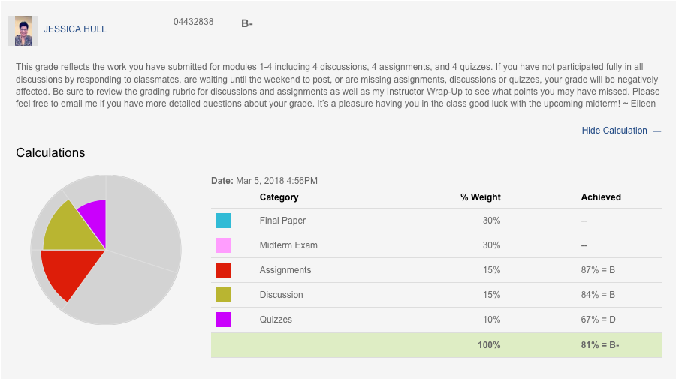

Comparing students’ charts gives the instructor a window into how the students are progressing.

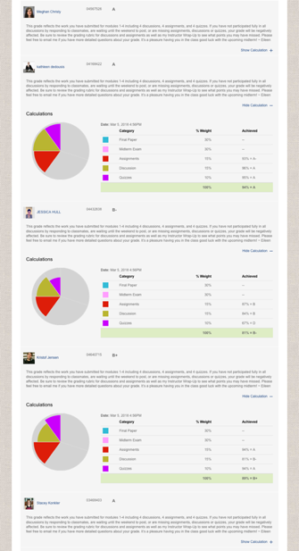

Individual students’ progress is reviewed in the Student Grade Detail. The Student Grade Detail provides a complete record of everything an individual student has done.

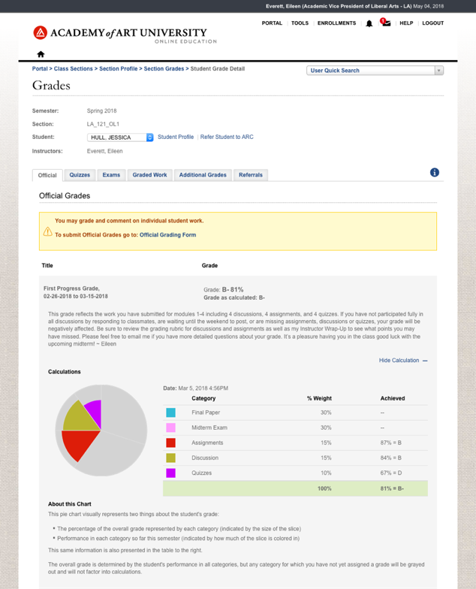

Grades from individual assignments roll up into the Student Grade Detail and to the Official Grade Form. The grading interface for individual assignments has also been upgraded. Instructors can grade using letter grades or enter in a percentage value.

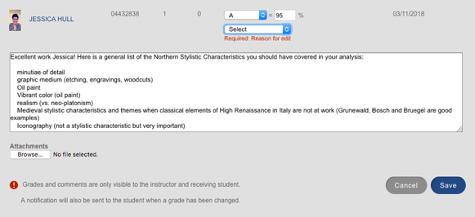

If a grade needs to be adjusted, the instructor can also make a note as to why the change was made.

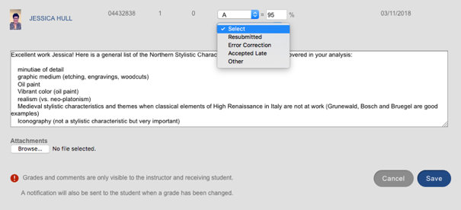

Lessons from Delivering Online Learning

The Academy of Art University has learned a number of lessons about delivering online art and design education since it first began offering online classes in 2002. These include the importance of:

* Matching or surpassing the onsite learning environment: Considerable resources and technical support are required to deliver engaging art and design education online (visually engaging web pages, cutting-edge slideshows, high volume of video demonstrations). The Online Education Department moved from leasing a Learning Management System (LMS) when the online programs began, to building its own. This proprietary system better serves the needs of art, design, and communication students working toward their degree online.
* Offering both asynchronous and synchronous support for online learning: The Academy has made a substantial investment in technology that allows real-time, audio-visual communication for graduate midpoint and final reviews, undergraduate and graduate class presentations, and demos and live department town hall and guest speaker events. The Online Education Department has appointed a team of Synchronous Learning Coordinators to support this endeavor. The Online Coordinators set up the appointed online meetings and run the technology to allow the students and participants to focus on the presentation and student work.
* Improving the online learning environment through continual research and development, and acting on faculty and student input and feedback.
* Providing substantial support for faculty building and refining online classes, including training, content writers/editors, instructional web designers, video production team.
* Training and continuing to support faculty new to online teaching: The Academy’s Online Education Department created the teaching coach program for new online faculty as a result of interviews with more than 40 online faculty members in 2005. Coaching is also available to continuing online instructors upon request. An online library provides access to more than 100 pages of resource materials to support online instructors. Training courses for online teachers are regularly revised and expanded based on faculty feedback. Teaching workshops are developed in response to instructor requests or perceived need.
* Supporting and ensuring regular, high quality faculty and student interaction in online classes: The Academy has established and distributes clear teaching standards based on research on teaching effectiveness. Online Instructional Review and Improvement Team (OIRI) members review online sections daily to ensure faculty adhere to these standards. OIRI staff reach out to struggling faculty to ensure compliance with policies, and work with individual teachers to make sure they meet general University policies, as well as those policies and behaviors appropriate to individual academic disciplines. The University regularly reviews and updates teaching standards to meet accreditation requirements and evolving best practices.
* Providing a 24/7 Help Desk with real-time phone and email support: Utilizing Adobe Connect products allows Help Desk personnel to see in real time what students or instructors are doing on their computer as they explain their problems. This technology also permits staff to take over a user’s computer (with the user’s permission) to directly correct problems with the user’s system or to show them how to properly complete a task.
* Adapting academic support services and technology to meet student needs: For example, the Online Education Department hired a team of two full-time staff to create captioning for hearing impaired students. Online ESL and Student Academic Support staff and the Online Writing Lab have also been essential to supporting online learning.
* Recognizing the comparative difficulty of retaining online students through graduation; the importance of communicating to students the reality of online classes, including expectations for student achievement and expected workload.
* The importance of listening and querying students about their online education experiences: What’s working, what they like, what isn’t, what can and should be improved; their challenges, etc. Student feedback informs and helps prioritize improvements to the online learning environment.
* Adapting business practices to growth; for example, shifting from postal delivery of thousands of demonstration CDs per semester to streaming media.

One unexpected finding was the positive impact that developing and teaching courses **online** had on **onsite** teaching practices. This phenomenon was examined in a research paper prepared and presented by Faculty Development department staff at the 2006 Professional and Organizational Development Network (POD) Conference.

APPENDIX 1  
Academy of Art University Online Class Components

|  |  |
| --- | --- |
| Class Home Page and Syllabus | Overview of intended learning outcomes, required materials, grading policy, online education policies, instructor bio, and introductory video. Same as onsite. |
| Course Outline & Weekly Learning Modules | The Course Outline is the detailed outline of the modules for the class. It includes links to all class components, including module pages, quizzes, assignments, exercises, and discussion topics. The Outline permits the instructor to see how individual students are progressing through the course content. The Outline also allows students to track their own progress through the course material.  All modules are presented as both text and images, as well as either video demonstrations or audio enhanced slideshows, and include interactive presentations, image galleries, vocabulary, and glossary lists. They contain the same information as the instructor’s onsite lectures.  The learning goals for each module are clearly stated before the student begins that week’s lesson. |
| Quizzes and Exams | Interactive web-based quizzes (true/false, multiple choice, list matching, or essay and short answer) are first made available during each week’s learning module. These open-book online quizzes are generally not timed and may be taken at any time during the module period to which they pertain. Midterm and final exams are usually offered for a limited time during the module in which they occur. All exam and quiz questions are randomized, to prevent students from sharing answers outside of their online courses. Exam questions are also randomly selected from a larger pool of questions, further ensuring the integrity of the exam. A one-at-a-time question format and time limits on exams can also be used. |
| Progress Questions | Embedded into module pages, progress questions are designed to re-engage students as they move through a learning module and to assess their understanding. Progress questions may be unscored — or they may be graded, and have regularly been used to take the place of module quizzes. In addition to true/false and multiple choice formats, progress questions may use such other question structures as sorting, matching, and other formats. Multiple progress questions (graded or ungraded) may be grouped together to serve as a drill or exercise that helps to build skills (in a language class, for example). |
| Video Demos | Faculty demonstrate techniques (such as drawing) through short video presentations. Screen capture videos provide students with a detailed audio/video demonstration of computer-based programs. Closed captioning is made available for students with hearing impairment.  **Fast Fact**: The Online Education Department has filmed over 14,500 demonstrations (not including screen-capture videos); they produce 300-500 demonstration videos each semester. |
| Weekly Discussions | Asynchronous posting forum where students interact with the instructor and other students (guided discussion of course content, sharing projects and critiques). The instructor creates discussion topics to correspond with the weekly learning modules. This forces students and instructors to address the same weekly content, so that the discussions are focused and timely. Instructors are required to interact substantively on a daily basis in the discussions.  **Fast Fact**: The Academy’s custom discussion application allows students and teachers to post text, images, links, audio and/or video files — and to record and post short webcam videos. |
| Weekly Assignments | Typically include readings related to class discussion topics, writing assignments, studio exercises, and creative projects. In addition, Exercises can be assigned that include drawing and sketching practice, research, etc.  **Fast Fact**: Assignments may be public (so submissions are visible to all students) or private (so that students can see only their own submissions). Students regularly post their work in the active assignment area. |
| Assignment Critiques | Using the Whiteboard or the new Notes Annotation tool (discussed above), an instructor may mark up a student’s visual assignment (image or video), add audio commentary, or quickly comment in writing. Instructors are also provided with a quick interface for grading projects, along with a private comment field specific to the grade. A mini-discussion area (sub-thread) is attached to each student project submission. The sub-threads can be used to foster discussions among students and the instructor about a specific student submission. Students are encouraged to view each other’s whiteboard critiques.  **Fast Fact**: The whiteboard was developed at the request of online instructors and allows robust, web-based visual critiques of student work. It is periodically enhanced based on suggestions or requests from instructors and students. |
| Class Mailbox | An internal email system is part of each online class. This allows private communications between the instructor and students, separate from the public and private forums in the discussion and assignment areas. |
| Portfolio Mailings | While most student projects can be delivered through electronic images and file transfers, some courses require that students physically mail in their portfolio/project for in-person review. Instructors in many studio courses perform critiques of physical work 1-2 times per semester (midterm and final projects). Feedback is typically given in writing or via recorded audio, which is posted to the class; alternatively, feedback may be written or printed out and mailed back with the project. Full-time Online Education administrative staff are dedicated to handling this large volume of student work. |

APPENDIX 2  
Faculty and Support Staff for Online Programs: Role and Qualifications

|  |  |  |
| --- | --- | --- |
|  | Role | Qualifications |
| Faculty | Develop, teach, and evaluate online classes | Professional experience in the field and an impressive portfolio are required both online and onsite.  For faculty in Liberal Arts (general education), Art History, and Art Education, a Master’s degree is normally required. |
| Academic Directors | Hire faculty and oversee academic programs (online and onsite are considered a single program). | Industry professionals with significant experience in the field. |
| Online Directors/ Coordinators | Develop and teach online classes. Help academic directors:   * Manage online curriculum * Recruit and support online faculty * Maintain cohesion between online and onsite classes * Review and approve new online classes * Conduct portfolio review * Facilitate selection of online student work for Spring Show | Appointed faculty member. |
| Vice President of Online Education | Oversees online education content development and delivery systems and processes. Responsible for overall online staffing, resource management, QA, and improvement to online systems and services. | Extensive experience creating innovative and effective online education. Management and operations expertise. |
| Instructional Media Producer | Working in partnership with build instructors and Editorial Project Leads, coordinates, manages, and produces instructional media content for the Online Education department. Instructional Media Producer staff plan, create, process, and implement a wide variety of text, audio, video, and interactive media elements throughout the lifecycle of each course build. | Extensive technical skills and experience in creating web-based media |
| Manager of Instructional Design Strategy | Provides leadership and guidance for the development of effective and engaging online courses, as well as for the Instructional Web Design team in their training and in the development of online courses. Guides and oversees the production processes, acts as liaison between Online Education and internal and external production teams, works in partnership with the Director of Creative Development to define effective online education tools and designs, continuously researches advancements in online course development, and contributes to the success of the Online Education Department by demonstrating professionalism, enthusiasm and superior customer service. | Extensive technical, leadership, and communication skills, as well as the ability to identify, manage, and prioritize multiple areas of need. |
| Editorial Manager | The Editorial Manager guides the development and presentation of effective, impactful instructional; provides leadership for the Editorial Team in their training and in the development of online courses; provides guidance and oversight of editorial and production processes. | Extensive editorial, leadership, and communication skills, as well as the ability to identify, manage, and prioritize multiple areas of need. |
| Editorial Project Lead | Working in partnership with build instructors and Instructional Medial Producers, assist faculty to structure, write, build and rebuild online courses. Assure that course content and assignments are clear and concise. Conduct quality assurance of all courses. | Background in writing and editing and/or advanced academic degree and/or prior experience in online learning |
| Course Captioning Team | Transcribes and creates captions for audio/visual media in AAU’s online classes, including video demonstrations, interviews, and other audio/visual content. Collaborates with Classroom Services to provide improved accessibility to online students throughout their academic careers. | Copy-editing skills and typing speed. Passion for the arts and/or education. Experience working in an office environment. Basic software skills. |
| Workshop Manager | Oversees, administers and coordinates synchronous and asynchronous academic support and tutoring services, that provide coordinated instructor-led support to online and onsite students.  Leads efforts to improve the online workshop program’s effectiveness and to identify other outcome-based academic support methodologies that enhance the academic learning experiences and retention of the Academy’s online student population. | Strong student-centered focus; commitment to student satisfaction, persistence and success  Strong written and oral communication skills  Ability to develop/maintain effective working relationships with faculty, students, and staff. |
| Video Production & Editing Staff | Produce high-level video content for all online classes using fully-equipped, state-of-the-art-in-house and portable studios. | Experience in shooting, editing, directing and technical production  Ability to produce video content on location at specialized art studios as needed, and to produce virtual field trips that give the online students access to the full educational experience |
| Instructional Designer | Define course templates for that support multiple formats of online offerings. Aggregate and synthesize student and Academic department input. Drive focus groups, define requirements, test and define engaging learning experiences and compelling course content that verifiably enhances persistence and student success. | Working knowledge of CMS and LMS systems.  Bachelor’s degree or higher in instructional design, education, or equivalent field. Experience in developing online, mobile training, and instructor-led courses, and experience with learning management systems. |
| Online Academic Development | Provide online academic leaders the tools, knowledge and support needed to develop and maintain their respective programs.  Key support and development areas include: the effective management of online faculty; administrative effectiveness, curriculum development and management, and student success.  Serve as a liaison between academic and non-academic support departments and functions. | Knowledge of and history in working in online education. Intimate knowledge of academic departments, their critical faculty and management and their program learning objectives. |
| Online Synchronous Services Staff | Manage web-based, live, two-way audio-video software used for graduate midpoint and final reviews; class presentations and demos; instructor and director online office hours; live workshops; online Town Hall meetings; faculty meetings; orientations; and tutorials. | Technical proficiency, knowledge of software platforms, experience working with students |
| Project Manager | Tracks, prioritizes and drives production requests across all academic departments, tracks and drives progress of all application development, retention and student support initiatives. Defines and implements productivity tracking across all groups. Projects performance critical paths using appropriate systems and techniques | Excellent analytical and demonstrated problem solving skills. Proven ability to proactively and quickly grasp, distill and synthesize concepts and details from diverse sources, identify trends, develop strategies, and implement high-impact solutions |
| Instructional System Developers | Develop enhancements for Learning Management and Content Management Systems. Technical quality assurance | Cutting-edge technical expertise. |
| Online Administrative Services | Provide administrative support as it pertains to Online Education and the Learning Management System. Manage the incoming and outgoing of student portfolio mailings. Coordinate proctoring for LA exams that must be taken onsite or with a proctor. | Experienced administrative professionals, preferably with a background of working in college administration. |

APPENDIX 3  
Using Technology to Improve Teaching and Learning

|  |  |
| --- | --- |
|  | Quality and Sufficiency of Services |
| Training for Faculty Developing Courses Online | *Online Course Development*: Mandatory training for faculty new to online course development at the Academy of Art University, this course was completely redesigned in 2015. It covers:   * the process of developing an online class * strategies for adapting classroom practices to the online environment * approaches to course design * writing lectures for course modules * creating effective content for studio courses * selecting images * creating videos and other media * tips for working with the course development team * online course development suggestions and resources * a gallery of available course components   Progress questions check that faculty understand the main points of the training. An interactive component gives course authors new to online education hands-on experience working in the online environment in which their classes will run. Discussion topics provide an opportunity to ask questions and to share information with other course authors. |
| Collaborative Online Course Development | Because an average online class consists of roughly 400 printed pages (100-150 web pages) of content (in addition to quizzes and exams, presentations and demonstration videos), a faculty member develops a new online class in collaboration with an **Editorial Project Lead** and an **Instructional Media Producer,** who help to structure the syllabus and produce the course in a timely fashion.  A **video-production staff** (technical directors, videographers, and editors) work with faculty to produce filmed demonstrations, field trips and guest speaker interviews; screen-capture videos; brief videos introducing the course; and voiceover narration for class media.  Student course evaluations offer indirect feedback on the quality of finished online classes (visual media and course content). Department directors and faculty offer direct feedback. All feedback for improvement is channeled into the course redesign process. |
| Online Teaching Library & Blog | The *Online Teaching Library* aggregates and makes available all the resources that Online Instructional Review & Improvement staff develop to support online teaching. At present, it includes more than 100 web pages, including tutorials, workshop recordings, guidelines and tip sheets. The site is password-protected.  (URL: <https://wiki.academyart.edu/display/OTLIB/Home>)  The *Online Teaching Blog*, highlights new additions to the Teaching Library, announces interface upgrades, and offers tips, reminders, and best practices for online teaching. Weekly *email outreach* alerts online instructors to new content. |
| 24-Hour Online Help Desk | 24/7 technical assistance for online students and teachers. Clearinghouse for issues raised by online students and teachers.  Online capabilities allow help desk staff to see student’s computer screen and even to take control to fix problems with the student’s system (with the student’s permission).  Students rate Help Desk services as part of their online course evaluations. |
| Technical Training for Students | Orientation to online learning and specialized tutorials on new features of the online learning environment prepare students to succeed in their classes. |
| Online How-to Library | 24/7 access to a library of basic instructions and online tutorials for students and faculty: academic expectations, computer basics, digital photography, scanning, image manipulation, and packing artwork for shipping. |
| Free Software & Equipment | **Adobe Creative Cloud**: Instructors and students receive a software key which allows free access to the Adobe Creative Cloud, including Adobe Premiere and After Effects.  **Audio Recording and Video**: Faculty can record audio directly into the browser using the Whiteboard.  **Webcam Video Recorder**: Faculty and students can record brief videos through the browser; video files are embedded into discussion posts.  **Streaming Media:** All video and audio files are now streaming, using a variable bit rate which allows the speed of the download and playback quality to automatically adjust to the amount that the user’s connection can handle at any one time. |
| Learning Management System (LMS) | The Academy of Art University LMS is custom-designed for teaching art and design online. The Academy has invested considerable resources in building its online classroom discussion area, which supports video and audio files in addition to text. The separate discussion threads for each student’s assignment lets instructors mark up images of student work and add audio files in Whiteboard.  Development staff regularly enhance the learning environment by upgrading the online class interface and developing additional tools for interacting with students and reviewing student work.  Students rate the quality of the online learning environment as part of their online course evaluations. The learning environment is upgraded periodically in response to instructor and student feedback.  Online Education has formed two Faculty Advisory Boards to inform the direction of development. Regular meetings are scheduled to review interface feature lists and design.  Surveys of both students and faculty are also used to answer specific questions about needed improvements. |
| Adobe Connect | Cutting-edge support for synchronous online learning through live, two-way, video-audio Adobe Connect web-conferencing, which complements the LMS:   * online portfolio reviews * online graduate midpoint and final reviews * online class presentations and demos * online instructor office hours * online live workshops * online Town Hall meetings and guest speaker events by department * online faculty meetings * online informational meetings with prospective students. |
| Cloud Computing | Cloud Computing – AAU Online servers are in the Amazon Cloud and ensures 24/7 access for online students, including:   * 24/7 database and server administration services * Servers are located in multiple geographic regions for disaster relief. * The online class system is highly scalable. * Servers are load-balanced, clustered, and support failover. |

APPENDIX 4  
Student Access to Support Services Online

|  |  |
| --- | --- |
| Online Supplies | Each semester, all online students receive notification emails and letters containing guidance on preparing for online courses and acquiring the necessary materials. **Software** (available at educational pricing from selected vendors)**, hardware, textbooks, and art supplies** required for a specific online course are also explicitly stated on the online Course Description page, along with links to relevant vendors. Class materials such as course readers, workbooks, and multimedia CDs are provided to online students at no extra cost when these supplies are included in the design of the course. |
| Bookstore | All required textbooks for online classes are available for purchase over the internet through eCampus. eCampus also maintains a textbook buy-back system for online students, as well as a variety of shipping services depending on geographical location and urgency. |
| Art Supplies | Art supplies are available for purchase online from the Blick website. Blick stocks and supports supply lists for AAU online classes. Students find their course on the Blick website, and access the list of supplies. Students have the ability to edit the list to buy only those items that they need. This information is updated each semester and kept current at all times. |
| Training, Software and Hardware | Free subscriptions to Total Training are provided. It is an online suite of training tutorials for Adobe software. Details can be found here: <http://media.academyart.edu/totaltraining/>  An online Music Library is provided of music loops that students can use in their projects. A link to the library is provided on the Portal page.  AAU provides the Adobe Creative Cloud at no cost to enrolled students, faculty, and staff.  AAU has an Apple store where students can buy their Apple tech at educational discounts: <http://www.apple.com/us_edu_74029/shop>. |
| Library | The AAU Library offers a wide array of resources and services online:   * *Ask a Librarian*: provides the opportunity for students and faculty to interact with a librarian via email, phone, and Adobe Connect for reference assistance * Searchable databases and digital image libraries with online tutorials on how to use them * Online subject guides for all majors * Ability to renew materials online * Large collection of e-books for checkout; electronic course reserve titles linked to in course module when available * Electronic request form for recommending titles   Current subscription databases include:   * Avery Architectural Index (EBSCO) * Berg Fashion Library (Oxford) * Building Green * Digital Tutors * ebrary Humanities Bundle (ProQuest) * ebrary Individual Purchases (ProQuest) * EBSCO Academic Search Premier * EBSCO Art Source * EBSCO E-Books * EBSCO OmniFile Full-Text Select * Hoover's Company Profiles (ProQuest) * IMDbPro * LUNA (Digital Image Database) * Material ConneXion * Mintel * Music Library * National Newspapers Core (ProQuest) * Oxford Art * Vogue Archive (ProQuest) * Warc * WGSN * WindowsWear Pro * WWD   The Library Director and staff librarians work directly with faculty to ensure that the collection is relevant to current Academy curricula. A librarian is available during normal library operating hours for reference and research assistance. |
| Student Self Service | A convenient way to electronically review catalog and course information, register for courses, add/drop courses, view midterm/final grades, apply for graduation, view advisor contact information, apply for financial aid, make a payment, and update personal information. |
| Online Financial Aid Advising | Every online student receives a packet of financial information that explains:   * Types of Federal, State and private aid available to students * How to apply for financial aid, step by step * How to receive entrance loan counseling online * Deadlines for the financial aid application process * How to pay online * The Academy's payment plan option * Summer scholarship information * Contact information for any financial related question * Links to apply for federal and private aid online * Answers to frequently asked questions   The Financial Aid Department has staff designated to assist students who are taking all of their courses online. Students may also contact any of the financial aid staff to assist with the application process or answer questions.  Each semester, a live, informational seminar on financial aid is offered over the internet using 2-way audio video with unscripted questions for prospective and current students. |
| Technology Support | The Online Help Desk is a full-service customer support unit operating 24/7. Online Help is available by phone, email, or directly from the navigation of online classes. Help Desk staff assist students and faculty with technical issues relating to their online classes; issues with enrollments or online accounts; support with navigation of online classes and use of the online system and tools; using the web; submitting homework assignments; mailing portfolios; acquiring username and password information; technical or mailing issues related to online course CDs; issues with attendance, grades, or online tests and exams; filing formal grievances; petitioning for a grade of Incomplete and coordinating the delivery of incomplete work online; resources available online; and how to contact another department for additional support.  The Online Help Desk uses state-of-the-art, live web software services to assist online students with technical or training issues that are otherwise difficult to discuss via email or telephone. With the student’s permission, the help desk technician can even take over the student’s computer and correct configuration problems for browsers or software. |
| Online Orientations & Tutorials | Online Student Academic Support (OSAS) staff teach an *Interactive Online Orientation*, in which all new online students are enrolled. This orientation, which runs before the start of each semester, is intended to familiarize students with the online environment and to help them succeed. It covers such practical issues as preparing for a class, online communication, resources, academic policies, and time management. In addition, many departments have created customized versions of this orientation with additional material designed to address the specific needs of their students.  Online Education staff create brief tutorials to orient online students to the LMS and to introduce them to critical new tools. Another important offering (available to both online students and instructors) is an online How-To Library, launched in Spring 2009. This series of tutorials provides instruction in many of the fundamental skills that online students need to succeed, including computer basics, digital photography, scanning, image manipulation, and packing artwork for shipping. |
| Online Academic Workshops | Online workshops offer all Academy students (online, onsite, or hybrid) free non-mandatory supplemental instruction and support in a group tutoring environment. Access to workshops is provided through the student’s LMS Homepage Enrollment tab. Once inside the workshop, students have the option to post questions in the discussion thread or interact directly with a workshop instructor during a live Adobe Connect session. The latter provides students a valuable opportunity to communicate with a workshop instructor in real time about homework questions, software, projects, etc. and seek feedback about their work. Workshops are matched to specific courses and students are automatically enrolled based on their associated course enrollments. Workshops are taught by Academy faculty who have been chosen for both their expertise and their passion for helping students. |
| Online Writing Lab | The Online Writing Lab (OWL): The Online Writing Lab is available 24 hours/day 7 days/week. All Academy of Art University students may submit up to 1,000 words of text twice per week. Students receive a response to their submissions via email within 24 hours. Online Writing Lab tutors are experienced writing instructors who teach effective writing strategies, offer guidance on ideas, clarity, organization, and grammar. |
| Online Language Support | Each semester several sections of many liberal arts, graduate art studies, and language-intensive art and design classes are designated for Online Language Support. An Online Language Support instructor is assigned to the designated sections and maintains a topic on the class discussion board called Language and Writing Support. The Online Language Support instructors communicate with students through this topic and email. They reach out to international students, domestic students who specifically request help, and students referred by the content instructor at regular intervals throughout the semester. |
| Online English as a Second Language (ESL) Classes | Two ESL classes are offered online:   * LA 103 Fundamentals of English Advanced undergraduate reading/writing class * GLA 612 Writing & Research for the Master's Student  Graduate course to help students prepare the written portion of their midpoint reviews * Also, ESL Language Support instructors are assigned to a number of Liberal Arts classes (in addition to the class instructor) to help ESL students succeed. |
| Online Academic Support & Online Tutoring | Links to “Free Academic Help,” prominently displayed on the User Home page, allow students to quickly request support from Online Student Academic Support (OSAS) in various areas (language & writing, study skills, time management, etc.). Online request forms auto-complete so that requests can be made with minimal effort.  Online instructors can also submit electronic referrals to OSAS to request help for students not performing satisfactorily in their online classes.  OSAS is automatically alerted when students receive a grade of D or F as a progress grade (Module 4, Module 11) or as a midterm grade (Module 7), so staff can reach out to struggling students. |
| Office of Classroom Services | Students with documented special needs or disabilities are invited to work with Classroom Services to arrange reasonable accommodations for online classes. The online department is staffed to deliver captioned versions of the media used within online classes (for hearing-impaired students). |
| Online Town Hall Meetings | Online students offer feedback to their academic departments through live, web-based meetings. |
| Online Course Community | Student Profile: a tool for uploading personal images and information including a bio, personal website and contact information. Class profiles are centrally available in each online course.  Portfolio: allows all users to post examples of their work, organize them into collections for specific purposes (including midpoint and final reviews), and share them.  Student Project Collaboration: allows students to specify their skills, opt in to be available for collaborative projects, search for collaborators with desired skills.  Student Lounge: Students can discuss anything of interest outside of class in the virtual student lounge area of the online class discussions. |
| Web and Email | Academy website, redesigned in 2014: offers links to campus events, news, and resources  My Academy Art: a free web-based bulletin board system for student discussions  Free student email accounts: news and events announcements  The Academy of Art University Classes app available for both iOS and Android |
| Online Midpoint & Final Reviews | The online department facilitates live two-way web conferencing to allow students to meet with review committees from their academic department. |
| Online Student Shows | Electronic galleries on the Academy website showcase excellent student work from both onsite and online students. |
| Spring Show | Online student work is consistently featured in the annual Academy Spring Show. Instructors have the ability to flag student work within the online learning system to be considered for inclusion in Spring Show. |
| Opportunities for Student Feedback | Questions pertaining to the overall satisfaction of students with their online courses are included in the midterm and final course evaluations. The online department regularly reviews responses specific to the online technology and delivery system. This information is often the basis for new developments and changes within the online system.  Online Education conducts surveys to review specific features and interfaces.  All courses in the Learning Management System have a Feedback button. |
| Career Services | The Academy offers a mandatory business curriculum that covers resume and cover letter writing, grant opportunities, business planning and contractual issues, career opportunities and job search strategies. Career resources are offered online. (<http://www.academyart.edu/resources/career-services>)   * **Free online job board**: work opportunities, internships and portfolio projects, updated daily.<https://apply.academyart.edu/industry/srch_index.asp> * **Career Toolkit**: general advice on resumes, professional letter writing, professional references, networking, informational interviews, and general interviewing techniques * **Job leads for full-time jobs**: emailed to recent graduates and seniors in specific fields. Seniors and alumni can link portfolio websites directly to the Academy website site for employer review. * **Industry on Campus**: Industry professionals, recruiters and alumni visit campus to review student portfolios, discuss hiring policies, and preview projects and work in the pipeline. (<http://www.academyart.edu/industry>)   On campus/online students are seek individual career advisement through their department directors and instructors. Online students can have their resumes reviewed by staff at the Online Writing Lab. |